How Random is That? Day 5

Overview of Day 5 Lesson
In this lesson, we focused on extending what students have been learning about judging whether an outcome could be reasonably explained by “random chance alone” to statistics they will see in the world around them, including how sample surveys of American adults can be conducted. We then include a research question that involved more than two possible outcomes (are people equally likely to be born on all seven days of the week) to see whether students could further extend the simulation model. In the final task, we will return to the data from the drops of water on a penny (from How Random is That? Day 2) to see whether students could use inferential reasoning with quantitative outcomes. Note that the tasks included in Day 5 are geared more towards highs school students, yet it may still be enriching to introduce this type of thinking to students in middle school as it is much different than purely mathematical thinking. We hope these tasks expand their ability to make data-based conclusions.

This lesson can begin discussion of components from the GAISE K-12 Guidelines and Common Core State Standards such as:

- Understand that a sample can be used to answer statistical investigative questions about a population. Recognize the limitations and scope of the data collected by describing the group or population from which the data are collected
- Recognize that data can be collected using surveys and measurements, and develop a critical attitude in analyzing data collection methods
- Generalize beyond the sample providing statistical evidence for the generalization and including a statement of uncertainty and plausibility when needed
- Recognize the uncertainty caused by sample-to-sample variability
- Use reasoning about distributions to compare two groups based on quantitative variables
- Compare results for different conditions in an experiment

This lesson also provides students with practice using the four components of statistical problem solving (formulate a question, design and implement a plan to collect data, analyze the data by measures and graphs, and interpret the results in the context of the original question) put forth in the Guidelines for Assessment and Instruction in Statistics Education (GAISE) Report. This is a GAISE Level C activity.

Common Core State Standards
- CCSS.Math.Content.7.SP.A.1
Understand that statistics can be used to gain information about a population by examining a sample of the population; generalizations about a population from a sample are valid only if the sample is representative of that population. Understand that random sampling tends to produce representative samples and support valid inferences.
- CCSS.Math.Content.7.SP.B.4
Use measures of center and measures of variability for numerical data from random samples to draw informal comparative inferences about two populations.
- CCSS.Math.Content.HSS.IC.B.4
Use data from a sample survey to estimate a population mean or proportion; develop a margin of error through the use of simulation models for random sampling.
- CCSS.Math.Content.HSS.IC.B.5
Use data from a randomized experiment to compare two treatments; use simulations to decide if differences between parameters are significant.

Audience
- This lesson was presented to 6th grade students but may be more appropriate for grades 9-12th.
- Prerequisites: Prior to this lesson, students should have experience with probability, simulation models, distributions of quantitative variables, and chance variability (e.g., as outlined in How Random is That? Day 1, 2, 3, and 4).

Time Required
1-2 class periods, or around 80 minutes

Technology and Other Materials
- Technology: Access to the internet, the website and Birthday Applet in Task 4, and the Penny Drops Applet in Task 5
- Day 5 handout, index cards (match the number of observations in the penny experiment per student group)

Lesson Plan

The primary goals of this lesson are to illustrate to students how they can apply the “inferential reasoning” they have been learning about to broader questions and to data they see in the media. This lesson includes five tasks. The goal of the first task is to spur class discussion on other questions they may have encountered that would benefit from considering random chance, such as whether they should be surprised at missing a particular color of M&Ms in a fun size bag. This is a good opportunity to recap the big ideas and to have students share their thinking. Students will then be presented with recent headlines about survey results, focusing on how inferential reasoning can be used to make generalizations about populations. Next, students will gather their data on birthdays of celebrities and compile the results as a class. This leads into simulation and an opportunity for students to investigate a categorical variable with more than two categories and to consider how to evaluate evidence against an “equally likely” model in this more complicated situation. Finally, students will revisit the Penny Drops data which was gathered previously. In this they will explore averages to decide whether the quantitative outcomes could plausibly be due to random chance. Because this is a more advanced investigation, you may prefer to present it as a demonstration, emphasizing again the focus on whether the observed results could have plausibly happened by chance alone.

Task 1

This task requires students to recall what they learned in previous How Random is That? lessons, or other previous knowledge about unusual observations in order to decide whether finding a bag of M&Ms with 25 pieces with no red ones is suspicious or not. Have students discuss with their neighbors to share ideas and review what they have learned. With the M&M context, you may want to think about whether the colors are equally likely or use published results on the claimed probability (e.g., 13% red). The latter would be interesting to simulate because finding zero reds in a random sample of 25 will not be as surprising as they may predict. ?”

Task 2

For Task 2, students will be shown a news article about a 2012 study where a sample of 2,200 people in the United States were asked “Does the Earth go around the Sun, or does the Sun go around the Earth.” In the study, 26.2% responded incorrectly. The headline was “1 in 4 Americans think the sun goes around the earth” (Grossman, 2014). The class will be asked to decide whether they believe the headline is an appropriate claim given the survey results. This requires students to consider whether their simulation models of a random process can also apply to the sampling process of such large-scale surveys. You can also transition to thinking more in terms of “margin of error.” The main goal is for students to realize that even if the sample results doesn’t match the claimed value exactly, and even though the sample size is much larger than any they have worked with before, the claimed value may still be plausible (and more digestible to the general public).

Task 3

This task introduces the classic “birthday problem” where students investigate the likelihood of two people sharing a birthday (Jones, 2017). An important aspect of this is for students to realize how surprising randomness can be and that probability is not always intuitive. First, have students make a prediction for part (a). In the first implementation of this task, students were asked to bring in birthdates of friends and family members. Not everyone remembered to do this, so in the second iteration, we asked them to shout out the names of some famous people.
Each student was asked to look up the birthday (including year) of five celebrities each (gathering on the order of 35 total). These birthdays were then examined to find a match (month and day). You could end by showing them a table of how the probability of at least one match changes as you increase the number of people in the room. (You can also remind them that there are theoretical ways to calculate such probabilities in lieu of observation/simulation.)

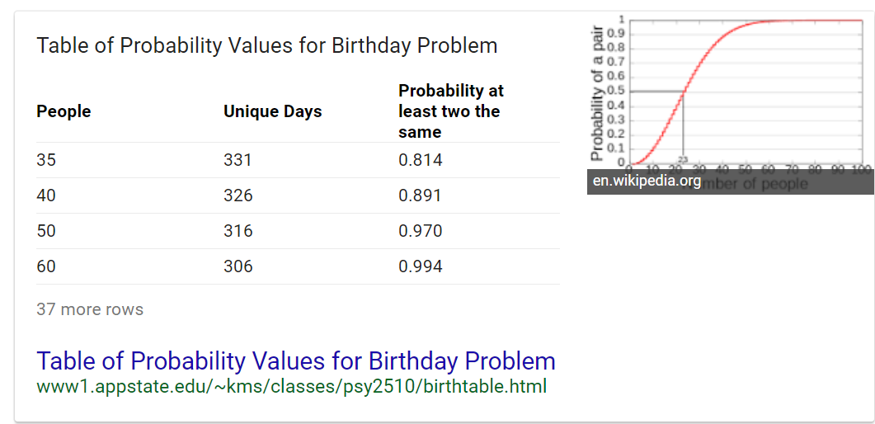

When students realize their predictions of the probability of a match were pretty far off, you can remind them that that is a typical observation and the “guess and check” aspect of the task increases students’ cognitive dissonance and makes the result all the more memorable. You will also want to emphasize the distinction between asking “two people sharing a birthday” and “someone having the same birthday as me” as two very different questions. You may want to show your students this clip from The Tonight Show with Johnny Carson (The Tonight Show with Johnny Carson, Feb. 6, 1980 (Excerpt), 2012, 03:15-05:21).

Task 4

The birthdays that the students have collected will continue to be used in this task. In our implementation, we showed a headline of a recent study of NHL players being more likely to be born earlier in the year. Similarly, there are “rumors” of some days of the week being more/less likely for children to be born (depending on the doctor’s golf schedule).

Students will need to use this time and date website to record the day of the week each birthday landed on, recording these in the table given on the handout. Pool the class’s results together so that the entire class is able to observe the findings. Students were very engaged by this data collection process. Many of them remembered historical figures and recent notable personalities (e.g., Ben Franklin, Mozart). We thought they might think of more modern-day figures and you may want to keep the list of individuals to a similar time period for this investigation in the case the pattern has changed over time. After the results were collected, a student made a graph/chart on the board of the class’s results for the number of observations for each day of the week.

Now have students discuss their idea for simulation for part (c). This will be challenging for them, but again encourage them to share their thinking with each other. We then demonstrated how to use this applet, following the directions provided on the handout.

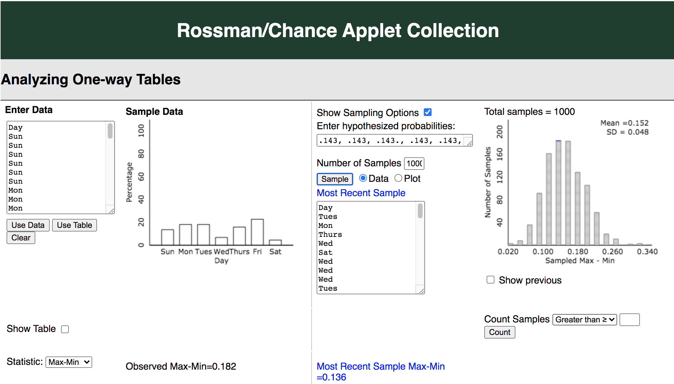

Students may struggle a bit with the larger process here; try to tie back to earlier discussions (could this have happened by random chance alone) as much as possible and focus on the underlying reasoning. You will also need to decide what to use for the statistic. For younger students, a simple statistic such as max – min or even max tally should suffice, but will still take some explaining of how it summarizes the differences among the day of the week categories.

Task 5

End this series of lessons by revisiting the Penny Drops data we gathered in How Random is That? Day 2. Remind students how we collected these data:
- Remember when we collected data on number of drops of water you can fit on the head of a penny, wanting to compare regular water to soapy water. We randomized which pennies would get which type of water. One of the sets of outcomes showed a higher mean for the plain water, but could this have just been by random chance? Maybe if we just mixed up the results at random, we would see a similar difference in the groups?

First they will be provided with this set of outcomes:

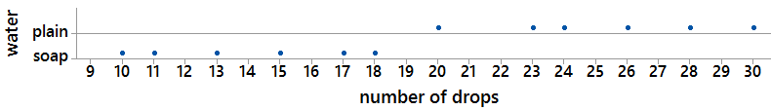

In part (c), they will use the Penny Drops Applet and data they gathered in the penny experiment (Day 2) to conduct a simulation based on our observations.

We asked students how they could simulate the mixing up of the results at random. Through class discussion we developed a plan to write the number of drops of water on index cards and shuffle up the index cards, randomly dealing six to represent each treatment group. Each student carried out one repetition, computed the difference in group means and shared their results.

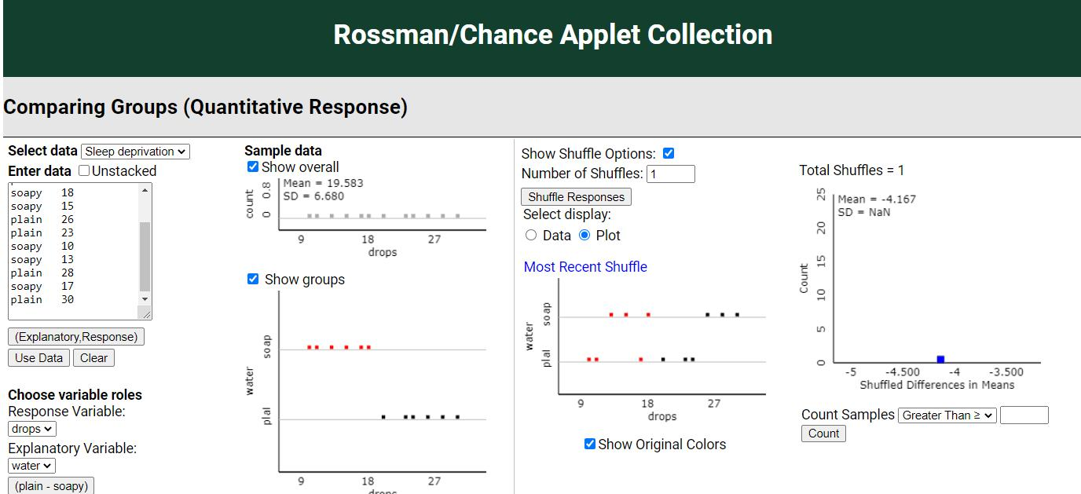

Then we demonstrated using this applet to carry out many more repetitions of the random shuffling process. This allowed us to demonstrate that for this first dataset, it would be very unlikely to find a difference in the group means as large as 11.17 simply due to an unlucky random assignment.

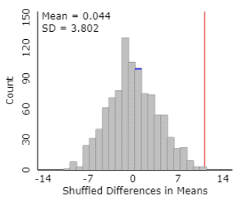

This process can be repeated for another dataset (e.g., another set of student results from when they carried out the study) where the observed difference isn’t nearly as compelling.

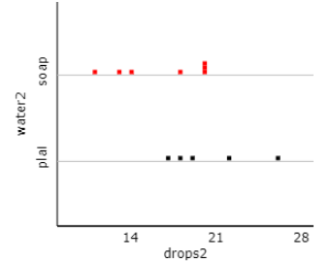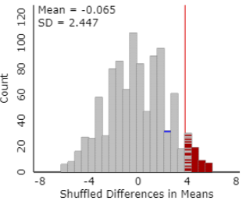
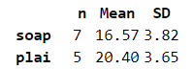

The overall goal is to help students realize that they can use their knowledge of chance models to help decipher when a difference could be chalked up to random chance and when it provides convincing evidence that something other than random chance is at play.

These last few activities were largely demonstration in our elective course as we neared the end of our time together. But we feel students were still about to make some sense of “How Random Was That!” In final feedback from the students, the ESP testing and the water drops experiment appeared to be their favorites.

Attached Materials

- Time and date website
- Birthday Applet (Analyzing One-Way Tables)
- Penny Drops Applet (Comparing Groups – Quantitative)

Reflections and Additional Recommendations

When looking at the days of the week for birthdays, our small group did not have any Saturday birthdays. The main goal is to have students realize that this doesn’t not automatically guarantee that the probability of a Saturday birthday is smaller (as we had actually conjectured ahead of time), but could simply be an artifact of the small sample size. The simulation helps them investigate whether the observed data could have plausibly happened with equally likely days. This caution to not “jump to conclusions” is an important theme through these lessons.

In Task 5 (the penny drops), students still exhibited predominantly local views of the data - they were most concerned with which data point was theirs instead of viewing the graph from a more global perspective. However, when students were asked whether they could tell whether their observations happened by random chance or not, they had the idea of using index cards and shuffling them up – a key insight of modelling the randomness in the study design. We believe the tactile simulation has a very important role to help students understand the reasoning process. Students were able to generate a “null distribution” and see that the observed difference was at the high end of the distribution indicating that such an outcome was possible but not very believable solely with “random shuffling.” Even though they still demonstrated some common misconceptions, we were pleasantly surprised at how well they seemed to apply the earlier informal inferential reasoning. By coming back to this task that was introduced in How Random is That? Day 2, we were able to gauge what the students had learned about randomness and variability through the series of lessons. Overall, the class was very engaged with this task as they were able to gather and draw conclusions from their own data. Actively learning and visualizing statistical concepts with the aid of technology gave them motivation to complete their own experiment (one they may see in middle school science courses as well).

References

American Statistical Association. (2020). Pre-K-12 Guidelines for Assessment and Instruction in Statistics Education II (GAISE I). https://www.amstat.org/asa/files/pdfs/GAISE/GAISEIIPreK-12_Full.pdf
Chance, B. L. (2021). Rossman/Chance Applet Collection 2021. Rossman/Chance. https://www.rossmanchance.com/applets/index2021.html
Grossman, S. (2014, February 16). 1 in 4 Americans Apparently Unaware the Earth Orbits the Sun. Time. https://time.com/7809/1-in-4-americans-thinks-sun-orbits-earth/
Jones, D. (2017, February 17). Sharing a Birthday: Technology-Supported Investigations in Middle School. Statistics Teacher. https://www.statisticsteacher.org/2017/02/17/sharing-a-birthday-technology-supported-investigations-in-middle-school/
National Council of Teachers of Mathematics. (n.d.). How Do Students Think about the Concept of Averages? NCTM National Council of Teachers of Mathematics. Retrieved March 19, 2021, from https://www.nctm.org/Research-and-Advocacy/Research-Brief-and-Clips/Statistics/
The Tonight Show with Johnny Carson, Feb. 6, 1980 (excerpt). (2012, September 17). [Video]. CornellCast. https://www.cornell.edu/video/the-tonight-show-with-johnny-carson-feb-6-1980-excerpt

