How Random is That? Day 4

Overview of Day 4 Lesson
In the previous lessons of How Random is That?, students used a coin tossing simulation to analyze the random behavior of coins (e.g., longest run of heads). In this lesson, they will transition to using a coin tossing model to represent human and animal behavior under certain assumptions, and then to using that model to draw conclusions for genuine research studies. They will also consider models of binary variables that are not 50/50 and how spinners can be used in the place of coins. Our goal is to scaffold the simulation activities to continue to build students’ intuition for inferential reasoning. We also collected data on the students for two of the activities to more fully involve students in the data investigation process.

This lesson can help spur discussion of the following components from the GAISE K-12 guidelines:
- Understand that statistical investigative questions take into account context as well as variability present in data
- Understand that a sample can be used to answer statistical investigative questions about a population. Recognize the limitations and scope of the data collected by describing the group or population from which the data are collected
- Use statistical evidence from analyses to answer the statistical investigative questions and communicate results with comprehensive answers and some teacher guidance
- Acknowledge that looking beyond the data is feasible
- Generalize beyond the sample providing statistical evidence for the generalization and including a statement of uncertainty and plausibility when needed
- Recognize the uncertainty caused by sample-to-sample variability

In this lesson, students can practice the four components of statistical problem solving put forth in the Guidelines for Assessment and Instruction in Statistics Education (GAISE) Report: formulate a question, design and implement a plan to collect data, analyze the data by measures and graphs, and interpret the results in the context of the original question. This is a GAISE Level B activity.

Common Core State Standards
- CCSS.Math.Content.7.SP.A.2
Use data from a random sample to draw inferences about a population with an unknown characteristic of interest. Generate multiple samples (or simulated samples) of the same size to gauge the variation in estimates or predictions.
- CCSS.Math.Content.7.SP.C.7
Develop a probability model and use it to find probabilities of events. Compare probabilities from a model to observed frequencies; if the agreement is not good, explain possible sources of the discrepancy.
  - CCSS.Math.Content.7.SP.C.7.a
Develop a uniform probability model by assigning equal probability to all outcomes, and use the model to determine probabilities of events.
  - CCSS.Math.Content.7.SP.C.7.b Develop a probability model (which may not be uniform) by observing frequencies in data generated from a chance process.

Audience
- This lesson was presented to 6th grade students but is appropriate for grades 6-12th.
- Prerequisites: Students should have a basic understanding of probability and how to describe distributions of data including shape, center, variability, and outliers. It’s also helpful but not required if students have had some experience with computer simulations such as those implemented the earlier How Random Is That lessons.

Time Required
1-2 class periods, or around 80 minutes.

Technology and Other Materials
- Technology: Access to the Coin Tossing (One Proportion) applet
- Day 4 handout, sets of 4 or 5 marked ESP cards with different shapes

Lesson Plan

The overall goal of this lesson is for students to create simulation models that can be used to answer genuine research questions about categorical variables. For example, is there convincing evidence that when playing Rock-Paper-Scissors, individuals tend to choose Scissors less than Rock or Paper? Students will engage in collecting data, considering variability in random processes, and using that evidence to draw conclusions. In the first task, as a warm-up and to familiarize themselves with the context, students will play Rock-Paper-Scissors with a partner and record results for analysis in Task 3. In the second task, students will be given the results from a study about dolphin communication. They will consider how they can apply the earlier coin tossing model to decide whether the observed result is consistent with the 50/50 model or provides evidence against the “random chance” explanation. In Task 3, they then apply this same reasoning to the Rock-Paper-Scissors data that they collected on themselves and to evaluate a larger research study. The emphasis is on using a value other than 0.50 for the hypothesized probability of success. Similarly, in Task 4 they will apply models with non 50/50 probabilities to a study about dogs sniffing cancer. Finally in Task 5, pairs of students will play a guessing game to determine whether their partner has extrasensory perception (ESP: perception or communication outside of normal sensory capability), with a different hypothesized probability of success.

Task 1

First, put the students into pairs. They will play 10 rounds of Rock-Paper-Scissors and record what their partner showed each time (R, P, S). These data can be used in Task 3. As a complement, here is a video you can show them about a Japanese Rock-Paper-Scissors robot that wins every time. The main focus on this activity is involving students in the data collection process and familiarizing themselves with the context. Another context you could remind them of here is to ask “is Punxsutawney Phil better than guessing” when the groundhog predicts the end of winter?

Task 2

Next students will be presented with a study on dolphin communication, conducted by Dr. Bastain as used in Introduction to Statistical Investigations (2nd edition, Wiley, 2020):
- Dr. Jarvis Bastain wanted to study whether dolphins could communicate abstract ideas (beyond simple feelings like “Watch out” or “I’m happy”). So, he trained them to push one of two buttons depending on whether a light was shining steady or flashing. Each time they pushed the correct button, they received a fish reward. Once they figured out how the game worked, he put a curtain between them and only showed the light to Doris. She then had to communicate with Buzz which button to push. In one trial, Buzz pushed the correct button 15 out of 16 times.

Ask students to consider: Could this have happened by chance alone?

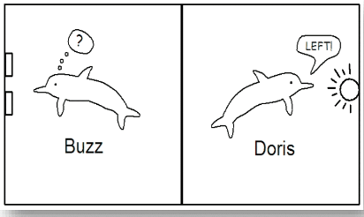

Have students answer parts (a) and (b). If you haven’t had students do a tactile simulation using coins before, we strongly recommend doing so here, assigning heads to “Buzz pushes correct button” and tails to “Buzz does not push the correct button.” In our implementation, we did see some evidence that students were understanding how they could use these methods to test their observations:
Teacher: How might we test whether we believe that pushing the correct button would
happen 15 out 16 times by random chance alone?
Student: Use the Coin Tossing applet

This opens up the discussion for how they should use the applet.

In part (c), they will use the Coin Tossing Applet where they will need to set the probability of heads, the number of tosses, and the number of repetitions. Have students discuss their choices with a partner before continuing to parts (d). In part (d), you can have them generate 1000 sets of 16 coin tosses and examine the distribution. How to use this distribution to make a conclusion about the study is the critical component and may require a fair bit of discussion. Direct them to the idea that “he got lucky” is not a believable explanation for Buzz’s performance.

Teacher: What do you think about getting 15 correct by random chance alone?
Student: 15 has a very, very, very small chance of happening
Teacher: What about if Buzz had only gotten 9 correct?
Student: 9 happens kind of enough so it’s not too surprising

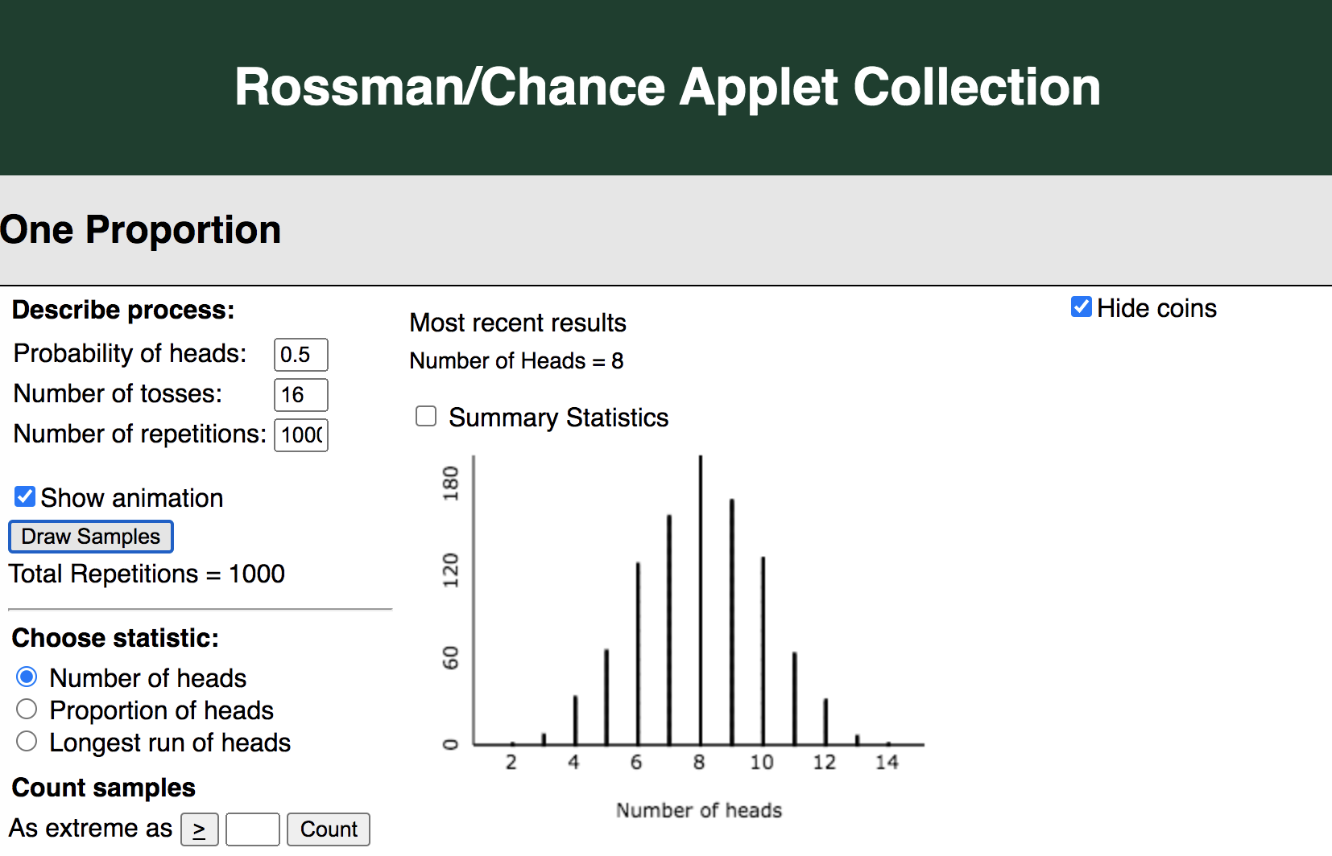

One student wrote: I don’t think he was guessing because the chances of him getting 15/16 by guessing is like 0.00001.

Students will generate a second graph for part (e) to evaluate a follow-up component to the study. They first should realize that they need to change the number of tosses to 28. Note that in the second study presented, it does turn out that the fish reward mechanism was malfunctioning.

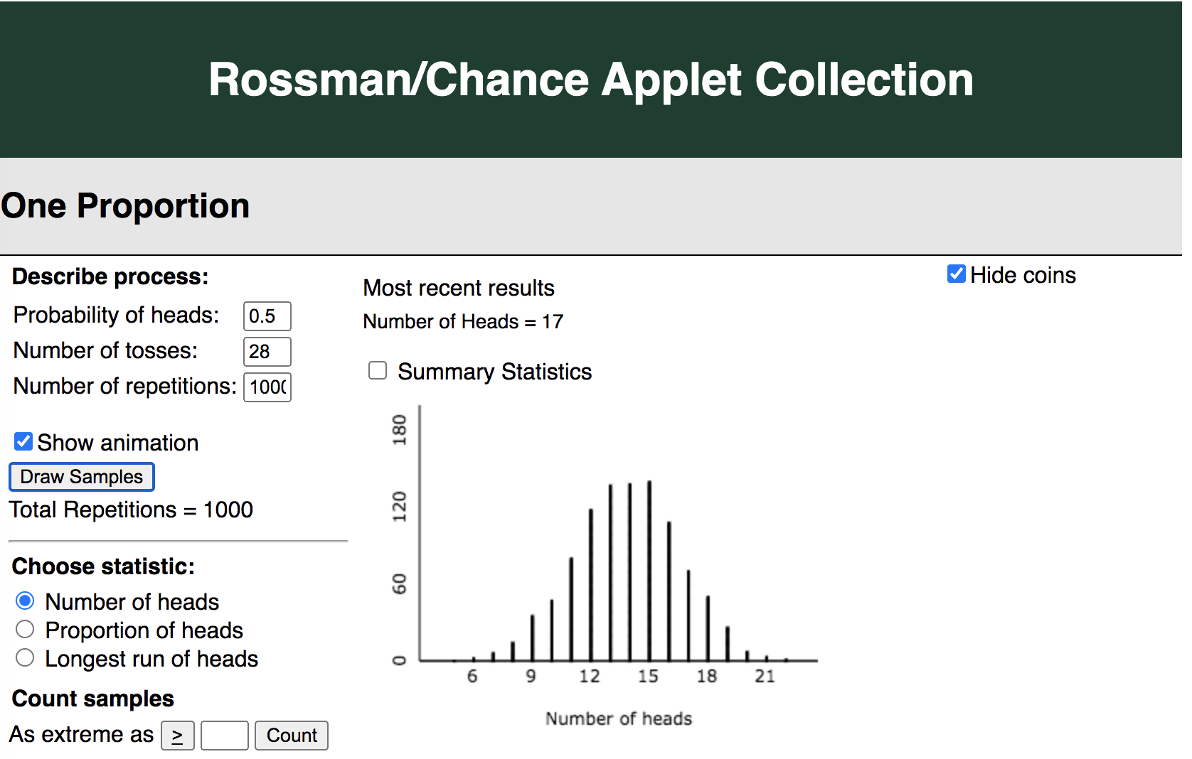

Ask a volunteer to share their conclusion with the rest of the class. Try to draw out how they are using the evidence, including the results from the simulation model, to make their conclusion. As much as possible, get students to phrase the conclusions/justification in their own words.

Teacher: Under our new conditions, Buzz only correctly chose the right button 16 out of 28 times. Do we think this could have happened by random chance?
Student: It’s not surprising at all to get 16 right.

Task 3

In this task, we revisit the Rock-Paper-Scissors scenario. Researchers have found that novice players tend to show scissors less often (Eyler et al., 2009), so the students will explore this discovery through simulation. Students are asked to consider how they should change the simulation model to reflect a 1 in 3 choice rather than a 1 in 2 choice. They will “design” the model by specifying the probability of “heads,” the number of tosses, and number of repetitions. In the Rossman/Chance applet the non 50/50 probability is represented by using spinners but you may also want to use tactile spinners or dice in class to start with. Students enjoy analyzing their own results, though we do not usually find convincing evidence that scissors is chosen less often (may not even be less than one-third). Encourage students to realize that this just means the “chance alone” model is plausible, but other models could be as well.

You can also transition this activity from each student analyzing their own data to looking at the class proportion: Ask students how many of them showed scissors on their first play. Have them raise their hands and count the students, noting the proportion of students who showed scissors first. You can compare these results to the 2009 study of 119 people playing against a computer, where 14 started with scissors. Continue to repeat the mantra “could this have happened by chance alone.” Some students will be ready to update the simulation model as necessary. With advanced students, you could ask them about the distinction between repeated measurements on the same individual and “first choice” measurements across different individuals and whether the simulation model applies equally well in both cases.

Task 4

Present students with the following study:

- A 2011 study in Japan (Sonoda et al.) tested an 8-year-old black Labrador (Marine) to see whether she could detect a certain type of cancer. The study was designed so that the dog first smelled from a bag that had been breathed into by a patient with this type of cancer. This was the standard that the dog would use to judge the other bags. Marine then smelled the breath in five different bags from five different patients, only one of which contained breath from a colorectal cancer patient (not the same as the original patient); the others contained breath from non-cancer patients. The dog was then trained to sit next to the bag which she thought contained breath from a cancer patient (i.e., had the cancer “scent”). If she sat down next to the correct bag, she was rewarded with a tennis ball. Marine was correct on 30 of 33 attempts.

Here is a news clip from Fox News about the cancer-sniffing dogs (time: 2:48).

Again, students will be asked to set up the simulation model and use the results to decide whether there is convincing evidence that Marine performs better than guessing.

Task 5

For the final task,
- Provide each pair of students with a set of four ESP cards with different shapes: circle, plus, square, star (or five with wavy lines).
- Tell them to have one partner shuffle the cards, select one at random, and concentrate “really hard” on the shape they see without showing their partner.
- That student’s partner will try to guess the shape they are seeing.
- Students should record the number of correct and incorrect guesses in 10 attempts.

These were the instructions provided to the students:
- Have your partner pick one of the cards at random and concentrate on the image very hard, while only showing you the back of the card.
- Can you sense what image your partner is looking at?
- Repeat 10 times, how many times where you correct?
- Were you correct more often that you would expect for someone who was really guessing every time?

Students can update and apply the simulation model to decide whether they believe their partner has ESP. At this point, we want to see whether students were able to design their own simulation model.

Discussion questions to continually ask students include:
- Could this have happened by random chance?
- How can you use simulation to help you decide?

Now that we have built to this big idea, consider creating a poster paper with the heading “Could this have happened by random chance?” to remind students of the big idea behind these tasks. You can have students share their conclusions in their own words. You can also provide a sentence frame like “I conclude that Marine (can/cannot) do better than guessing because it would be (very/not) surprising to see Marine identify so many samples correctly by chance alone,” using different sentences for the different tasks. Display the poster in your classroom to highlight the big ideas and terminology from these tasks and to help students see how they are using the same form of inferential reasoning each time.

Attached Materials

- Coin Tossing Applet (One proportion)
- Rock-Paper-Scissors video
- Dog sniffing cancer clip

Reflections and Additional Recommendations

With careful scaffolding and repetition of the big ideas,and building on earlier lessons about randomness and distributions/variability, some of these young students were able to start using inferential reasoning. In particular, many students appeared to begin feeling more comfortable making judgements about which observations are more/less typical in the simulated distribution.

For our implementation of the ESP task, we had the teacher use marked cards from Penguin Magic. Each card contains a slightly different marking on its back, enabling the teacher to successfully guess which shape is on the front. Students were not aware of this and were quite impressed by the teacher’s ability, refusing to believe she generally had ESP and becoming quite determined to prove otherwise.

References

American Statistical Association. (2020). Pre-K-12 Guidelines for Assessment and Instruction in Statistics Education II (GAISE I). https://www.amstat.org/asa/files/pdfs/GAISE/GAISEIIPreK-12_Full.pdf
Cancer-sniffing dogs help create sensors to detect marker. (2013, October 3). [Video]. Fox News. https://video.foxnews.com/v/2717038293001#sp=show-clips
Chance, B. L. (2021). Rossman/Chance Applet Collection 2021. Rossman/Chance. https://www.rossmanchance.com/applets/index2021.html
ESP Test Magic Tricks. (2002). Penguin Magic. https://www.penguinmagic.com/s/esp+test
Eyler, D., Shalla, Z., Doumaux, A., & McDevitt, T. (2009). Winning at Rock-Paper-Scissors. The College Mathematics Journal, 40(2), 125-128. Retrieved March 19, 2021, from http://www.jstor.org/stable/25653686
Sonoda, et al., (2001). “Colorectal cancer screening with odour material by canine scent detection,” Gut, 60: 814-819.
Japanese Janken robot wins rock-paper-scissors every time - video. (2017, February 21). [Video]. The Guardian. https://www.theguardian.com/technology/video/2013/nov/06/japan-janken-robot-wins-rock-paper-scissors-every-time-video
National Council of Teachers of Mathematics. (n.d.). How Do Students Think about the Concept of Averages? NCTM National Council of Teachers of Mathematics. Retrieved March 19, 2021, from https://www.nctm.org/Research-and-Advocacy/Research-Brief-and-Clips/Statistics/
Tintle, N., Chance, B. L., Cobb, G. W., Rossman, A. J., Roy, S., Swanson, T., & VanderStoep, J. (2020). Introduction to Statistical Investigations, 2nd Edition (2nd ed.). Wiley.

