How Random is That? Day 3

Overview of Day 3 Lesson
This lesson will expand on what students learned about patterns to randomness (e.g., How Random Is That Day 1) to further explore how they can use simulation models to investigate random processes. The two tasks in this lesson are similar to the Rats Beat Humans lesson in trying to convince students that knowledge of patterns in randomness can be helpful in predicting outcomes. The first task will focus on sequences of heads in coin tossing. The second task will focus on the Let’s Make a Deal Monty Hall problem. In both tasks, students will be provided an opportunity to observe results directly and then move to a simulation model to explore the long-run properties of the process. At the end of each task, a challenge question will be provided to gauge students’ understanding of the concepts presented in this lesson.

GAISE K-12 Components

- Learn to use the key features of distributions for quantitative variables, such as: center, variability, and shape.
- Use reasoning about distributions to compare two groups based on quantitative variables
- Probability is about quantifying randomness
- Develop simulations to determine approximate sampling distributions.

This is a GAISE Level B activity.

Common Core State Standards
- CCSS.Math.Content.7.SP.C.6
Approximate the probability of a chance event by collecting data on the chance process that produces it and observing its long-run relative frequency, and predict the approximate relative frequency given the probability.
- CCSS.Math.Content.7.SP.C.7: Develop a probability model and use it to find probabilities of events. Compare probabilities from a model to observed frequencies; if the agreement is not good, explain possible sources of the discrepancy.
  - CCSS.Math.Content.7.SP.C.7.B
Develop a probability model (which may not be uniform) by observing frequencies in data generated from a chance process.
- CCSS.Math.Content.HSS.IC.A.2
Decide if a specified model is consistent with results from a given data-generating process, e.g., using simulation.

Audience
- This lesson was presented to 6th grade students but is appropriate for grades 9-12th.
- Prerequisites: Prior to this lesson, students should have a basic understanding of probability as a long-run relative frequency.

Time Required
1-2 class periods, or around 80 minutes.

Technology and Other Materials
- Technology: Access to the applets referenced in the handout.
- Day 3 handout, pennies (one for half to all students)

Lesson Plan

This lesson contains two tasks. In task 1, students will first make up a sequence of coin tosses they would expect to see from tossing a coin, which they will then compare to a real sequence of coin tosses that they gather themselves. Students will calculate the longest run of heads in each set of tosses and add their results to two separate dot plots, and then use the graphs to make comparisons about the results. Next, students will use an applet simulation to explore the distribution of the runs of heads. This task ends with a challenge question which assesses whether they can decide whether a particular “streak” (e.g., a “hot hand”) is surprising or not. The second task involves the Monty Hall problem from the TV show Let’s Make a Deal. Students will be presented with the scenario and then asked whether they think one of the strategies is better than the other, which they will then explore through an applet simulation. The lesson ends with another challenge question to gauge their understanding of the concepts.

If you are recapping How Random is That? – Day 2, you can show them some of the results from the Penny Drops tasks and how them how they would decide whether the difference in the number of waters they found between the two treatments is/is not convincing that the difference is real vs. what we might expect from simply natural variation.

Task 1: Coin Tossing

This activity was adapted from Activity-Based Statistics (Scheaffer et al.). First, ask students to make up a sequence of 20 coin tosses. They should not use a random number table or technology but should use their intuition. Then provide each student with a coin and have them toss the coin 20 times and record the individual outcomes. (If you have a large class, you can split the class into two groups rather than asking students to do both components. You could also ask students to make either sequence outside of class and bring in the results.)

After they have recorded each sequence of 20 “tosses,” ask them to determine the longest run of heads in their sequence. You can then have a volunteer leave the room while the students record the results on two different unlabeled dotplots. You will want to set up the axes (to match scaling) and have the students decide which set of results to put on which graph (outside of the volunteer’s hearing). After all students have shared their results, ask the volunteer to return and identify which dotplot includes the results for the real coin tosses and which for the made-up tosses. We anticipate that the real sequences have a higher average than the made-up sequences, and students may be impressed by the volunteer’s ability. Class discussion should focus on what features distinguish the two graphs and how human intuition of randomness can be faulty (expecting more back and forth and short-run “evenness” in a 50/50 process).

You can then ask students how they would be able to better understand the distribution for this “statistic,” and hopefully (after the earlier lessons), they will consider using simulation. Using this version of the Rossman/Chance Coin Tossing applet, you can select the longest run of heads as the statistic rather than the number of heads. Students should set the sample size to match the 20 tosses, recording the longest run of heads in each set of tosses. Emphasize that the computer is doing exactly what they did when they physically tossed the coin (assuming perfect probabilities), just faster, allowing for a lot more sets of 20 tosses. Students then describe the pattern in this distribution and which outcomes are typical and unusual. You can compare the computer simulation results to their actual coin tossing and discuss the similarities and any differences between them. Try to help them differentiate between real differences in the made-up and actual results, which should be bigger than the “simulation error” between the actual results and the computer simulation.

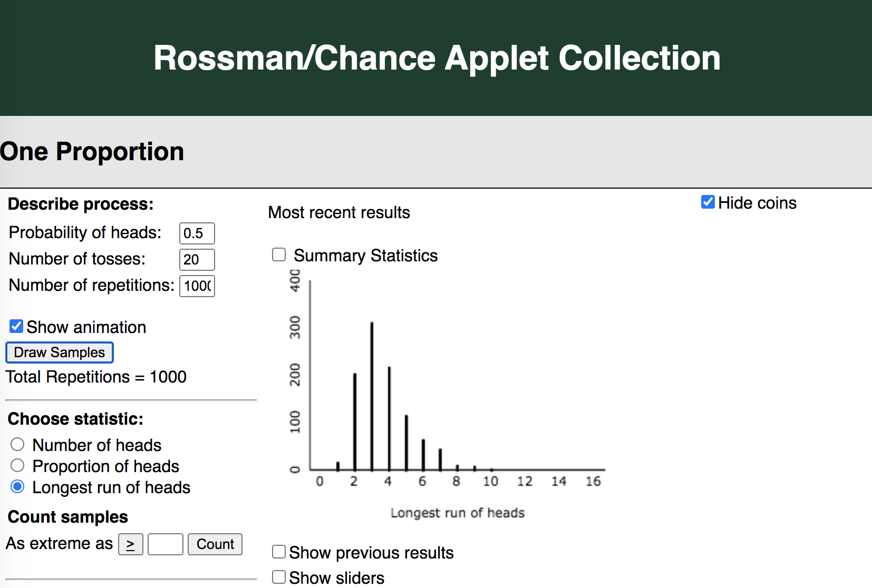

To end this task, students will be presented with a challenge question where they will apply their understanding of the ideas about typical and unusual observations in a new context with a 50/50 probability.

Task 2: Let’s Make a Deal

Begin this task by introducing the Monty Hall Let’s Make a Deal TV show to the students, making sure students understand how the game works:

- Let’s Make a Deal was a TV show in the 70s hosted by Monty Hall (and revived in 2009). Contestants vied to play games of chance to win prizes. In one such game, the contestant was presented with 3 doors. Behind one of the doors was an undesirable prize (say a goat) and behind one of the doors was a very desirable prize (say a racecar). Contestants were asked to pick one door. Then the host revealed a goat behind one of the other doors and presented the contestant with the option of staying with the original pick or changing to the other door (e.g., Ellis, 1995).

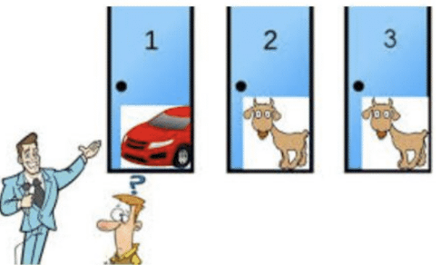

The image above is a useful visual to show the students (Monty Hall Paradox, 2015). You may be able to find a video of the actual game show (or the movie 21). You can also divide the students into pairs, identifying one as the host; give each pair three index cards with goat written on the back of two of the cards and car written on the other. Instead of goats and car, students can choose their own desirable and undesirable prizes. The host can ask the partner to pick a door and then reveal one of the goats, etc. We set up a model of doors (hanging index cards using clothes pins and a coat hanger) that allowed 2-3 student volunteers to be “contestants,” with the prize of a pizza coupon.

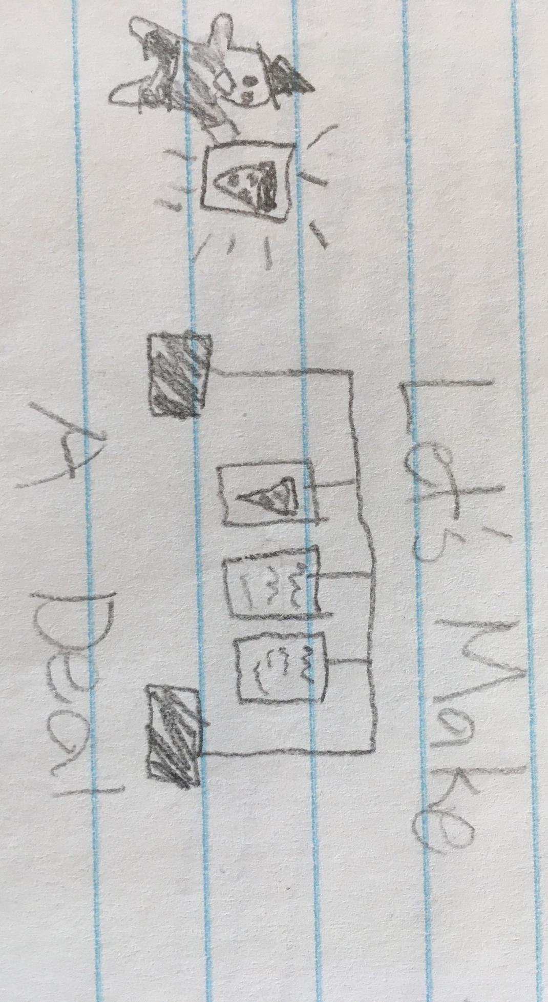
Student rendition of “tactile” Let’s Make a Deal game

Students will then be asked which strategy (“stay” or “switch”) they believe is best and why, leading them to consider playing the game a large number of times with each strategy to decide. We used the Rossman/Chance Monty Hall applet:

- Click one of the other doors and you will be shown a goat behind a different door.
- You can click on the same door to stay or click on the other door to switch.
- The applet will keep track of whether you win the car or lose (“win” the goat).

Eventually they can see the results across 1,000 plays with each strategy, which clearly shows the superiority of the switch strategy.

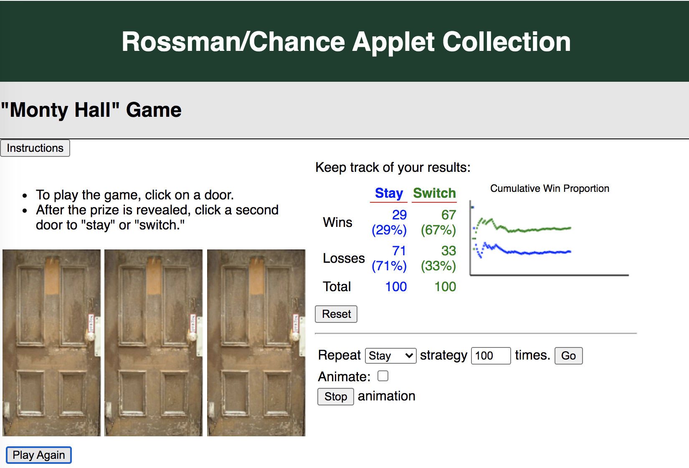

The Challenge Question here involves a different task (putting pennies on edge and then see which side they tend to land on when the table is bumped). Have students observe the majority and see whether they can suggest how to use a simulation to decide whether the observed result could have happened “by random chance alone.” Students might be able to suggest using the computer to run the experiment many times in a world (with the same sample size) where the pennies are equally likely to fall on heads or tails. This is a nice prelude to the next lesson in our series.

Attached Materials

- Coin Tossing Applet (One proportion)
- Monty Hall Applet

Reflections and Additional Recommendations

The tactile activities are helpful in aiding student understanding of the computer simulations (and allowing for more interesting grade-appropriate “prizes”). Make sure students “believe” the connections between the actual coin tossing and what the computer is doing and that they “trust” in the validity of the computer results.

A key component of Task 1, the coin tossing activity, is having a volunteer/teacher leave the room and then come back inside to make observations about the graph. If the volunteer is able to distinguish the distributions and correctly identify which is which, this should impress the students and make the lesson more memorable. Depending on the knowledge of the volunteer and the number of observations, a compelling difference may or may not be evident. If the teacher cannot be the one to leave the room, use a teacher aid or a student, reminding the volunteer that most students do not predict that there will be a run of heads that is longer than 3, however it would not be very unusual for a student to actually flip 8 heads in a row. This relates back to the misunderstandings students may have with randomness and expecting an outcome that is closer to 50/50 in the short run. Also emphasize that although there appears to be real differences between the made-up and actual results, there is still variability and uncertainty among different sets of 20 tosses.

Some guiding discussion questions to ask students include:
- Are you convinced that there is a genuine difference between the distributions here?
- How big of a difference between the methods is enough to conclude it is not “by chance alone”?
- How many heads would a student need to toss in a row to convince you they were cheating?

In the Monty Hall problem, students initially had a difficult time understanding why switching doors gave them a better chance of winning. Using the applet in this task helped to convince them that there is a real difference. Students tend to trust what the computer tells them at this young age rather than dismissing it as magic. However, having students discuss why the probabilities turn out to be 1/3 and 2/3 will better solidify the big idea, especially for older age groups. Playing the role of host and seeing the “information” that is revealed by which door the host opens can help as well. The visual showing the relative frequency settling down with additional repetitions can be an effective way to help students understand how to interpret probabilities in general.

References

American Statistical Association. (2020). Pre-K-12 Guidelines for Assessment and Instruction in Statistics Education II (GAISE I). https://www.amstat.org/asa/files/pdfs/GAISE/GAISEIIPreK-12_Full.pdf
Chance, B. L. (2021). Rossman/Chance Applet Collection 2021. Rossman/Chance. https://www.rossmanchance.com/applets/index2021.html
Ellis, K. M. (1995). The Monty Hall Problem. Monty Hall Problem. https://www.montyhallproblem.com/
Monty Hall Paradox. (2015). [Illustration]. https://montyhallparadox.wordpress.com/tag/naked-statistics/
National Council of Teachers of Mathematics. (n.d.). How Do Students Think about the Concept of Averages? NCTM National Council of Teachers of Mathematics. Retrieved March 19, 2021, from https://www.nctm.org/Research-and-Advocacy/Research-Brief-and-Clips/Statistics/

