How Random is That? Day 2

Overview of Day 2 Lesson
After students have discussed ideas related to measuring and representing data and that there can still be patterns to randomness during Day 1, in this lesson students explore a selection of genuine data sets to focus on different interesting characteristics of distributions. The primary goal is to help students visualize variability and think about key features of a distribution, moving students towards a global view of distributions instead of focusing only on individual observations. By the end of the lesson, we ask students to play data detective and identify which graphs best represent different variables. The last task asks students to collect data that can be used in later activities; this is a fun hands-on experiment that relates to a key concept in science. Students don’t need to know a lot about statistics to see a difference! Depending on time constraints and student understanding, you may choose to select a subset of these tasks.

GAISE K-12 Components
The lessons included in How Random is That? follow the four components of statistical problem solving put forth in the Guidelines for Assessment and Instruction in Statistics Education (GAISE) Report. The four components are: formulate a question, design and implement a plan to collect data, analyze the data by measures and graphs, and interpret the results in the context of the original question. This is a GAISE Level A activity.

Common Core State Standards
- 6.SP.A.1: Recognize a statistical question as one that anticipates variability in the data related to the question and accounts for it in the answers. For example, "How old am I?" is not a statistical question, but "How old are the students in my school?" is a statistical question because one anticipates variability in students' ages.
- 6.SP.A.2: Understand that a set of data collected to answer a statistical question has a distribution which can be described by its center, spread, and overall shape.
- 6.SP.B.5.B: Summarize numerical data sets in relation to their context, such as by: Describing the nature of the attribute under investigation, including how it was measured and its units of measurement.
- 7.SP.B.4: Use measures of center and measures of variability for numerical data from random samples to draw informal comparative inferences about two populations. For example, decide whether the words in a chapter of a seventh-grade science book are generally longer than the words in a chapter of a fourth-grade science book.

Audience
- This lesson was presented to 6th grade students, but could be used in as early as 5th grade.
- Students should have completed How Random is That? Day 1.

Time Required
1-2 class periods, or around 80 minutes.

Technology and Other Materials
- Technology: access to webpage and datasets through link listed in the handout on Task 2
- Day 2 handout, rulers, pennies (13 for each pair of students), droppers, plain water, soapy water.

Lesson Plan

This lesson includes 6 possible tasks that build on the Day 1 activities. The goal is for students to visualize variability by creating and interpreting various graphs and to use graphs to assess evidence about a claim. The succession of these tasks will allow students to develop skills by having them apply knowledge about the context of a graph/variable to develop an understanding of how to identify and describe key features of a distribution. The hope is that by using datasets where they can relate to the context (e.g., body measurements, temperatures), they will develop their understanding of why data vary and why variables may behave differently from each other.

In Task 1, students will gather their own data by measuring forearm and foot length to explore a claim made by Da Vinci (Dove, 2015). By graphing the data, students can use the overall pattern in the data to assess the claim, drawing a conclusion even in the presence of variability and uncertainty. In Tasks 2 and 3, students are given different graphs (or can be asked to create the graphs) that have different interesting features including shape, variability, and outliers. We tried to use datasets/contexts that would be familiar to the students so that they could bring in their outside knowledge in drawing conclusions. Students then apply these investigative skills in Tasks 4 and 5 to anticipate variable behavior. In Task 6, they will gather their own data by counting the number of drops of water than can fit on the head of a penny which will be used in Day 5 of How Random is That?.

Task 1: More Measurements

Students will begin the lesson by measuring forearm and foot length. Start by explaining how to measure forearm length: the crook of the elbow to the wrist. Students are provided with the image below.

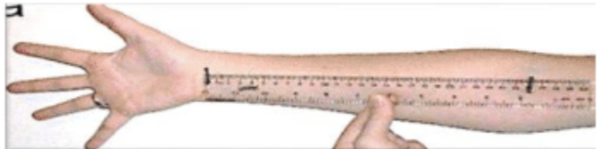

For the foot length, students should be barefoot with weight distributed equally on both feet. To measure foot size: measure the distance between the Pternion (the rearmost point of the heel) and the tip of the longest toe, parallel to the foot axis (the line connecting the Pternion and the tip of the second toe. Students will be provided the image below.

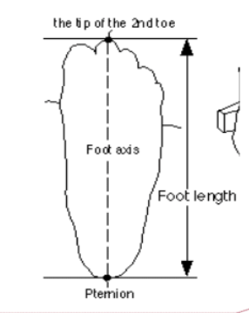

After collecting the data, you can ask students how to assess Da Vinci’s claim that the length of the foot is less than or equal to the length of the forearm. In particular, how can they use the data they have collected to assess the claim. One approach is to create a dotplot of the differences to look for patterns (e.g., do the observations center around zero). Encourage students to see how they can make tentative conclusions even in the presence of variation in the data. Possible discussion questions include:
- Based on this data, what do you conclude? Explain your reasoning.
- Have we proven that the claim is true/false?
- Do you think this relationship has changed since Da Vinci’s time?
- Are there other ways we could compare these observations than looking at the differences? (e.g., with older students you could look at a scatterplot)

Task 2

Students are given a graph and asked to discuss what they “notice” and “wonder” about the distribution. You can also ask them to create their own graph, using pencil and paper, or an online tool. If you use technology, be sure to select a tool that is straight-forward for the students to use so they can maintain their focus on the context of the data rather than the mechanics of constructing a graph. The rowingMen16.xlsx data file found in Day 2 datasets includes more details on the individual rowers. This is helpful for identifying outliers by name. In particular, students can discover that there are 9 rowers listed for the 8-man event, which helps identify the coxswain. If your students are not familiar with rowing, you can investigate as a class and consider showing photos or a short video.

Possible discussion questions include:
- What do you think the average of the data is? Do you think the average does a good job of representing a “typical” rower’s weight?
- Why is there a lower cluster of observations? (Which events are they in? Are there special rules for that event?)
- Why do you think there is a dot all the way to the left of the graph? Which event is he in? Why might there be only one? (Students often focus on “balancing” the weight of the boat)

Task 3

This task, adapted from Workshop Statistics, follows a similar style to Task 2, asking students to notice interesting features and compare distributions. (Again, students could be asked to create the graphs themselves, just watch references to “top graph” vs. “bottom graph” and make sure the graphs use the same scaling.) Introduce this task by noting that the original Jurassic Park book provided dot plots of dinosaur heights. The author uses these graphs as the first clues that the dinosaurs are not as controlled as the park’s creator would like to believe. In particular, students are told that “One character argues that one of these distributions is characteristic of a normal biological population, whereas the other is what one would have expected from a controlled population which had been introduced in three separate batches (as these dinosaurs had).” Students are asked to decide which distribution reflects which population. You may want to remind them to consider comparing shape, center, spread, and outliers. While the author points to the distribution with three humps as reflecting three separate batches (perhaps with the dinosaurs evolving and growing larger, less under control), you can also ask students why the very normal looking distribution looks suspicious and was likely made up by the author. Younger students may struggle more here, but with more experience, students may realize that the distribution is almost “too normal” and not likely representative of actual measurements. You can remind students how their measurements in Day 1 showed patterns but also some natural irregularities in the measurement process.

Possible discussion questions include:
- What are the key features of each graph?
- How do the graphs compare to each other?
- What might lead to the distinct behavior of each graph?
- Did your graphs (from Day 1) look this “regular”?

Task 4

In Task 4, students are presented (or you could ask them to graph, again on the same scale) average monthly temperatures in one year for San Diego, CA and for Atlanta, GA, asking them to conjecture which is which. The focus is again on what distinguishes the two graphs and why that makes sense for this context. In particular, the focus here should be on the variability or spread of the distributions and how, as one might expect, the temperatures for Atlanta show more variation month to month than the temperatures of San Diego, CA (known for its temperate climate).

Possible discussion questions include:
- Which observations represent winter months and which represent summer months?
- What do you think the average monthly temperature for our city would compare?
- Which city would you rather live in? What would you like to be true about the “center” and the “spread” of the temperatures in your ideal city?
- If you could only pick “center” or “spread” which would you rather be in control of?

You could certainly choose to explore further with these datasets, like adding boxplots on top of the dotplots and/or changing to histograms and explore different bin widths.

Task 5

To help assess students’ understanding of how to use context knowledge to match graphs and variable behavior, in this task they are given variables and graphs separately and need to match them together. These data were obtained through a survey of college students where they were asked the following questions:
- How much did you like the last Jurassic Park movie you saw on a scale of 0-9?
- How many brothers and sisters do you have?
- What is the last digit of your phone number?

Students can be given the graphs or asked to produce them with a free online tool.
Students will proceed to answer part (b) which asks which question goes with which graph where they will also explain how they are deciding. You may want to remind students that the small values are on the left-side of the axis and large values are on the right-side. Encourage them to think about their own experiences and encourage them to add numerical values along the horizontal axis to see whether the scales make sense. Remind them that even if “digits” are equally likely, they won’t always happen exactly the same amount of time. During class discussion, be sure to focus on their reasoning, not only their final matches.

Task 6
In the last task for the day, students are asked to make a prediction on how many drops of water can fit on the head of a penny. Such predictions can keep students engaged and help them access the reasonableness of their final answers. Most students will be surprised at how many drops they end up getting. Students should be divided into pairs to conduct this experiment. Assign one student in each pair to be a dropper, and the other to be the randomizer. Each pair should be given 12 pennies, plain water soapy water, and an eye dropper. Then, they will follow these directions and fill out the table:

- Place the 12 pennies heads up in random order.
- Use the 13th penny to decide whether you are using plain water or soapy water each time
- Load the dropper and count how many drops of water you can put on the penny before it spills over.
- Record the number of drops for 6 pennies with the plain water and 6 pennies with the soapy water. (You can flip the 13th coin until you have 6 of one type and then finish with the other type or you can allow for unequal group sizes.)

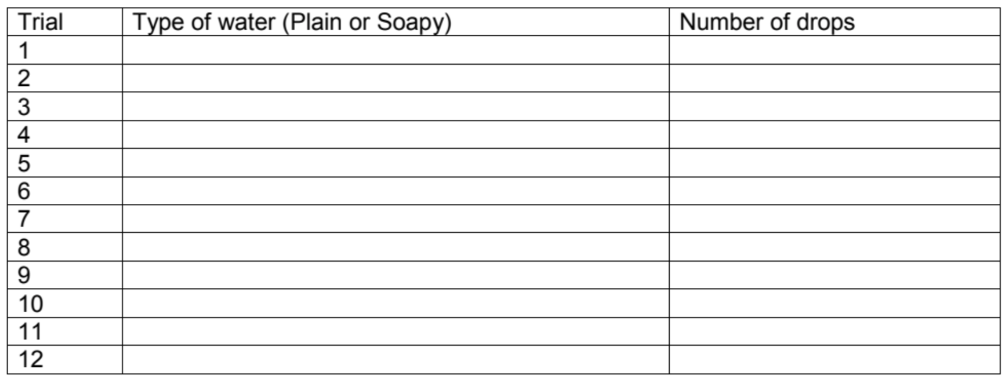

Students can be asked now or in a later class session to graph the two sets of measurements as they have seen a few times in this Lesson and compare the behavior of the two distributions. The measurements may have a lot of variability, but they should be able to see that the soapy water leads to noticeably fewer drops of water by breaking the “skin” of the water. The quality of responses will depend on the grade level of the students.

Attached Materials

- Descriptive Statistics Applet
- Day 2 datasets

Optional Technology Instructions

Task 2: Column A of the Day 2 datasets “Mystery datasets” file contains the weights of the 2016 Men’s Olympic Rowing team or go directly to the rowingMen16.xlsx file and copy and paste column E. These data can be pasted into an online tool (e.g., the Descriptive Statistics applet from the Rossman/Chance collection) to produce the dotplot. In this applet, students can check the “includes header” box and then press the Clear button to empty the text window. Then they paste in the column of data and press Use Data. A checkbox allows them to add the mean.

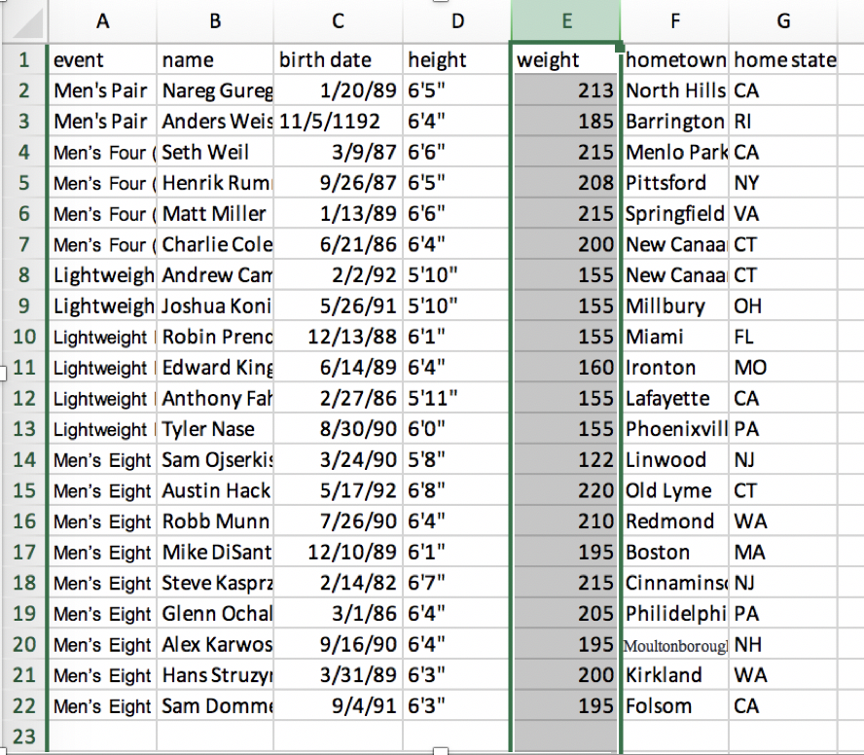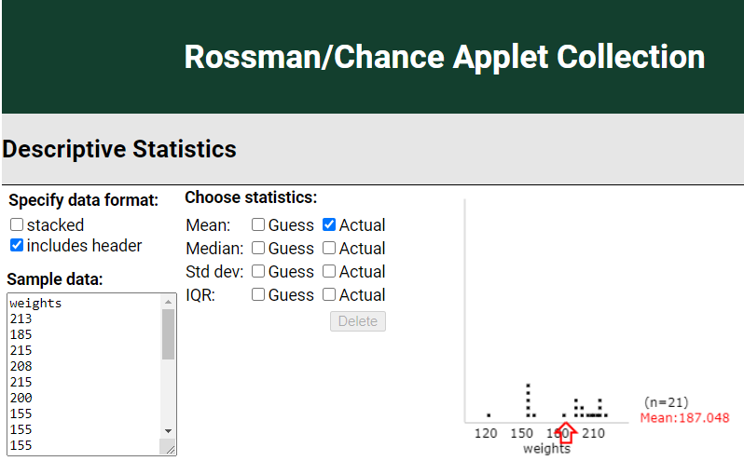

Task 3: Columns C and D in the Day 2 datasets “Mystery datasets” file contains the data in “stacked” format. Students can use an online applet to compare the two distributions on the same axis scaling. For example, the Descriptive Statistics applet from the Rossman/Chance Applet Collection now allows you to “separate” observations by a categorical variable. Students can copy both columns to the clipboard and then paste into the data window as above. They should check the “stacked” box first. Then press Use Data and then they can use the pull-down menus to specify the quantitative and categorical variables.

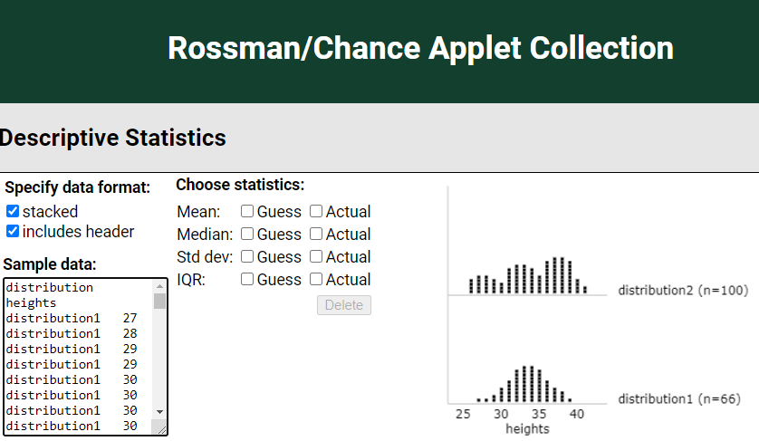

Task 4: Columns F and G in the Day 2 datasets “Mystery datasets” file contains the data in “stacked” format. Students can use an online applet to compare the two distributions on the same axis scaling. For example, the Descriptive Statistics applet from the Rossman/Chance Applet Collection now allows you to “separate” observations by a categorical variable. Check boxes allow you to show the means and standard deviations as well.

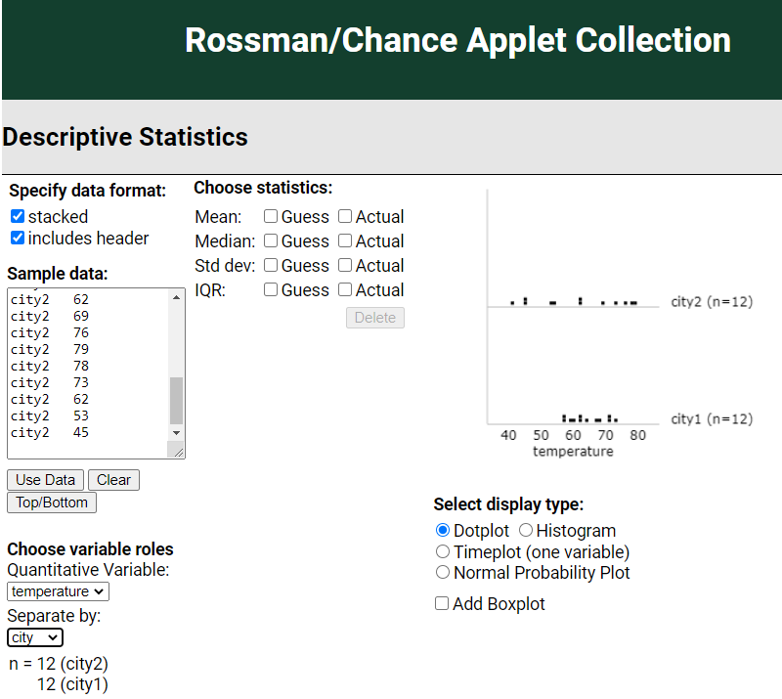

Task 5: To obtain these graphs, they will columns I and J in the Day 2 datasets “Mystery datasets” file and paste them into the applet.

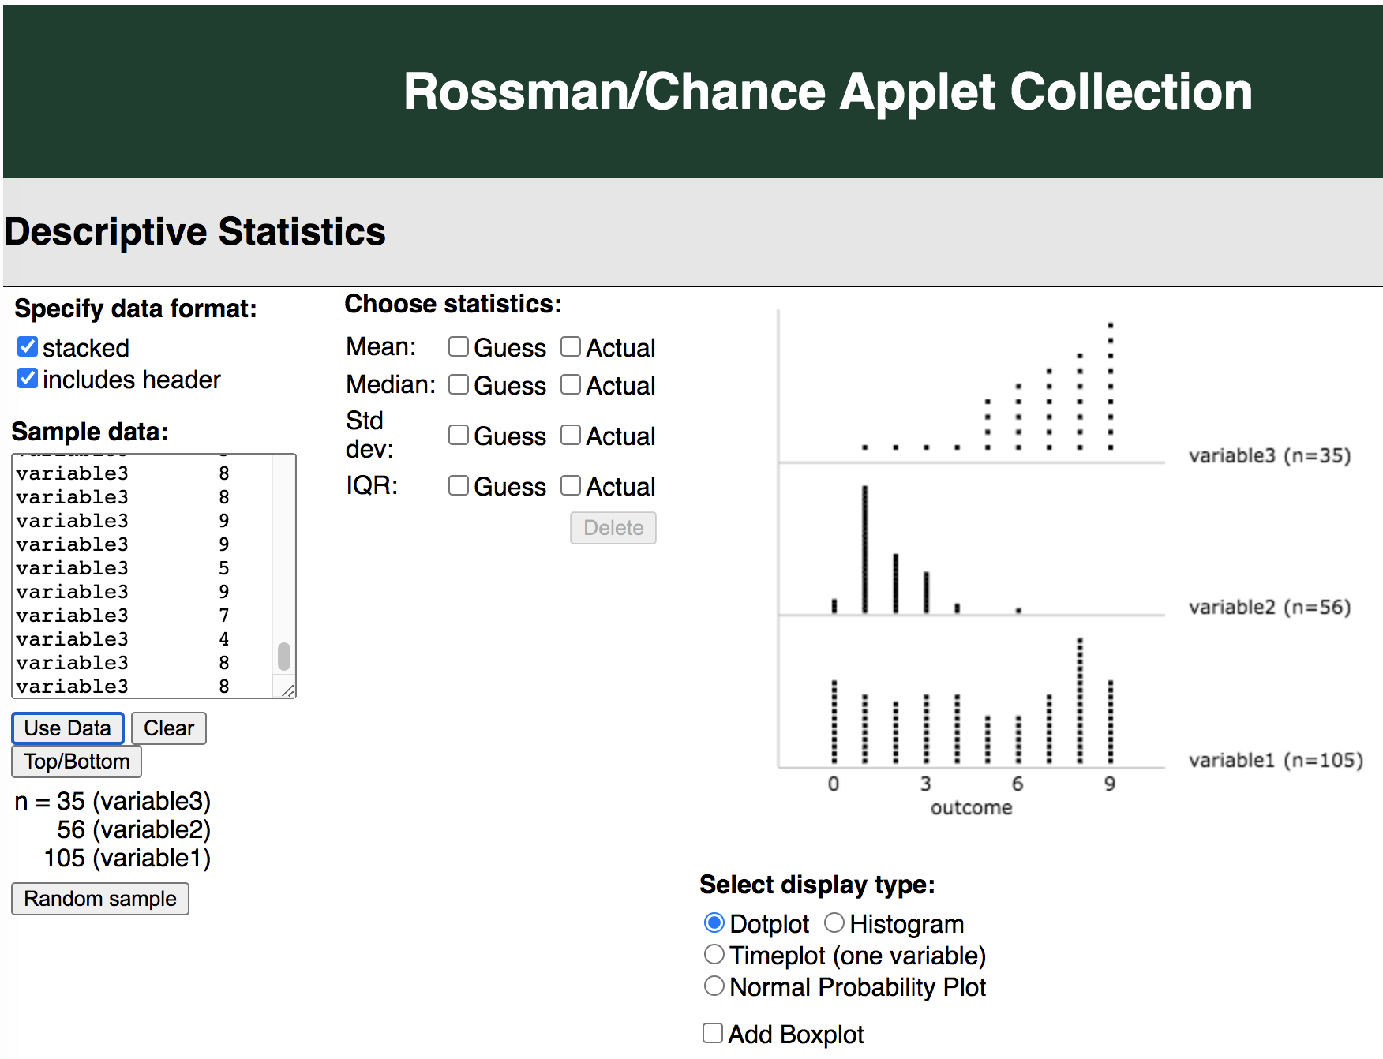

Reflections and Additional Recommendations

Students were reasonably engaged by the data contexts and they appeared to gain understanding in possible reasons and explanations for variability. With younger students, you may want to do even more collecting of data on the students themselves. In looking at the various distributions, students still tended to rely on a more “local view” of the distributions. For example, with the rower data, when asked about “center,” they were more concerned with the cluster of data points and the modal value instead of identifying a value that represented the overall trend of the data. However, they were able to relate to the idea of a coxswain and why he would be an outlier in this context. Helpful tips for avoiding this misconception of local vs global views are provided in the NCTM Standards on the topic of averages and visualizations. For example, to help students think of an average as “representative” of the data at hand, you could include an activity that targets average as “fair share” as proposed by Utts (2013) and others, giving each student a block for each letter in their name, having students create one big pile of all of their blocks combined, then dividing them equally so that each student has the same number of blocks.

References
American Statistical Association. (2020). Pre-K-12 Guidelines for Assessment and Instruction in Statistics Education II (GAISE I). https://www.amstat.org/asa/files/pdfs/GAISE/GAISEIIPreK-12_Full.pdf
Chance, B. L. (2021). Rossman/Chance Applet Collection 2021. Rossman/Chance. https://www.rossmanchance.com/applets/index2021.html
Crichton, M. (2012). Jurassic Park: A Novel. Ballantine Books.
Dove, L. L. (2020, July 27). Is your foot really the same length as your arm from wrist to elbow? HowStuffWorks. https://health.howstuffworks.com/human-body/parts/foot-same-length-as-arm-from-wrist-to elbow.htm#:%7E:text=The%20length%20%22between%20the%20elbow,%5Bsource%3A%20da%20Vinci%5D
National Council of Teachers of Mathematics. (n.d.). How Do Students Think about the Concept of Averages? NCTM National Council of Teachers of Mathematics. Retrieved March 19, 2021, from https://www.nctm.org/Research-and-Advocacy/Research-Brief-and-Clips/Statistics/
Rossman, A. J., & Chance, B. L. (2011). Workshop Statistics: Discovery with Data (4th ed.). Wiley.
Utts, J. (2013, January). The Importance of Statistic Education [Slides]. Keynote. https://www.ics.uci.edu/~jutts/ChileKeynote.pdf

