HOW FAST ARE YOU?  Published: August 2017 |  |  | 
Maryann Huey | Alana Linde | Dan Aalbers
Drake University | Drake University | Hampton-Dumont High School
maryann.huey@drake.edu | alana.linde@drake.edu | daalbers@hdcsd.org

Student Handout

How Fast Are You? An Activity of Reaction Times
Student Handouts

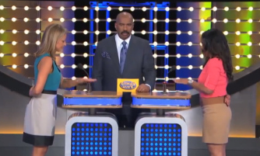
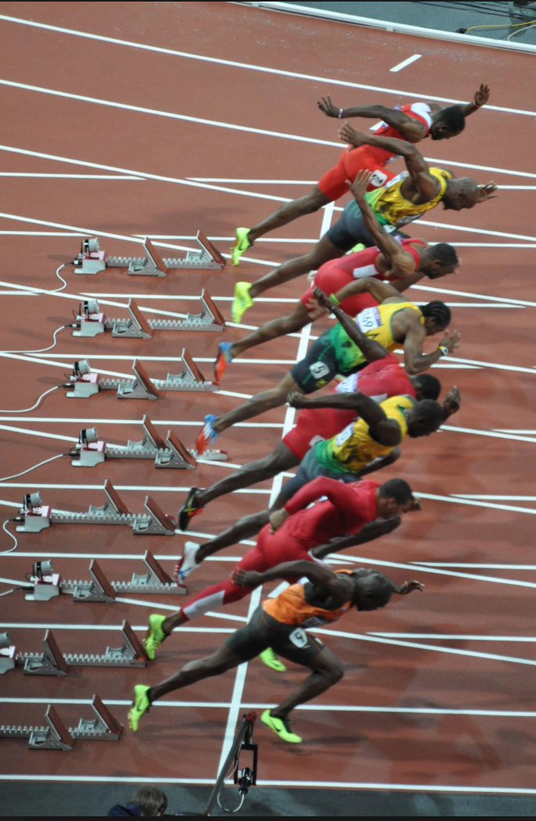

In the 100-yard dash, the race is often decided by who can react the fastest from the racing blocks. To the left is a picture of runners reacting as fast as they can during the men’s 100-yard dash in the 2012 Olympics held in London, England. (image from https://en.wikipedia.org/wiki/100_metres)

In game shows, like Family Feud with Steve Harvey on the right, reacting quickly with an answer could win you and your family thousands of dollars. (image from: http://www.cinemablend.com/television/1613320/family-feud-just-hit-a-huge-milestone-get-the-details)

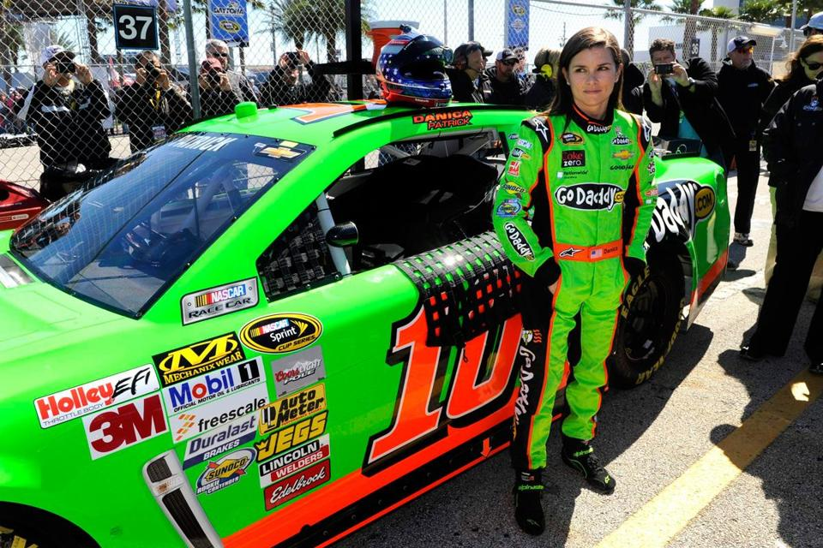

In NASCAR racing, reaction time is critical for both winning and avoiding major injury. Shown to the left is Danica Patrick, one of the most celebrated female drivers in NASCAR history. Danica, born in Wisconsin and raised in Illinois, is one of only two females who have completed both the Indianapolis 500 and the Daytona 500. (image from: https://c.o0bg.com/rf/image_960w/Boston/2011-2020/2013/02/24/BostonGlobe.com/Sports/Images/patrick.jpg)

Question: How fast is your reaction time compared to others?

1. Formulating a Question
Working with a partner, make a prediction about who you think will have the faster reaction time and the most consistent reaction time. Note: You don’t have to agree with your partner!

________ Fastest Reaction Time ________ Most Consistent Reaction Time

2. Collecting Data
2a) Go to the web site http://ww2.amstat.org/education/cas/2.cfm

Before collecting data, practice with the tool 3 to 5 times to make sure you know how it works.
Then, collect 20 reactions times. Have your partner record each time in the table below for you. Discard any trials that extend beyond 1 second. Once completed, switch roles.

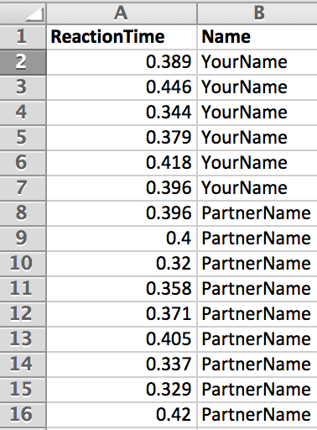
2b) Upload data: Using a spreadsheet tool, enter your data and your partner’s data into a spreadsheet. In the first row, type the word “ReactionTime” into column A. In column B, type the word “Name”. In row two, start entering the actual data. Enter one person’s data first using the format shown below for all 20 values in the rows 2 through 21, with the reaction times in the first column and name in the second. Once completed, enter the other person’s data in rows 22 through 41. Save your file when completed with the title, “ReactionTimeData”.

Only one computer is needed per team of two. Logon to Tuvalabs, https://tuvalabs.com/, go to “My Data Sets”, and upload your spreadsheet file, ReactionTimeData. Go here for help in uploading data https://tuvalabs.com/resources/upload_instructions/.

2c) Represent data: Select a “Dot” representation for a dot plot. Drag the “Name” attribute to the y-axis and the “ReactionTime” attribute to the x-axis. Two stacked dot plots should be visible for you and your partner. Click on the text box to edit the title.

2d) Looking at your data, what does a typical reaction time seem to be for you?______________

Why did you choose this value?____________________________________________________

2e) Would you revise your prediction in from part 1 regarding who is faster? __Yes __No

Say why or why not:____________________________________________________________

2f) Looking at your data, would you say that your reaction time was consistent? __Yes __No

Say why or why not:____________________________________________________________

2g) Would you revise your prediction from part 1 regarding who is more consistent? __Yes __No

Say why or why not:____________________________________________________________

2h) Do you think the reaction times recorded are accurate for you? __Yes __No

Say why or why not:____________________________________________________________

 CHECK POINT

3. Analyzing Data
3a) Typical reaction time: You can insert the mean, median, and mode by clicking on the symbol with three stacked lines, as well as other features. Explore these choices and features. To see the exact values, place your cursor over the lines. Record both the mean and median of your data and your partner’s below:

______ secs (My mean response time) ______ secs (Partner’s mean response time)

______ secs (My median response time) ______ secs (Partner’s median response time)

Say which measure is more representative or typical of the data and why below:
____________________________________________________________________________

____________________________________________________________________________

Based on the measures of center that are most representative, which person is typically faster according to the data recorded?

____________ is typically faster.

3b) Variation of the data: Analyze the variation in your data and your partner’s in the following ways.

3i) Range: Recall this is the largest value minus the smallest value

_________ secs (My range) ______ secs (Partner’s range)

3ii) Inter-Quartile Range (IQR): Using Tuvalabs, you can find the range of the inner half of the data using the box-plot feature. Place your cursor over the boxplot and the value of the inter-quartile range will be shown. The IQR is the distance between the 75th percentile of the data and the 25th percentile of the data or the range of the middle half of the data.

_________ secs (My IQR) ______ secs (Partner’s IQR)

3iii) Mean absolute deviation (MAD): Using Excel and a built in formula called “AveDev”,
we can calculate the MAD for your data and your partners. First, move your partner’s data to
a new set of columns, as show below using “cut” and “paste”. Then, insert the formulas below, and save the file.

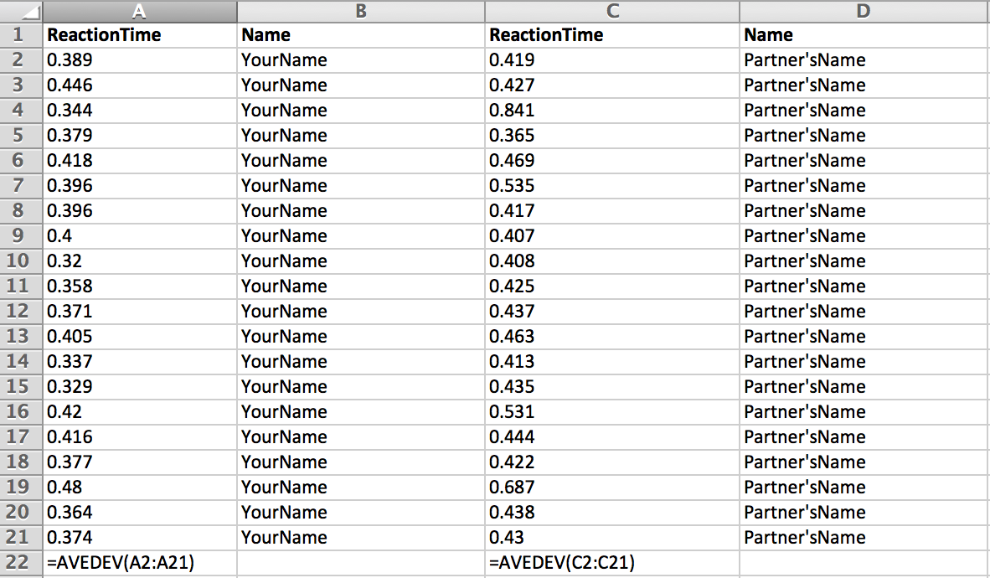

_________ secs (My MAD) ______ secs (Partner’s MAD)

Say which measure is more representative or typical of the variation in the data and why below:
____________________________________________________________________________

____________________________________________________________________________

Based on the measures of variation that are most representative, which person is usually more consistent with their reaction time according to the data recorded?

________________ is usually more consistent.

CHECK POINT

4. Interpreting results:

4a) Looking at the data displays in Tuvalabs, do your conclusions about who is typically faster and who is usually more consistent make sense?

Describe how the shapes of the data distributions either support or contradiction your analyses in part 3. Be sure to speak to both conclusions in your response.

Fastest:_______________________________________________________________________

_____________________________________________________________________________

Most consistent:________________________________________________________________

______________________________________________________________________________

4b) Do you think that this analysis is representative in general of you and your partner? Would these results or similar results likely occur again if you were to repeat the activity?
__Yes __No

Say why or why not:____________________________________________________________

4c) What could be causing a difference between you and your partner besides your reaction times?

4d) If we wanted to find out for sure who was fastest and most consistent, what additional steps would you recommend?

How Fast Are You? Exit Slip

Name: ……………………………………… Date: …………………

Below are 20 reaction times for two students, Elise and Bryce.

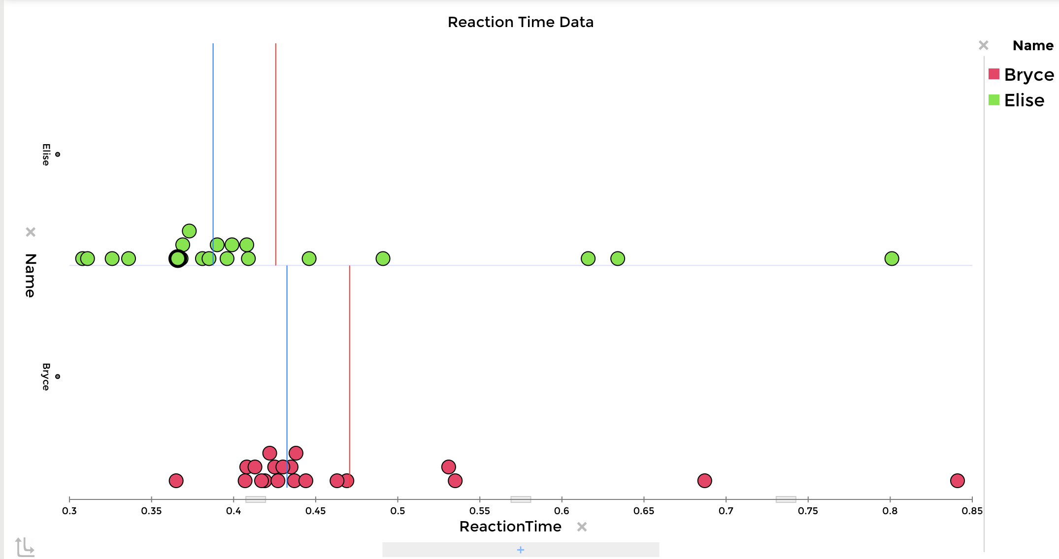

Elise has a mean reaction time of 0.426 seconds and a median reaction time of 0.3875 seconds.
Bryce has a mean reaction time of 0.471 seconds and a median reaction time of 0.4325 seconds.

- Based on the stacked dot plot representations of the data, who would you say is typically faster and why?

- Again using the stacked dot plot representations, who would you say is typically more consistent in terms of reaction time and why?

- What measure of center and variation do you think represents the data better?

Elise: ___Mean OR ___ Median ___IQR OR ___ MAD

Bryce: ___Mean OR ___ Median ___IQR OR ___ MAD

Say why:____________________________________________________________

