Bubble Trouble!  Peter Banwarth  Oregon State University  peter.banwarth@gmail.com  Published: May 2014 | 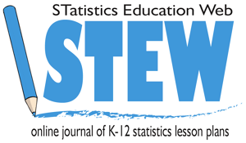

Overview of Lesson
This lesson has two goals. The first is to have students generate data and calculate descriptive statistics to describe the distribution of a sample drawn from a random process. The second is to compare trials from different experiments and use them to make some judgment about the underlying processes.

In this lesson students will determine if the size of a bubble blown in water is affected by different additions to the water. Students will design an activity to explore this. They will use numeric summaries including the mean and 5-number summary, comparative boxplots, and dot plots to summarize the data they collect. Students will draw conclusions about the effect of additions to water on bubble size based on these numerical and visual representations of the data.

GAISE Components
This is a GAISE Level B activity. Students will formulate questions by beginning to pose their own questions and beginning to recognize the distinction between a population, a census, and a sample. Students will collect data by designing and conducting comparative experiments. Students will analyze data by expanding their understanding of a data distribution, quantifying variability within a group, and comparing two or more distributions using graphical displays and numerical summaries. Students will interpret results by describing differences between two or more distributions, and understanding basic interpretations of measures of association.

Common Core State Standards for Mathematical Practice 1. 1. Make sense of problems and persevere in solving them.
- Reason abstractly and quantitatively.
- Construct viable arguments and critique the reasoning of others.
- Model with mathematics.
- Use appropriate tools strategically.

Common Core State Standards Grade Level Content (Grade 7)
7. SP. 1. Understand that statistics can be used to gain information about a population by examining a sample of the population; generalizations about a population from a sample are valid only if the sample is representative of that population. Understand that random sampling tends to produce representative samples and support valid inferences.
7. SP. 2. Use data from a random sample to draw inferences about a population with an unknown characteristic of interest. Generate multiple samples (or simulated samples) of the same size to gauge the variation in estimates or predictions.
7. SP. 3. Informally assess the degree of visual overlap of two numerical data distributions with similar variabilities, measuring the difference between the centers by expressing it as a multiple of a measure of variability.
7. SP. 4. Use measures of center and measures of variability for numerical data from random samples to draw informal comparative inferences about two populations.

NCTM Principles and Standards for School Mathematics

Data Analysis and Probability Standards for Grades 6-8
Formulate questions that can be addressed with data and collect, organize, and display relevant data to answer them:
- formulate questions, design studies, and collect data about a characteristic shared by two populations;
- select, create, and use appropriate graphical representations of data, including histograms and box plots.
Select and use appropriate statistical methods to analyze data:
- find, use, and interpret measures of center and spread, including mean and interquartile range;
- discuss and understand the correspondence between data sets and their graphical representations, especially histograms, stem-and-leaf plots, box plots, and scatterplots.
Develop and evaluate inferences and predictions that are based on data:
- use observations about differences between two or more samples to make conjectures about the populations from which the samples were taken;
- make conjectures about possible relationships between two characteristics of a sample on the basis of scatterplots of the data and approximate lines of fit;
- use conjectures to formulate new questions and plan new studies to answer them.

Prerequisites
Students will need to know how to calculate numeric summaries for one variable, including the mean and five-number summary. Students will need to know how to construct and interpret comparative box plots. Students will need to know how to construct a dot plot.

Learning Targets
Students will be able to design a simple experiment to collect data comparing two random processes. Students will be able to calculate numeric summaries, construct box plots, and make informal inferences based on visual evidence. Students will be able to make informal critiques of experimental designs.

Time Required
Two class periods (about two hours).

Materials Required
One beaker/cup for each student.
Half of the beakers have 1 cup of the control: Water with liquid hand soap added (~ 2 tsp per gallon)
The other beakers are split between the following treatments (these are optional, you can use some or all of them, or create others):
- Water with liquid hand soap (~ 2 tsp per gallon) and salt added (~ 1/2 tsp salt per cup)
- Water with liquid hand soap (~2 tsp per gallon) and glycerin added (~ 1/8 tsp or 20 drops per cup)
- Hot water (not too hot to touch) with liquid hand soap added (~2 tsp per gallon)
- Water with liquid laundry detergent (same concentration as control)
- Water with liquid dish soap (same concentration as control, use concentrated dish soap for stronger effect)
- Pure water

Note: The teacher may want to test the bubble diameter of the control and adjust the concentrations so the bubbles are neither too big nor too small (10 cm is a good target), then alter the treatments to have the same concentrations. In testing, the bubble diameter for the different treatments was ranked (smallest to largest):

Pure water | Hand soap with salt, hot water with hand soap | Hand soap, hand soap with glycerin, laundry detergent | Liquid dish soap

Straws
Rulers
Pencils
Graph paper for making box plots
Calculators or similar technology (e.g. tablets)
Activity sheets for data collection (provided on page 14), one per pair of students
Class data sheets (provided on page 15), one for the control and one for each treatment
Paper towels and pure water to clean the tables following the experiments

The GAISE Statistical Problem-Solving Procedure I. Formulate Question(s)

The lesson can begin with a general discussion of the surface tension of water. Surface tension is created by the cohesive forces formed by hydrogen bonds between neighboring water molecules (Perlman, USGS at http://water.usgs.gov/edu/surface-tension.html). On the surface of a liquid, the cohesive force between molecules on the surface is stronger than the force between surface molecules and molecules within the interior of the liquid. This causes the surface molecules to resist stretching or breaking apart, even when denser objects are placed on the surface. Surface tension can be observed in many natural settings. Water poured in a narrow beaker or graduated cylinder forms a meniscus (a slight depression in the surface of the water). Water skippers (aka water striders) are small insects that can rely on surface tension to walk on water. Surface tension is critical for the survival of plants, which use capillary action (the movement of liquid through narrow channels) to draw water upward from their roots into their leaves for use in photosynthesis. All of these properties can be demonstrated, with a needle or small paper clip taking the place of a water skipper and a paper towel taking the place of a plant. The USGS Water Science School is an excellent basic resource for information about surface tension (http://water.usgs.gov/edu/surface-tension.html).

The large surface tension of water is what causes water to bead up on solid surfaces and form round raindrops. This surface tension also makes it very difficult to blow bubbles in pure water, since the surface tension resists expansion. Different additives to water can affect the surface tension. Soaps (surfactants) reduce surface tension by interfering with the hydrogen bonds enough to allow the water molecules to spread out with less force applied. Surfactants also form layers on both sides of the bubble, slowing the evaporation of the water.

This experiment tests the effects of different additives (hand soap, dish soap, glycerin, etc.) on the surface tension of water, as measured by the diameter of bubbles formed from the different solutions. The teacher can begin the experiment by asking the students if they think the surface tension of water can be affected by different environmental variables. Have students write some specific questions that they think would be interesting to investigate.

Examples of questions:
What does surface tension allow water to do (support floating objects, move by capillary action, bead up on certain surfaces)?
Does temperature matter for surface tension?
What sort of additives could affect surface tension?
Does adding salt change the surface tension?
Does adding soap change the surface tension?

Design and Implement a Plan to Collect the Data
Tell the students they will be generating data to explore these questions and divide them into pairs. Ask students to think about how they could collect this data. If no student suggests blowing bubbles, ask them if they think that the size of a bubble might be related to surface tension.

Some things they should consider:
How can they accurately measure bubble size?
How should they compare the size of bubbles for a treatment versus a control?
Who should blow which bubbles – should one team member blow one kind and the other blow another kind?
How many bubbles should they blow for each kind of water?

The teacher should note that the surface tension of pure water is so strong that it is extremely difficult to blow bubbles in. For the control the class will use water with hand soap which is a mild surfactant.

After students discuss possible ways to collect the data, describe the experimental procedure. This experiment will also benefit from a demonstration, so it is a good idea for the teacher to try it a couple of times before showing the class.

The experimental procedure: have the students pair up; each pair of students should choose one treatment water sample to test against the control (water with liquid hand soap). Give each pair a beaker of the control water and a beaker of their chosen treatment. One student should put some control water on the table (e.g. by putting the straw in the beaker, placing his or her thumb over the top of the straw, emptying the straw on the table, and repeating this a few times) and spread the water around by hand to create a puddle. It helps to create some small bubbles or foam on the surface of the puddle to make it easier to measure the bubble diameter later. This can be done by agitating the puddle with the student’s hand or making small bubbles in the beaker and transferring them to the puddle. The student then places the straw in the puddle and gently blows to create a bubble that adheres to the table like a dome. The more gently the student blows, the better. This may take some getting used to. Once the bubble forms, the student should lift the straw just off the table, keeping it inside the bubble, and continue to blow gently. This will allow the bubble to expand without puncturing its skin with the straw. If the bubble is centered in the puddle, it will expand toward the boundary of the puddle, pushing the foam outwards. If the bubble expands all the way to the edge of the puddle, by continuing to blow gently, it should be possible to expand the puddle as well as the bubble. Eventually the bubble will be stretched too thin and it will pop. Since the puddle should be slightly foamy, the popped bubble will leave a ring on the table. The student’s partner should quickly measure the diameter of the bubble using the centimeter side of the ruler. Fractional centimeters can be rounded to the nearest half centimeter or the nearest centimeter. The students should get at least a few practice tries to get the hang of it before recording data. Each student should blow 10 bubbles (20 total of control water) and record the diameters on the activity sheet (provided on page 14). Every so often they should add more water to the puddle to ensure there is enough water for good bubbles. Once the students try the control water, they can switch to the treated water and repeat the experiment, again recording the data on the activity sheet.

The following pictures illustrate the data collection process:

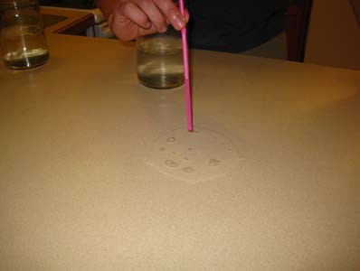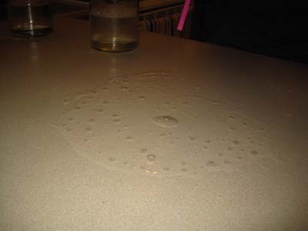
Picture 1. Putting control water on the table. Picture 2. View of control water on the table.

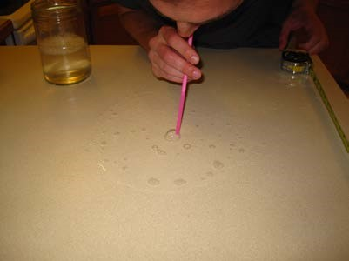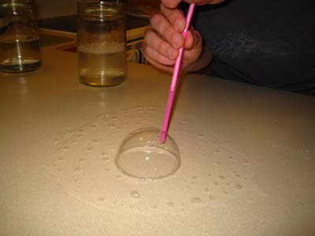
Picture 3. Starting to blow a bubble. Picture 4. Still blowing the bubble.

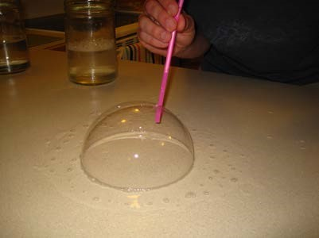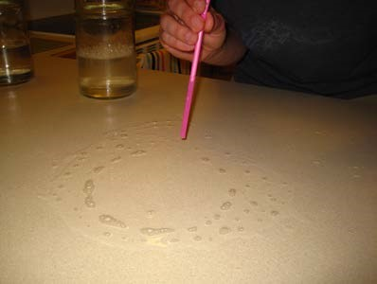
Picture 5. Still blowing the bubble. Picture 6. The bubble has popped.

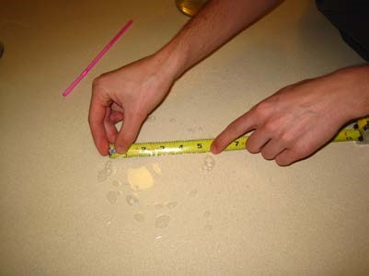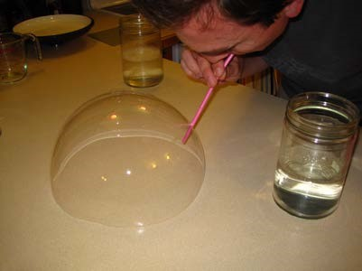
Picture 7. Measuring the bubble diameter. Picture 8. Example of a liquid dish soap bubble.

Once the students collect all of their data, they should record it on the class data sheets under the appropriate columns (provided on page 15). Each treatment has its own data sheet that has a blank dot plot, on which students record their measurements. If there are many diameters above 20 cm, the teacher can append another page to extend the interval.

Analyze the Data
The analysis has two main parts.

First, students should investigate the average diameter that a bubble achieves with control water and with treated water. Ask students what statistics they can compute in order to describe the average diameter.

Second, students should investigate if control water bubbles have different diameters than treated water bubbles. Ask the students what numerical or graphical approaches they could use to investigate this question.

After a class discussion, have students investigate these two questions by computing the mean and five-number summaries for their own data sets, broken into control water and treated water.

Sample five-number summaries in centimeters:
 | Minimum | Quartile 1 (Q1) | Median | Quartile 3 (Q3) | Maximum
Control (Hand soap) | 2.5 | 3.5 | 7.0 | 10.0 | 13.5
Treatment (Glycerin) | 3.0 | 10.5 | 12.5 | 14.0 | 19.0

Once students find the five-number summary, they should determine if there are any outliers using the standard approach: Calculate the interquartile range: IQR = Q3 - Q1. An outlier is any value that is more than 1.5 times the IQR either below Q1 or above Q3.

Next have students construct comparative boxplots using the 5-number summaries, incorporating the outlier restrictions (i.e. the whiskers should be extended to the largest and smallest values that are not outliers). The outliers are given as separate points. Students should discuss what the 5 number summary tells them (e.g. the median is a measure of the center of the data and the IQR and the minimum and maximum demonstrate the spread of the data).

Sample comparative box plots:

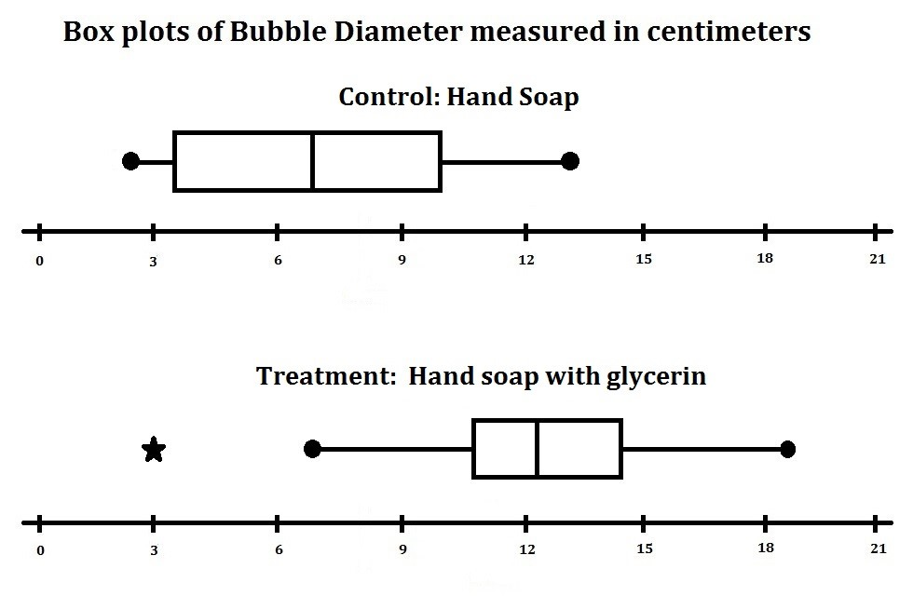

IV. Interpret the Results.
Using the numerical summaries and boxplots, students will answer the questions of interest.

Students can examine the numerical summaries to describe how large a bubble can be blown in the control water and in the treatment water. They can describe the spread of the data for the two types of water. The numerical summaries and the box plots can be used to decide if the treatment has an effect on bubble diameter. Students can also discuss how much larger or smaller the bubble diameter is when using the treatment water. Students should decide if the evidence presented in the box plots and summaries convinces them that there is a difference in the bubble diameter between the control and treatment water. For example, even though the median bubble diameter is larger for glycerin water than for the control water, there is a significant amount of overlap. About 50 percent of each sample overlaps with the other. The evidence does not strongly support the hypothesis that glycerin increases bubble diameter compared to hand soap.

After students discuss their own results, they should compute the 5 number summaries and create box plots using the data on the control and the treatment they selected from the class data sheets (page 13) to determine if their results agree with the results from the larger sample size. When doing this, students should realize that the samples they generated are just one of many possible samples.

Once students discuss in their pairs, the teacher gathers the class and leads a discussion of the activity. Topics for discussion can include the value of the 5 number summary in understanding center and spread, whether the mean or the median is a better measure of the center, the usefulness of comparing box plots of different data sets, criteria that a comparison must meet to be considered convincing evidence, samples as a limited set of outputs from a random process, etc.

The teacher should also ask students if they think that measuring bubble diameter was a good way to measure surface tension. E.g., if dish soap had a larger average bubble diameter than hand soap, does that mean that water with dish soap has a smaller surface tension than water with hand soap?

There is also an opportunity for a discussion of measurement error, since students are measuring by hand the diameter of bubbles that may not be perfectly circular, and the rings left by the popped bubbles may be difficult to see at times.

Assessment
1. In another class, group A tested the control water versus water with food coloring added. Here are their numerical summaries based on 20 trials of each type of water. In addition, suppose the second smallest diameter bubble for food coloring water is 1.5 cm.

 | Minimum | Quartile 1 (Q1) | Median | Quartile 3 (Q3) | Maximum
Control (Hand soap) | 6.0 | 8.0 | 10.5 | 12.5 | 17.5
Treatment  (Food coloring) | 0.5 | 4.0 | 5.0 | 6.0 | 7.5

Use the summaries to determine if there are any outliers for each data set. Recall that the second smallest diameter for food coloring water is 1.5 cm. Create box plots from these summaries.
Is there evidence that there is a difference in bubble diameter for the hand soap water versus food coloring water? Explain your answer.

2. Group B is testing hand soap water versus salty hand soap water, while group C is testing hand soap water versus hot hand soap water. Their two box plots are presented below on the same scale, (without units).

Does one pair of comparative box plots present stronger evidence that the treated water makes larger bubbles compared to the other pair? Explain your answer.

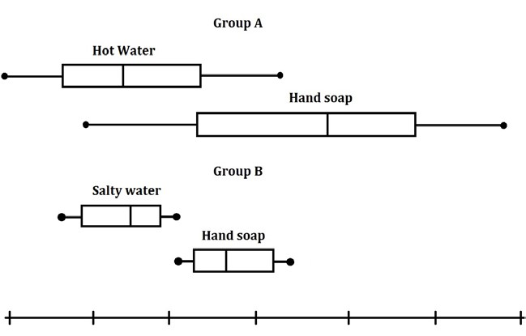

3. Group D is testing the control water. They record their measurements as follows:

Control (Hand Soap)
Trial number | Bubble diameter (cm)
1 | 1.0
2 | 1.5
3 | 1.5
4 | 1.0
5 | 2.0
6 | 2.5
7 | 3.0
8 | 2.0
9 | 2.5
10 | 5.0
11 | 4.5
12 | 7.0
13 | 8.5
14 | 10.0
15 | 9.0
16 | 13.5
17 | 20.5
18 | 17.0
19 | 18.0
20 | 22.0

Based on their table, do you have any concerns about their experimental procedure? Suppose after they test the control water they test laundry detergent water and, based on their results, they claim that laundry detergent water produces larger bubbles. Would you believe them? Why or why not?

Answers

1. This question is designed to assess the student’s ability to use the procedures they learned during the activity and make interpretations.

There is no outlier in the first data set. There is one outlier in the second data set (the minimum of 0.5 cm), since the second smallest diameter is within 1.5*(IQR) of the lower quartile. Based on the box plots, there is informal evidence that food coloring water bubbles have a smaller diameter than hand soap water bubbles. This is because there is very little overlap between the boxplots, and the difference in the medians is 5.5 cm, which seems large relative to the size of the bubbles.

2. This question is designed to assess how students judge the importance of center and spread when comparing distributions.

The medians are farther apart for group A’s data compared to group B’s data. This would indicate that group A has stronger evidence for a difference in diameters. On the other hand, the spread of group B’s data is much smaller, and there is little overlap between the box plots. This would indicate that group B has stronger evidence for a difference in diameters. A good answer would include 1) both of these observations, 2) which of the criteria (center or spread) is more important in this case, and 3) why the student thinks so.

3. This question is designed to have students critique the claims of a statistical conclusion.

The diameter of the bubbles generally increases as the number of trials increase. This would indicate that the students are getting better at blowing bubbles, and would cast doubt on a random sample drawn from a consistent underlying process. The reason they found that laundry detergent water produces larger bubbles is probably due to their increased skill in blowing bubbles, rather than a different effect of laundry detergent on the water itself.

Possible Extensions
Students can create histograms from the class data to analyze the distributions of the bubble diameters. The teacher can lead a discussion of using the histograms to compare the different treatments to the control.

Students can test how different amounts of the hand soap (or other treatment) affect bubble diameter. They can construct a scatterplot of the results and a line of best fit.

For extension to GAISE level C: Students can calculate the standard error of the sample data sets, then use an unpaired t-test on the control and treatment to conduct a hypothesis test of equality of means. If students tested different amounts of a treatment, they could conduct a regression to predict the bubble diameter given a certain amount of the treatment.

References
- Cobb, P., & McClain, K. (2004). Principles of instructional design for supporting the development of students’ statistical reasoning. In The challenge of developing statistical literacy,reasoning and thinking (pp. 375-395). Springer Netherlands.

- Common Core State Standards Initiative (2010). Common Core State Standards for Mathematics. Washington, DC: National Governors Association Center for Best Practices and the Council of Chief State School Officers.

- Franklin, C., Kader, G., Mewborn, D., Moreno, J., Peck, R., Perry, M., & Scheaffer, R. (2007). Guidelines for assessment and instruction in statistics education (GAISE) report. Alexandria: American Statistical Association.

- Konold, C., & Pollatsek, A. (2005). Conceptualizing an average as a stable feature of a noisy process. In The challenge of developing statistical literacy, reasoning and thinking, (pp. 169- 199). Springer Netherlands.

- National Council of Teachers of Mathematics. (2000). Principles and standards for school mathematics (Vol. 1). National Council of Teachers of Mathematics.

- Perlman, Howard, contact. (2014). Surface tension and water. The USGS Water Science School. http://water.usgs.gov/edu/surface-tension.html. Accessed May 2, 2014.

- Reading, C., & Shaughnessy, J. M. (2005). Reasoning about variation. In The challenge of developing statistical literacy, reasoning and thinking (pp. 201-226). Springer Netherlands.

- Watson, J. M. (1997). Assessing statistical thinking using the media. The assessment challenge in statistics education, 107-121.

- This lesson is developed from one that the author did in eighth grade science class (1997-
1998), taught by Linda Mitchelle at Cheldelin Middle School, Corvallis, Oregon.

Bubble Trouble! Activity Sheet
Use this activity sheet to record the data from your experiments
Control (Hand Soap) |  |  | Treatment (__________)
Trial number | Bubble diameter (cm) |  | Trial number | Bubble diameter (cm)

Mean of Control Bubble diameter: _______________ cm

Mean of Treatment Bubble diameter: _______________cm

5 Number summaries (bubble diameter in cm)

 | Minimum | Quartile 1 (Q1) | Median | Quartile 3 (Q3) | Maximum
Control (Hand soap)
Treatment (__________)

Interquartile range of Control Bubble diameter: ________________cm

Interquartile range of Treatment Bubble diameter: _______________cm

Construct the comparative box plots on your graph paper.
