Instructions: Creating the Random Selection Task Surveys in Google Forms
RANDOM SELECTION TASK PART I

Step 1: Accessing Google Forms

Sign-in:
- Login/sign-in to your Google Account
Open Google Forms application:
- Click on the “Google Apps” icon in the upper right corner to access Google “Forms” from the menu to create a new survey.
- Scroll down and click on the purple “Forms” app icon.

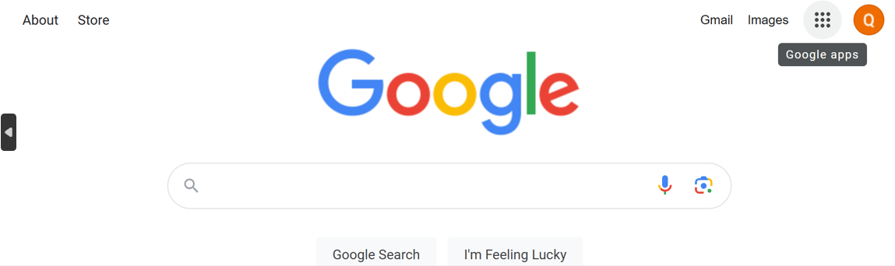

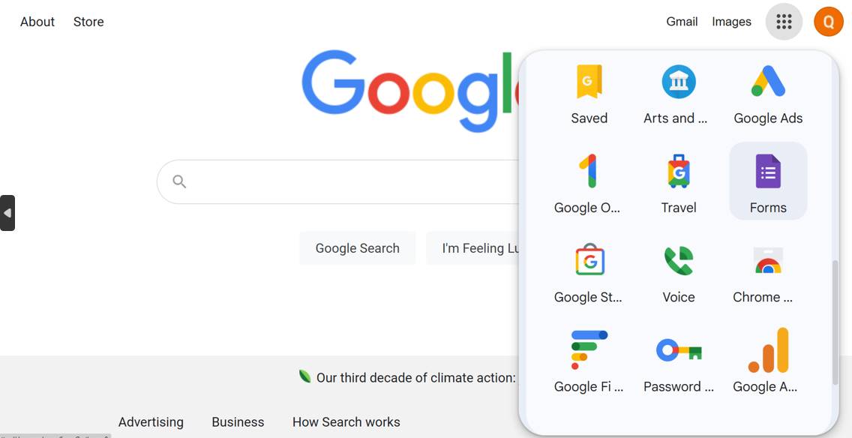

Step 2: Creating NEW Google Forms document.

To Create a new Google Form/Survey:
- Go to “Google Forms”.
- Click the  icon to open a new ‘Blank Form’.
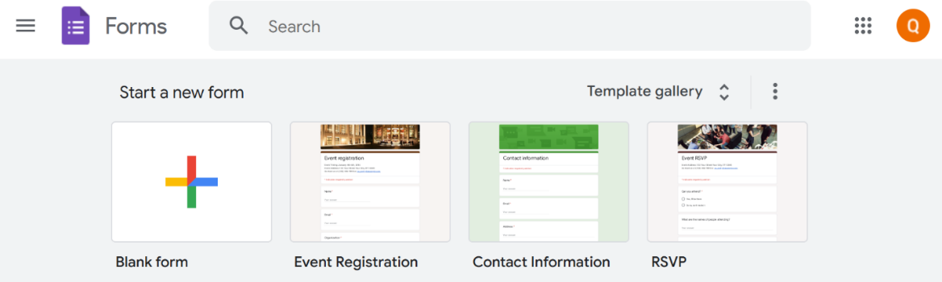

Naming your new Google Form/Survey:
- Give your ‘Form/Survey’ a name and provide a brief description of your ‘Form/Survey’.
- For example, you can name your form ‘Random Selection Task’ or ‘Random Selection Task Part 1 or ‘Part 1 Random Selection Task’

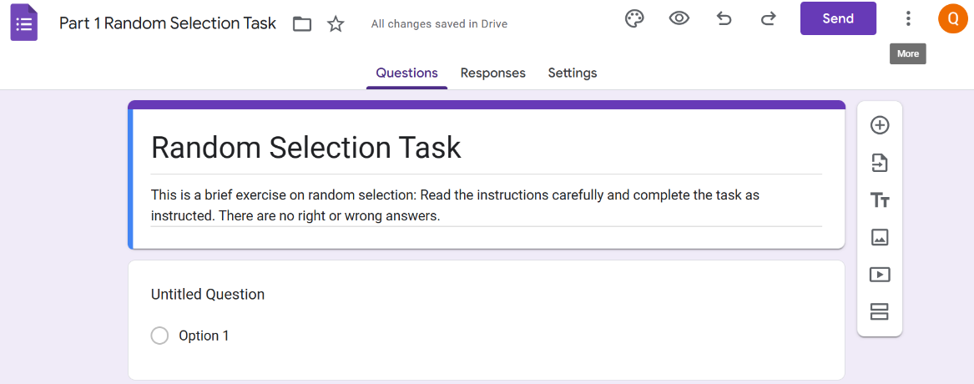
Step 3: Adding Questions, Sections, Editing and Formatting in Google Forms

Adding Questions and Response Choices to your Google Forms/Survey:
  - Add questions by clicking ‘Add question’ icon  located on the top of the white ribbon to the right of the form name/description and then select the question type (e.g., Check boxes, multiple choice, short answer, paragraph etc.)
- Select ‘Checkboxes’ from the dropdown menu

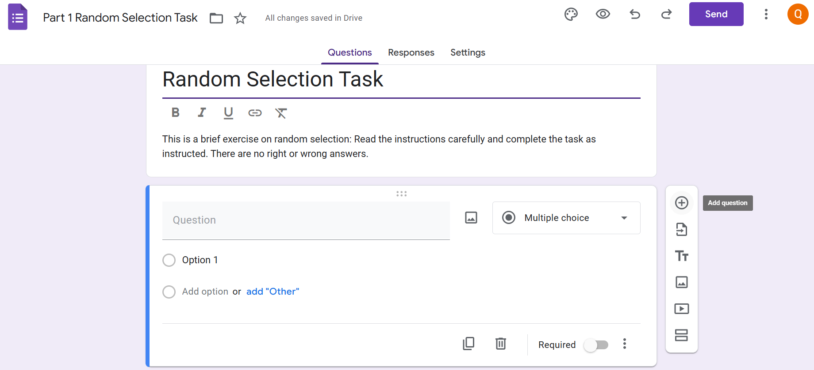
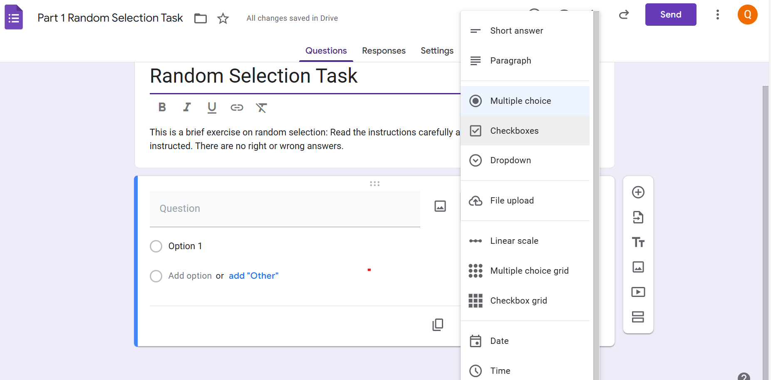
Adding Questions and Response Choices your Google Forms/Survey (con’t):
  - Type in the following questions for the Random Selection Task
  - Question 1 in the activity reads as follows:
Q1. Below are 20 FEMALE first names. Please read through the entire list and select a random sample with exactly five (5) names.
  - Instructors can generate a list of 20 Female and 20 Male names based on the demographic breakdown of ethnic groups at their current institution.
  - The names used in this activity are solely for demonstration purposes and it is left to the discretion of instructors, implementing this activity, to choose a mixture of familiar and unfamiliar names relative to the student population they serve. The instructor can also utilize a Google search for familiar and unfamiliar names to generate the list of 20 Female and 20 Male names.
  - Set Question 1 responses to ‘Required’ 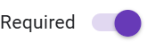 . To require students to answer specific questions (i.e., randomly selecting 5 names) before moving on to other questions in the survey, toggle the ‘Required’ button on the bottom right of the screen next to the ‘Delete’ icon/button.
  - Once ‘Required’ is toggled on, click on the ‘More options’ icon to the right of the ‘Required’ button to select from the drop-down menu the following option: ‘Response Validation’. (Note: The ‘Response Validation’ option will not show up on the drop-down menu unless you have first selected the question type to be ‘Checkboxes’
  - The ‘Response Validation’ should be set to the following: ‘Select exactly 5’.
  - The ‘Custom Error Text’ for selecting less/more than 5 names can be as follows: “You are seeing this message because you either selected less than 5 names or more than 5 names.”
  - To add ‘response/answer’ choices) to your survey (i.e., add 20 Female names) repeatedly click on ‘Add option’  in the response section of the question box until you have added all 20 names.
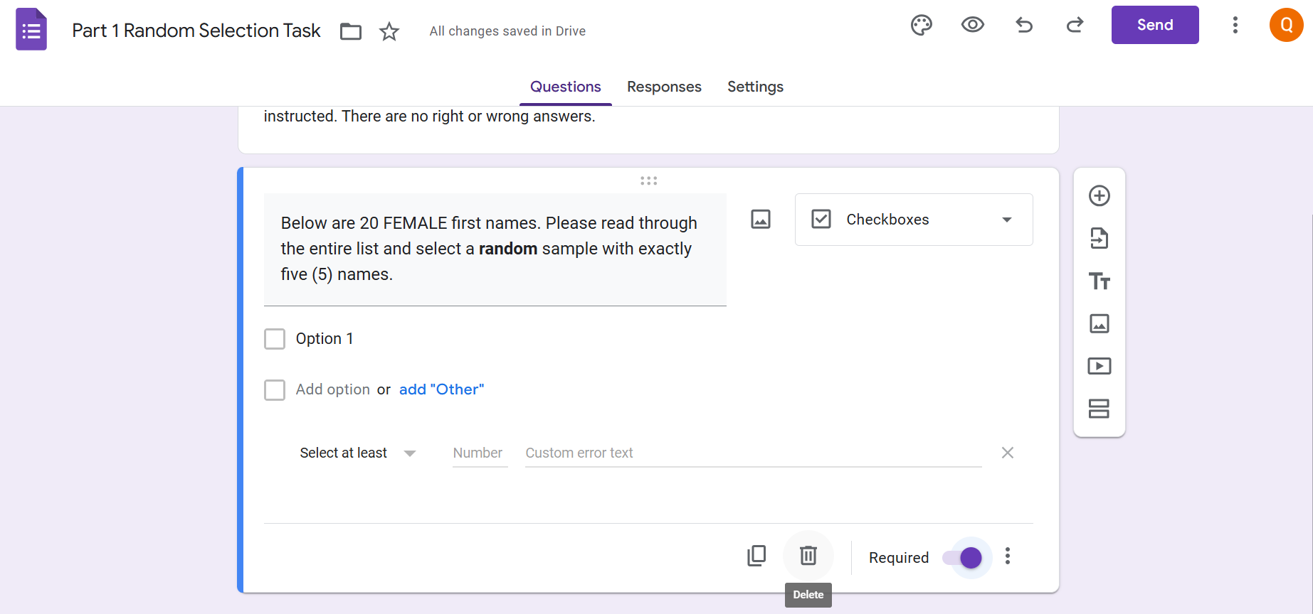

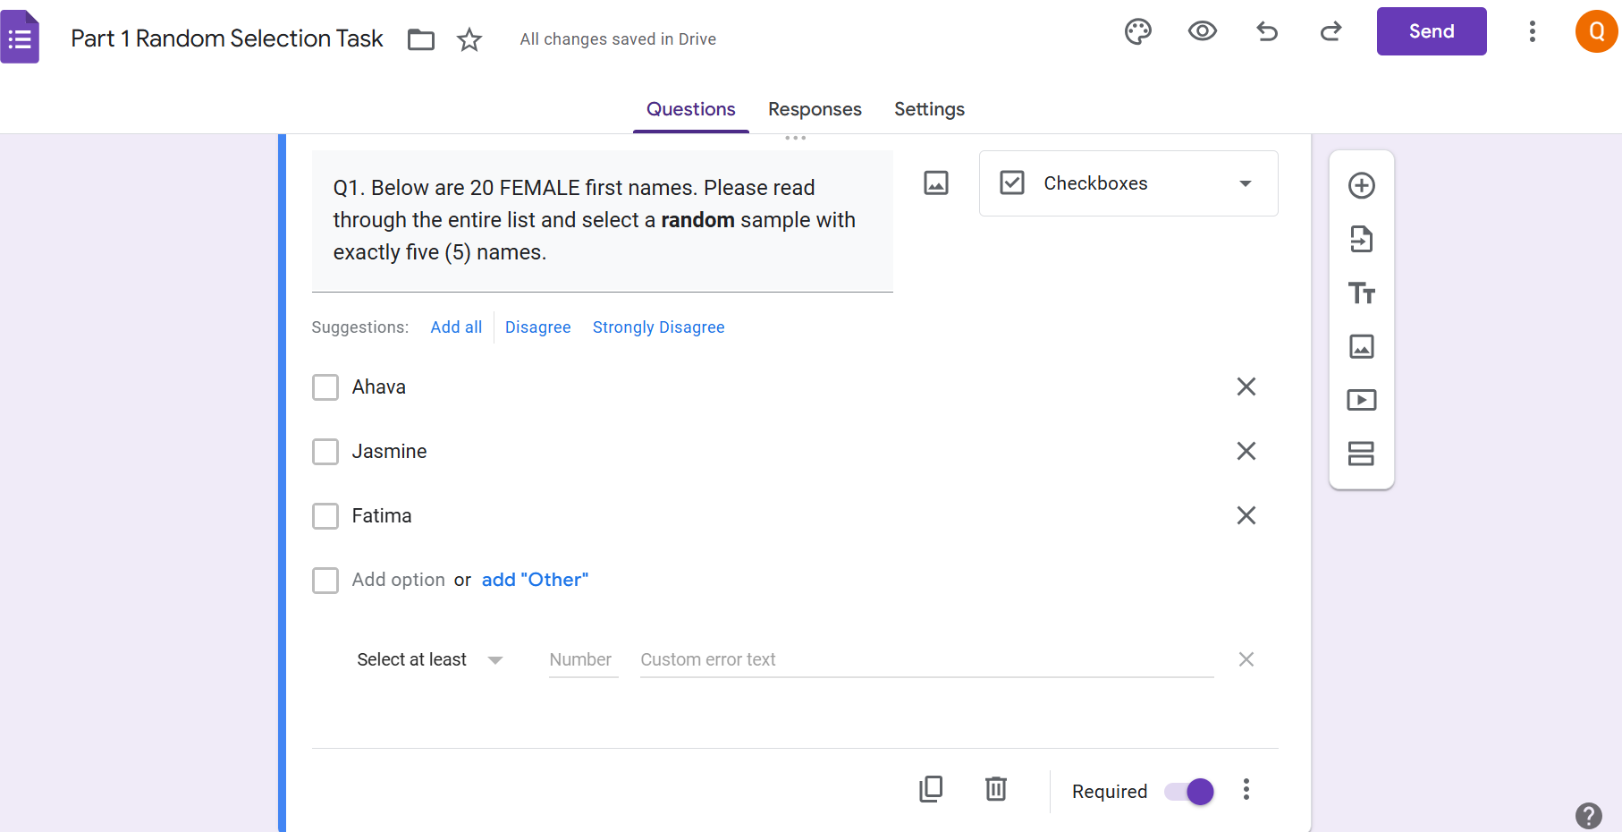

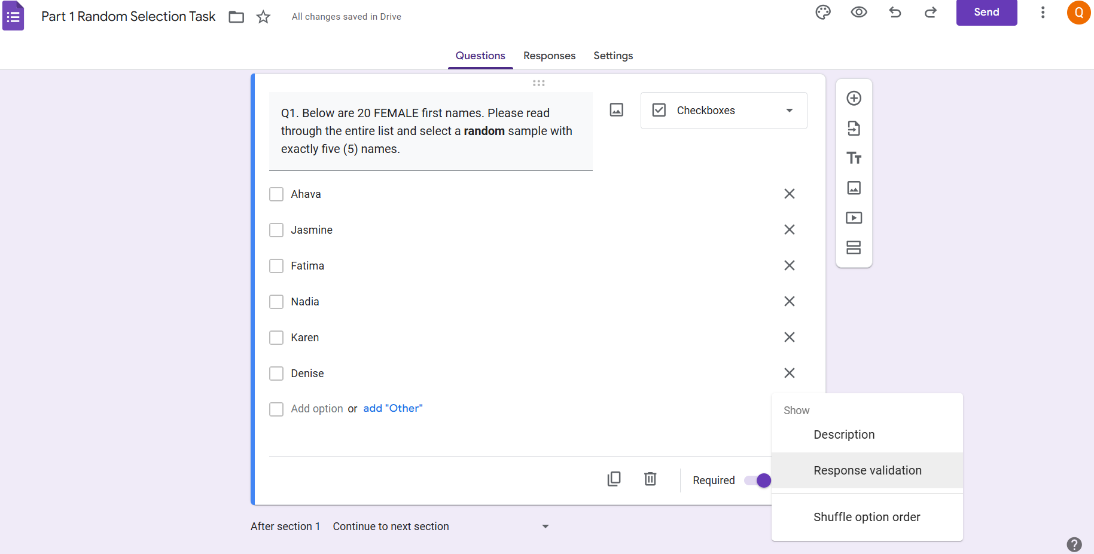

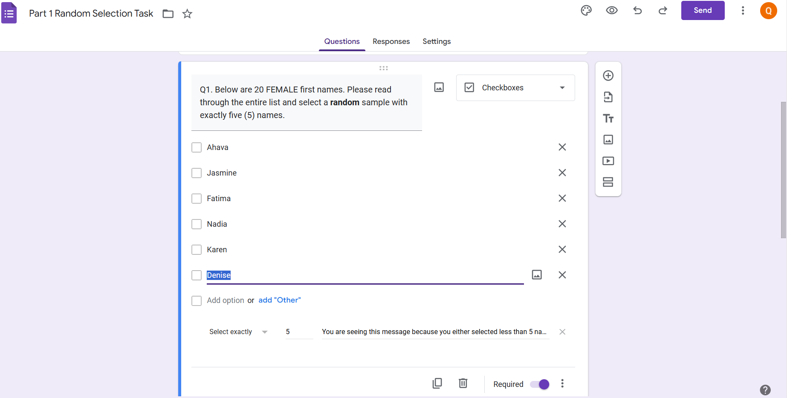

Adding Additional Sections and Questions to your Google Form/Survey:
- Click ‘Add section’ icon found on the white ribbon adjacent to your question 1 to add Section 2 of the survey and copy the title and description from Section 1 on to Section 2.
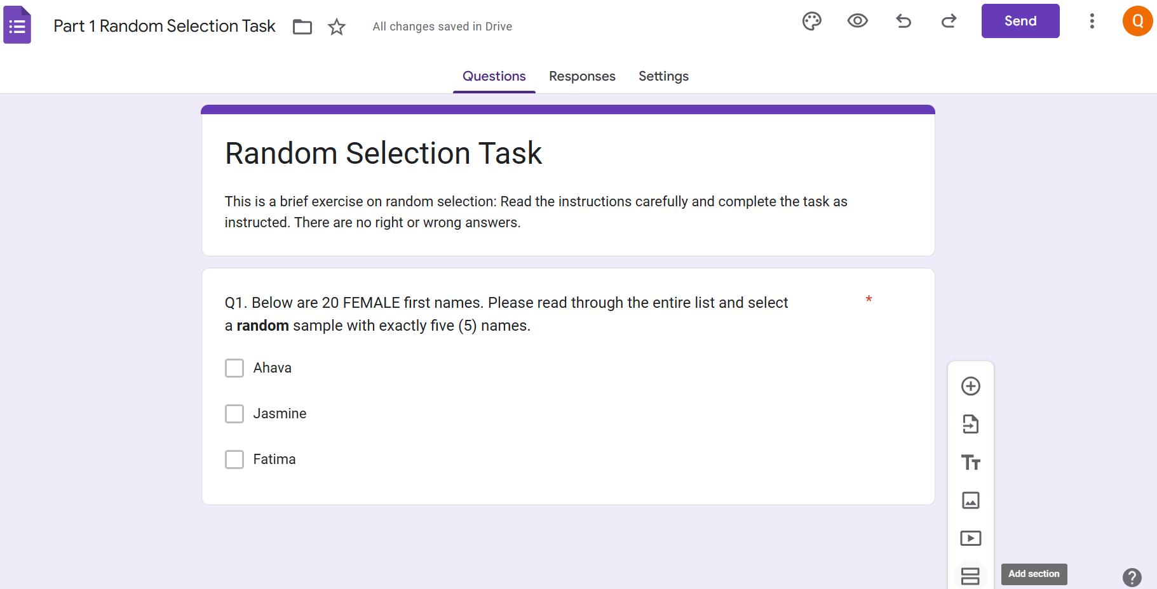
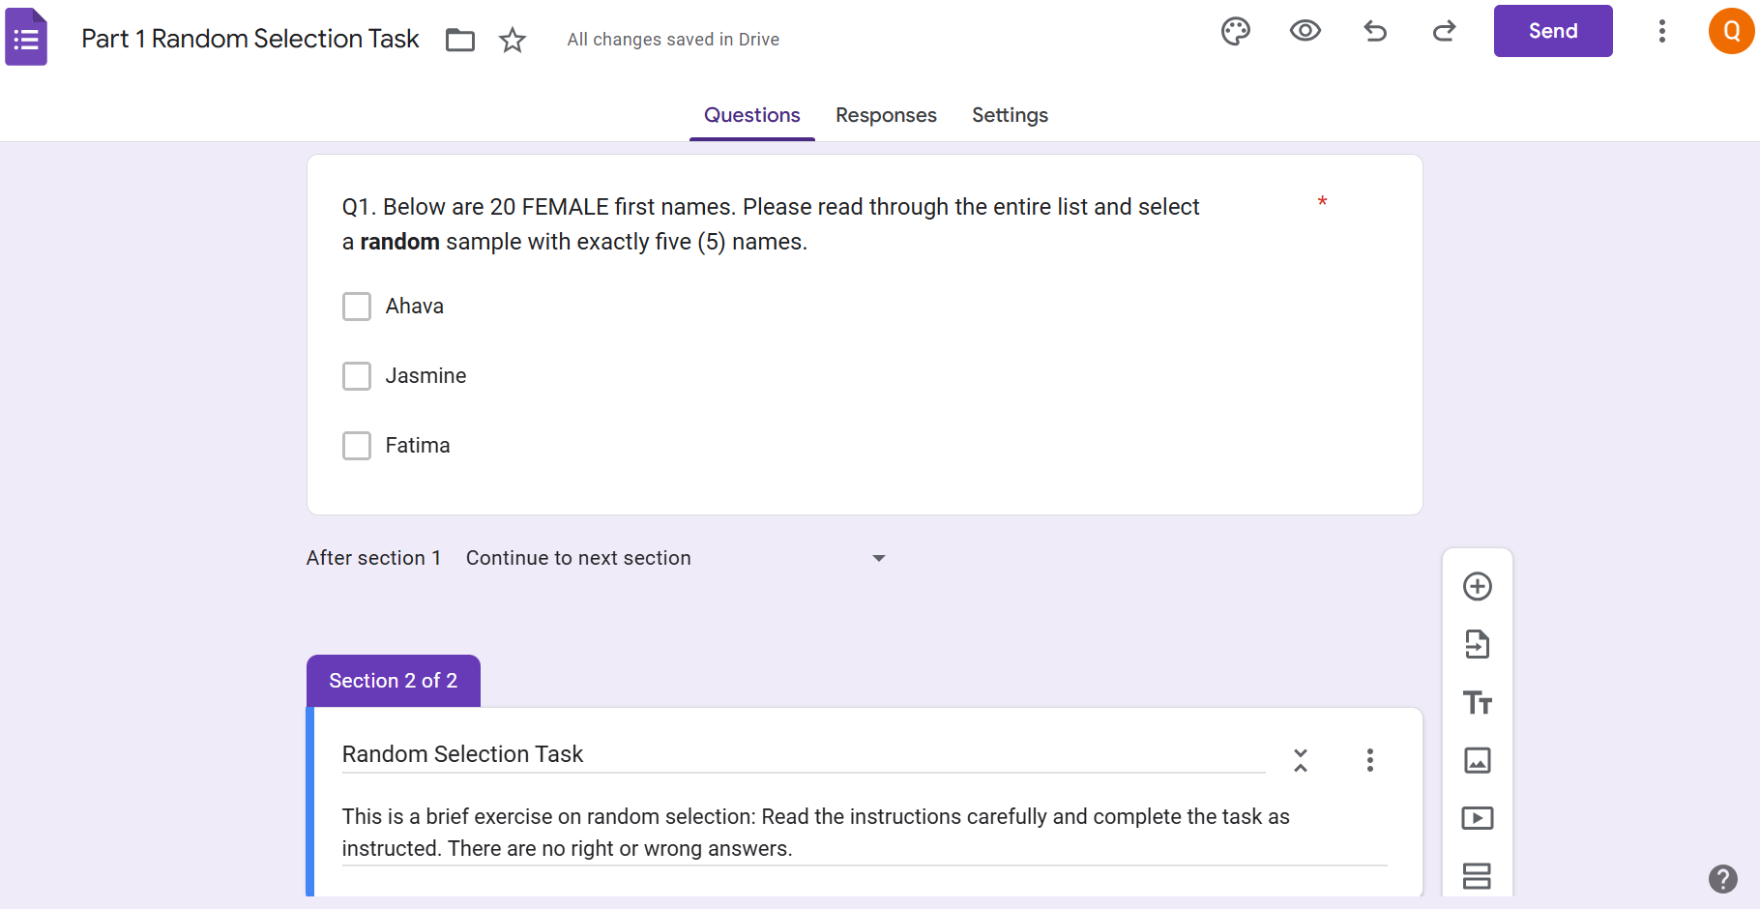
  - To add your question 2, click “Add question” icon and select the question type (Select ‘Check boxes’)
  - Question 2 in the activity reads as follows:
Q2. ‘Below are 20 MALE first names. Please read through the entire list and select a random sample with exactly five (5) names.’
  - Set Question 2 responses to ‘Required’
  - Follow instructions from 5. Adding Questions and Response Choices to insert response/answer options (i.e., add 20 Male names)
Duplicating Questions in your Google Forms/Survey:
- When multiple questions follow the same format Google Forms, the ‘copy’ or ‘duplicate’ function can be used by clicking the ‘Duplicate’ icon to copy the formatting of the previous questions, response choices and formatting to subsequent questions.
- Once you copy the question you can change the question wording while keeping everything else the same.
- To delete a question, click on the ‘Trash can’ icon on the lower right of your question text box, to the right of the ‘Duplicate’ icon

Undo/Redo Edits or Deletions in your Google Form/Survey:
- To undo an edit or deletion click the back ‘Undo’ arrow icon in the upper right-hand corner of your google form page
- To redo an edit or change implemented click the forward ‘Redo’ arrow in the upper right-hand corner of your google form page

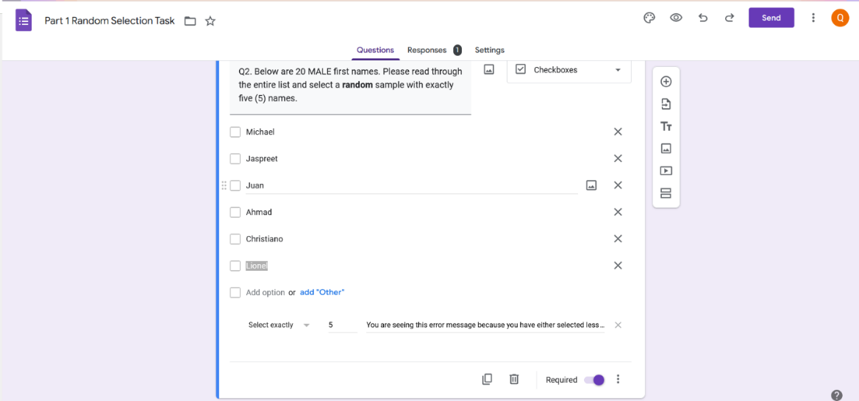

Redo
Undo
Delete
Duplicate

Previewing your Google Form/Survey:
- You can preview your finished survey at any time by clicking the ‘Preview’ icon located in the top right of your google forms page and to the left of the ‘Undo’ icon .
  - Previewing your survey will take you to a new browser tab and to return to editing your questions simple close the new preview tab
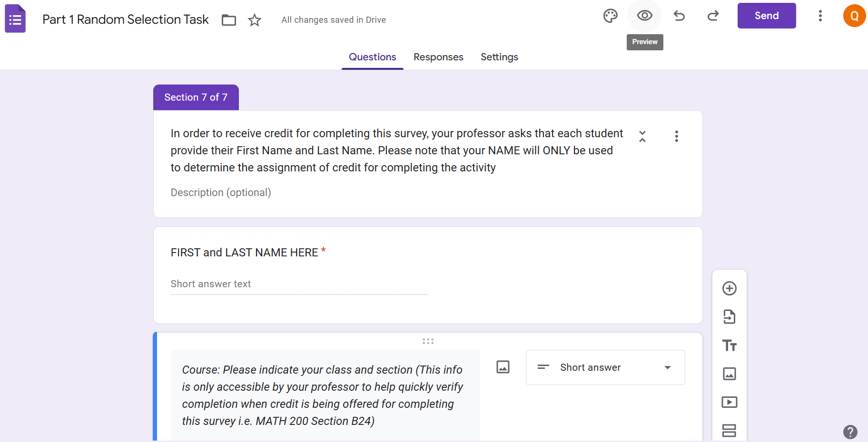
Step 4: Deploying your Google Forms Survey
Sharing/sending your Google Form/Survey:
- When completed and ready, share your Google Form/Survey via email or a link.
- To share your survey link with potential participants, 2 options discussed:
- Send via email
- Click purple ‘Send’ 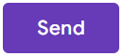 to the top right of forms page
- Enter email addresses in space provided
- Then click ‘Send’
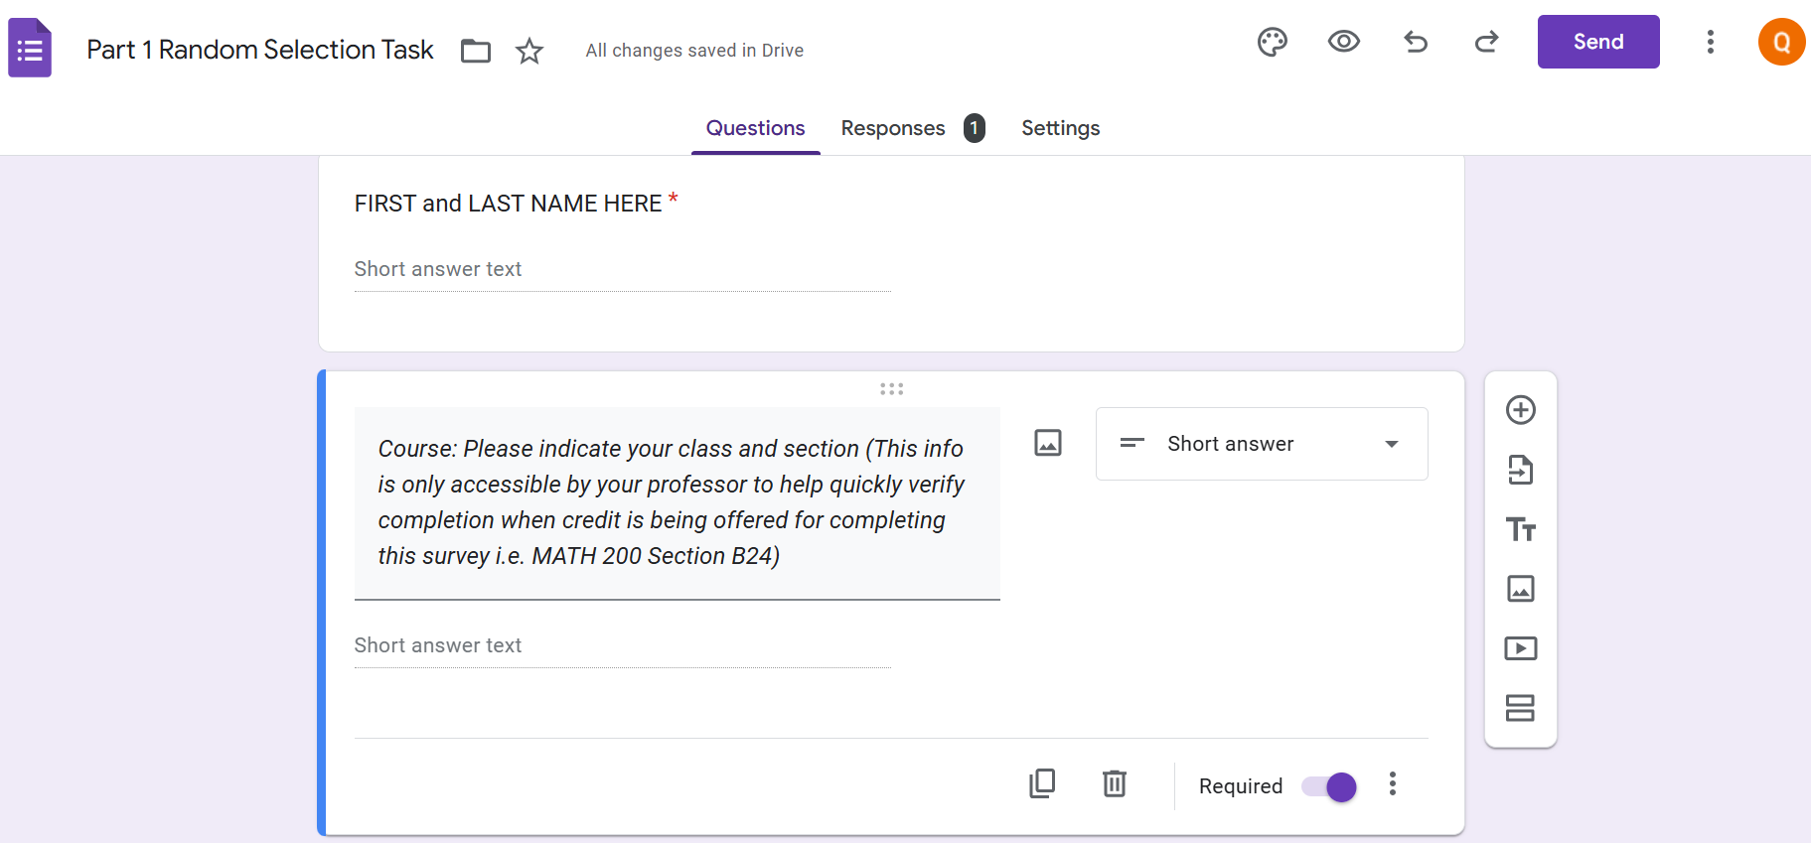

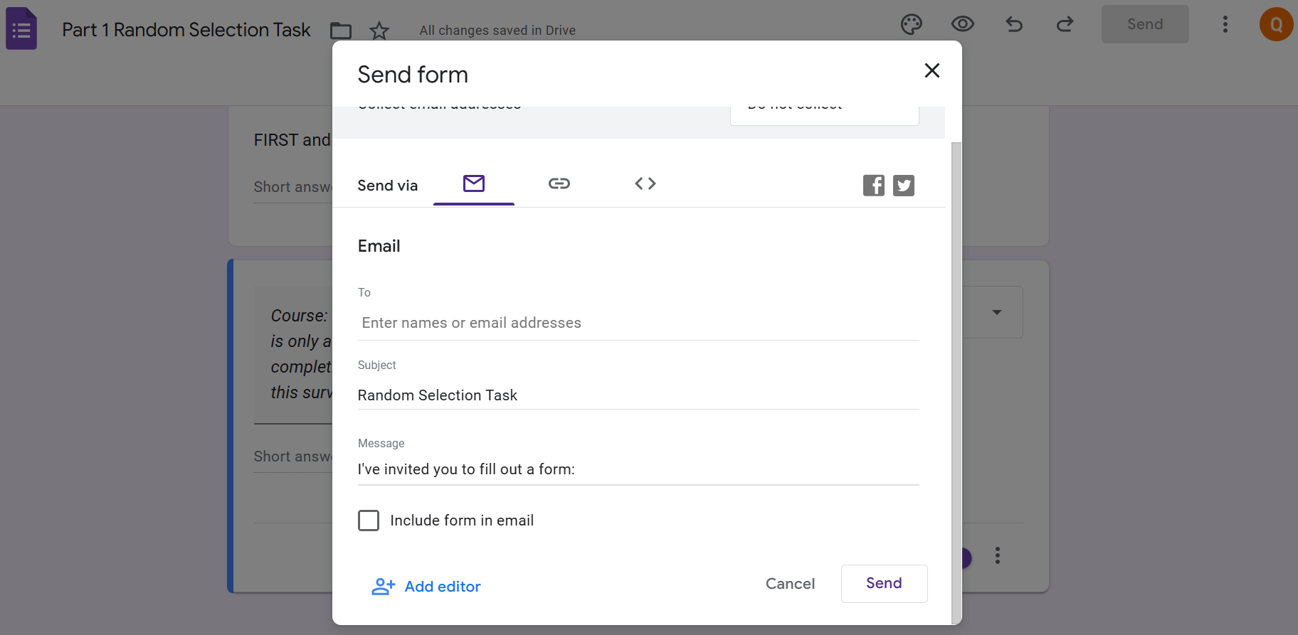
- Send the link to the survey
- Click purple the ‘Send’ button in top right of forms page
- Next the click the ‘Link’ icon to the right of the ‘email’ icon on the send options menu page.
- Check the box to “Shorten URL” 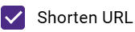 on the bottom left of the send option menu page.
- Finally click the ‘Copy” 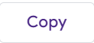button on the bottom right of the send options menu page to copy the shortened link to your survey to share with potential participants.

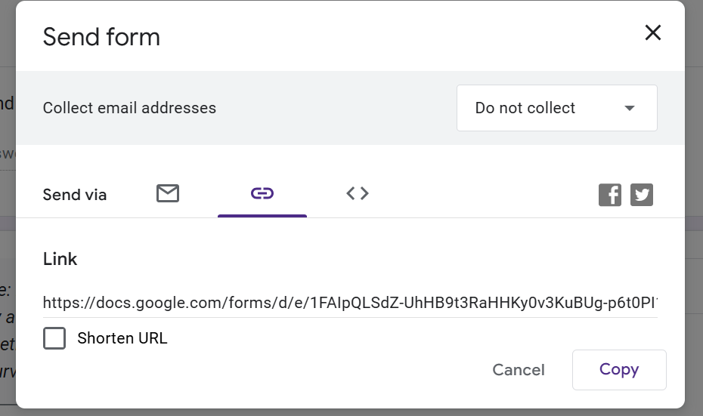
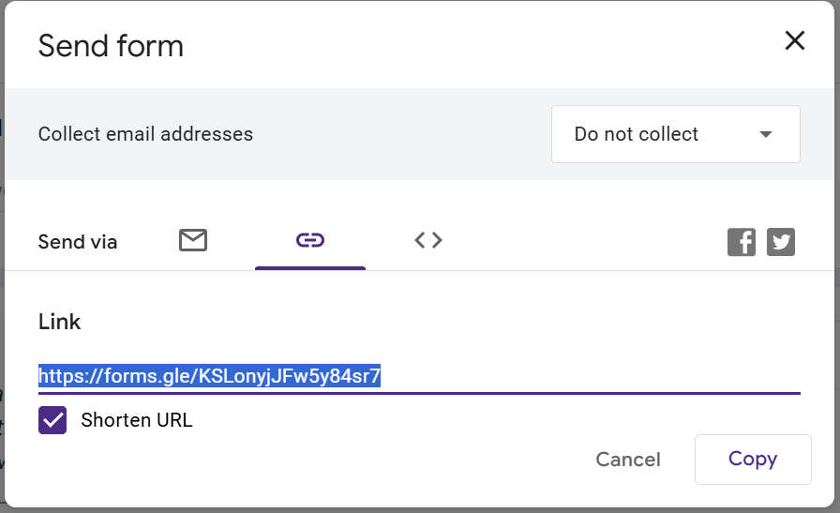
Step 5: Accessing and Viewing your Google Forms Survey Results

Viewing Survey Responses in Google Forms:
- Click the ‘Responses’ link in the top middle of your Google Forms page to view participants response to each question.
- Responses will be presented in bar chart and pie chart formats with corresponding counts and percentages.
- Responses can be viewed in three formats: summary, question, and individual.

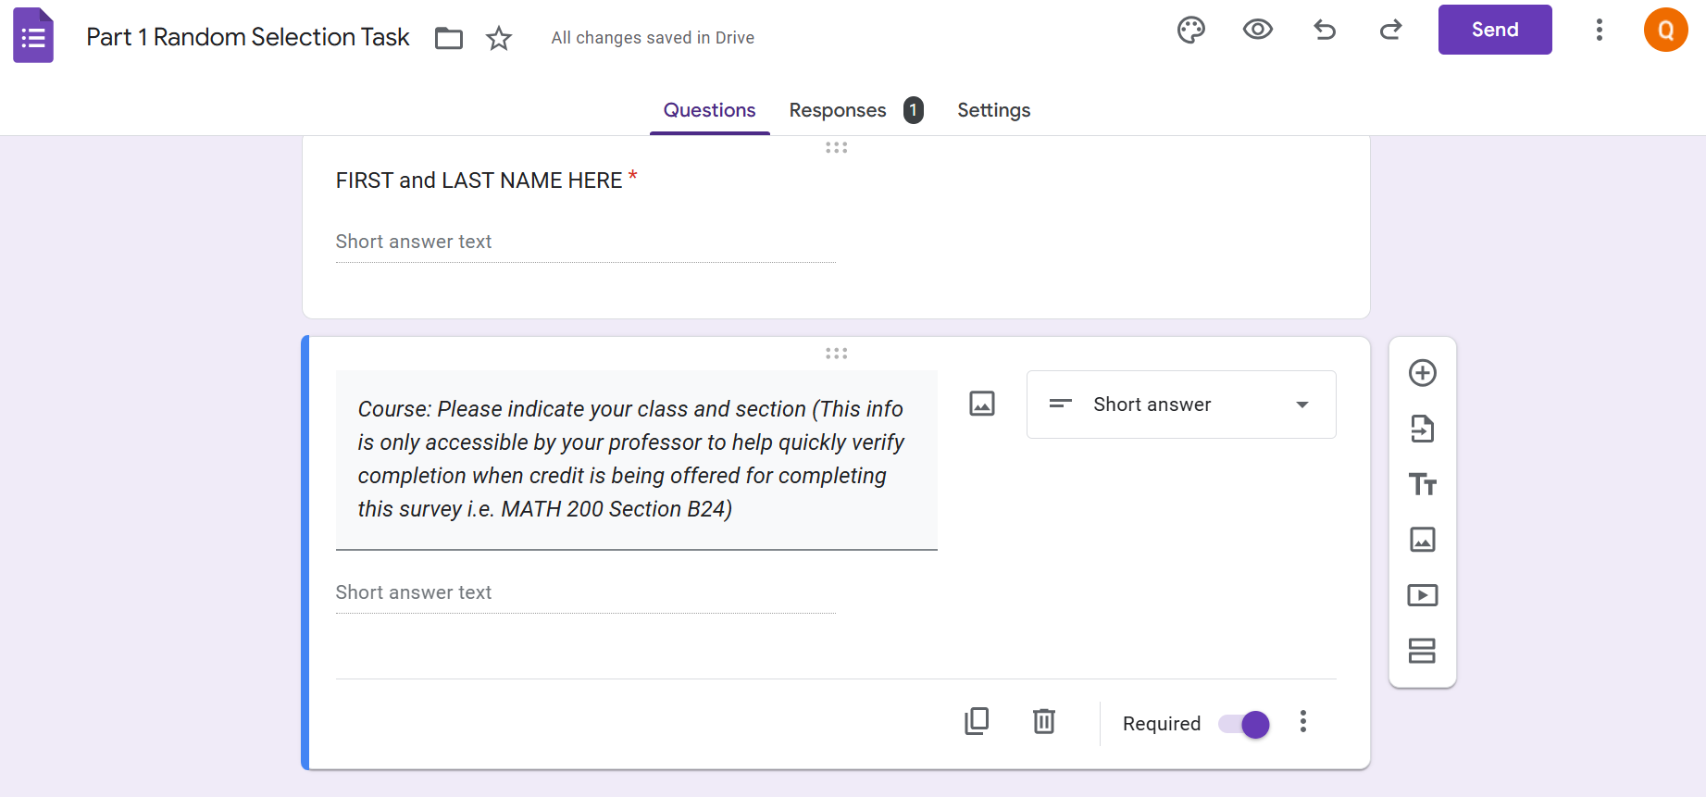

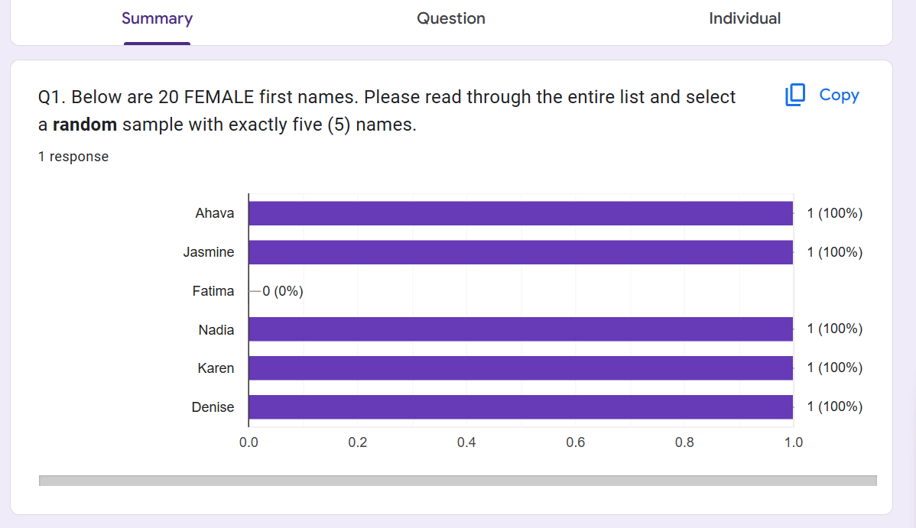

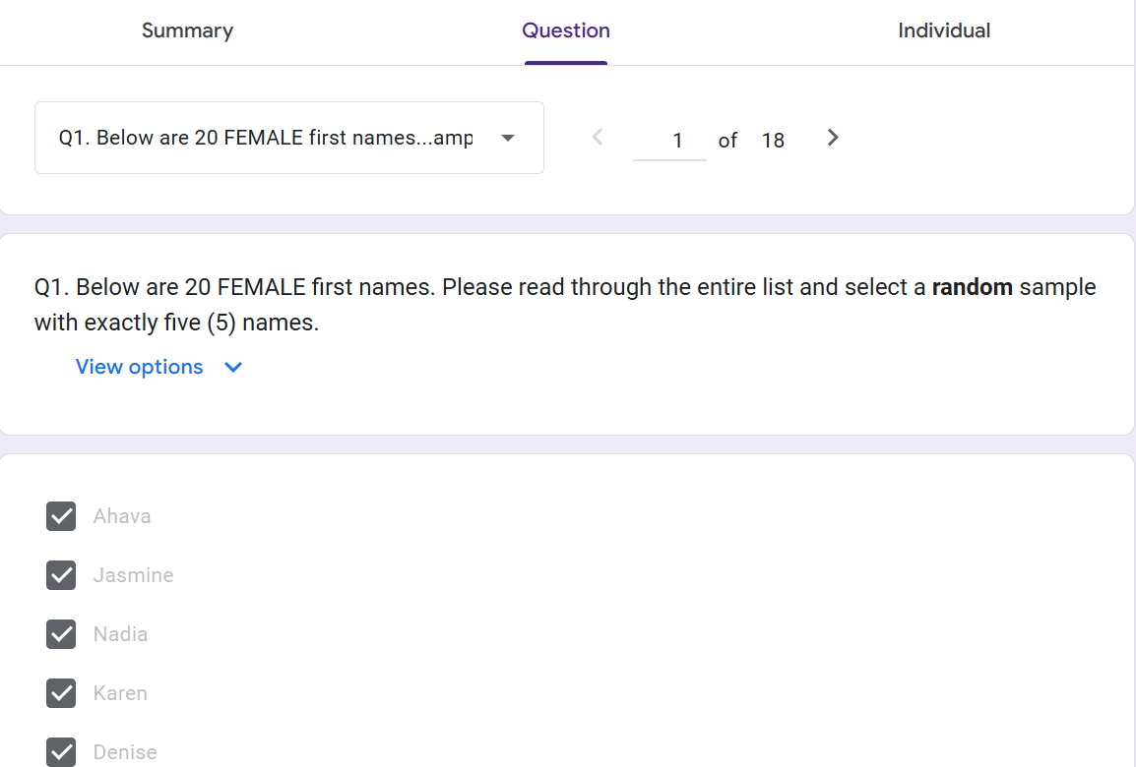

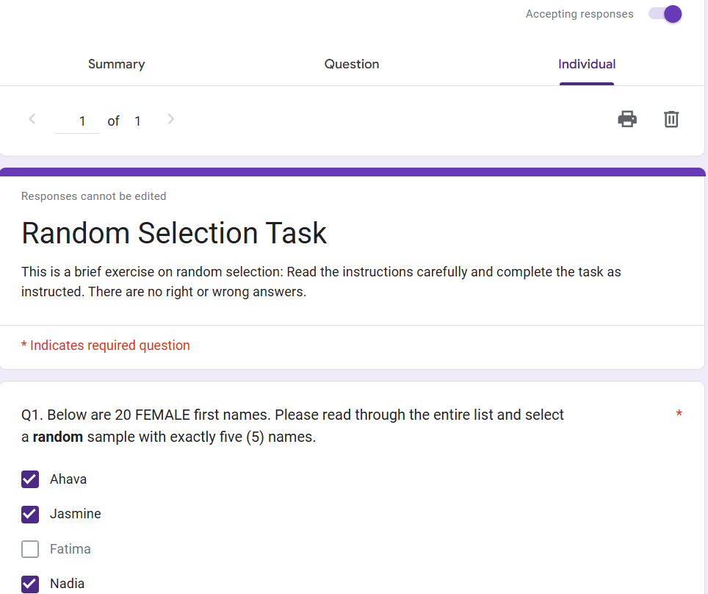

Step 6: Closing your Google Forms Survey to End Data Collection

Close Survey-End Data Collection:
- To close the survey and end data collection simply toggle to the left, the purple ‘Accepting responses’  button located in the top right of the Responses page (beneath the ‘Link to Sheets’  icon).
- Once the ‘Accepting responses’ button is toggled off the area will turn red and indicate that the survey is ‘not accepting responses’ 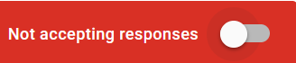
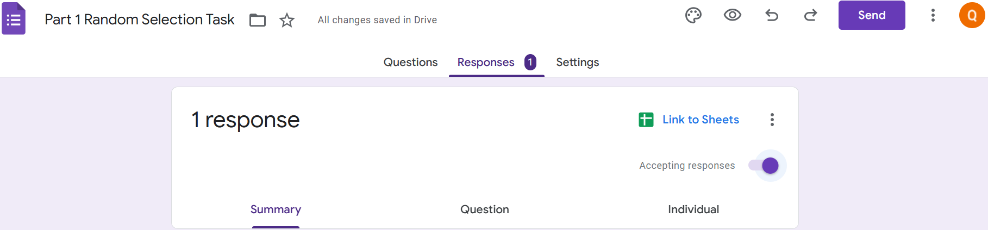

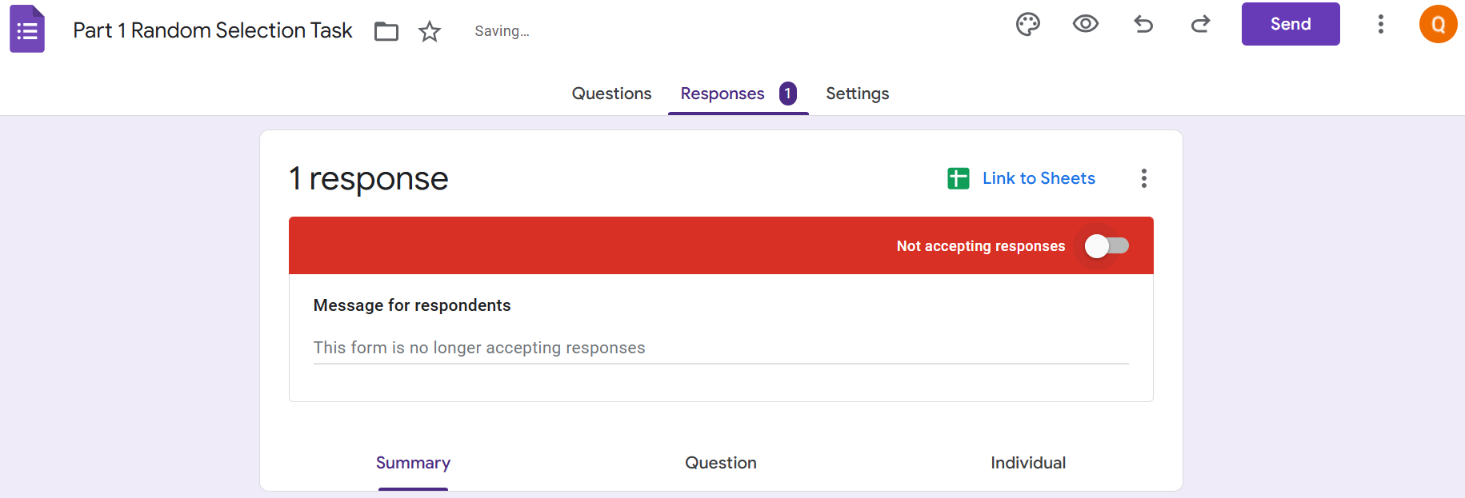

Step 7: Exporting Google Forms Survey Date to Google Sheets

Link Google Forms/Survey Responses to Google Sheets Spreadsheet:
- Click the ‘Link to Sheets” icon at the top right of the Google Forms responses page.
- Linking your survey to ‘Google Sheets’ will send your survey responses to the ‘Google Sheets’ spreadsheet where more detailed analyses can be conducted.
- You will be prompted to ‘select the destination for response.’
- Choose the ‘Create a new spreadsheet’ option and click the ‘Create’ button at the bottom right of the pop-up screen.
- A new ‘Google Sheets’ document will pop up in a new tab.
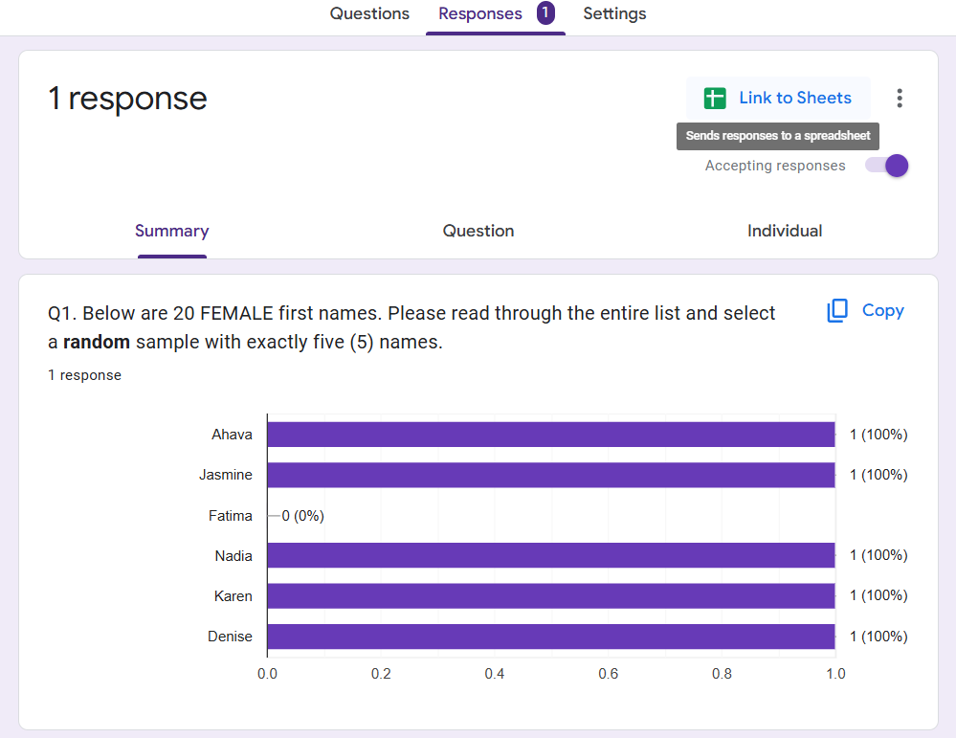

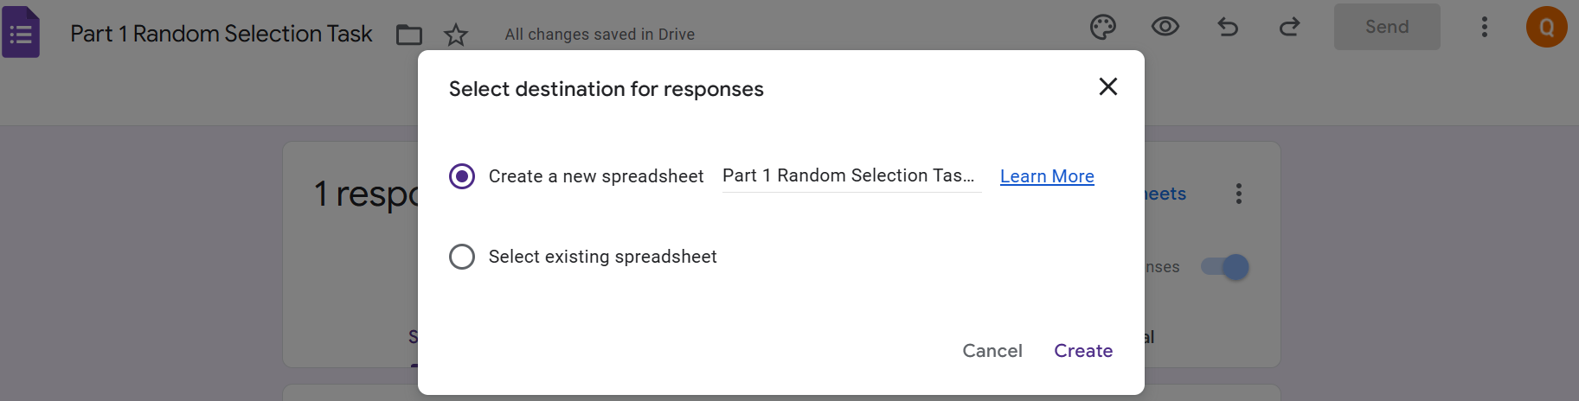

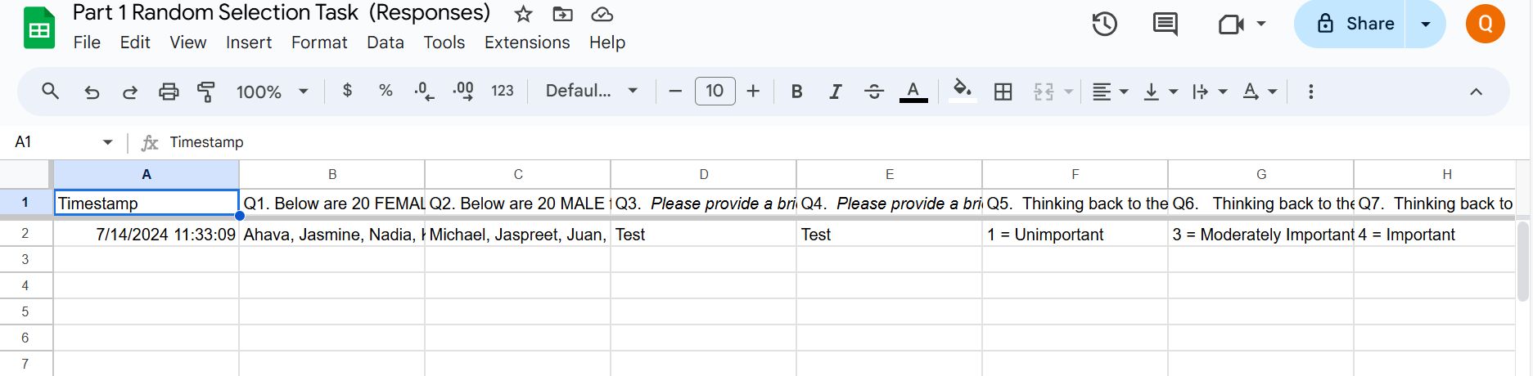

Step 8: Exporting Google Forms Survey Date to Microsoft Excel-CSV File

Download/Export Google Forms/Survey Responses to Microsoft Excel:
  - NOTE: Instructions are provided here for instructors who have a preference and access to Microsoft Excel but please note that instructions for constructing ‘Bar Graphs’ in this activity will focus on the utilizations of ‘Google Sheets’
  - Click the ‘Responses’ link in the top middle of your Google Forms page to view participants response to each question.
  - Choose the ‘Option’icon and select the ‘Download responses (.csv)’ from the down menu.

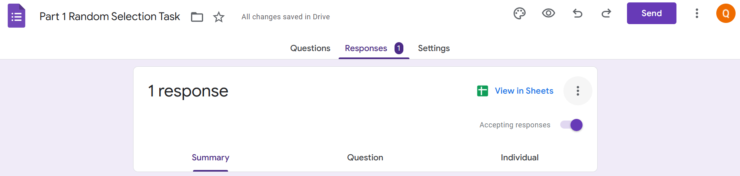

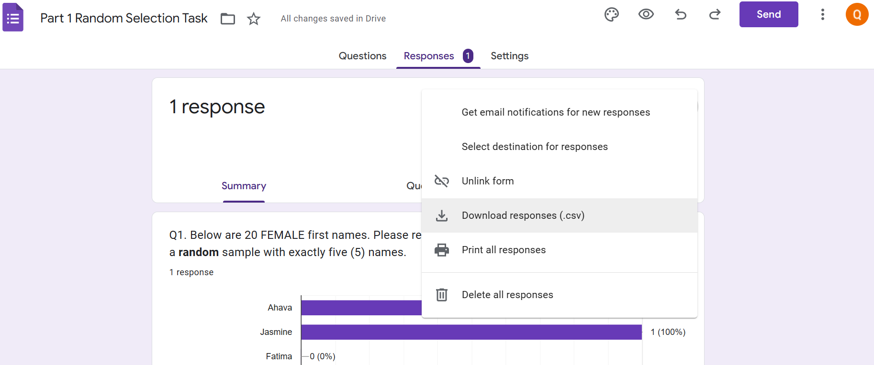

Step 9: Create Bar Graph to Show Distribution of Name Selections (SEE separate instructions for creating Bar Graphs of student female/male name selections using Google Sheets)
--------------------------------END--------------------------------------------------------

