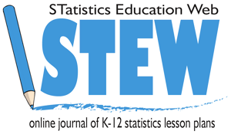
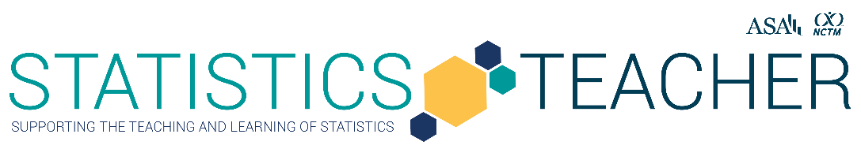

Do Rewards Boost Creativity?
Alyssa Noland, Chattahoochee High School (Johns Creek, GA) & Kennesaw State University
Published: November 2023

Overview of Lesson
Do rewards boost creativity? This lesson allows students to explore if intrinsic (self-motivation) or extrinsic (physical rewards) are a better motivator for best results on a creativity assessment. Research studies have shown that creativity is best motivated by oneself through intrinsic factors (Cho & Perry, 2012; Edirisooriva, 2014; Kuvass & Dysvik, 2009), but will these results play out in the classroom? Student generated data will be created through different classes completing a task of trying to write the most English words they can create out of the phrase “Statistics is Fun.” One group will do the activity for fun (intrinsic) as a warm up and another group will be able to win a candy prize (extrinsic). Then students will develop investigative questions about the two groups in the activity, create hypothesis tests, and statistically compare the data using a t-test for two sample means. Students will conduct their analysis (using a graphing calculator or R Statistical Software) and then interpret their results. Extensions for this activity could allow students to connect their specific findings with current research on motivation.

Type of Data
- Two Quantitative Variables
- Data is generated or collected as a class

Learning Objectives
- Students will develop, conduct, and analyze a hypothesis test to determine differences in the data for two treatments.
- CCSS.MATH.CONTENT.HSS.IC.B.5:Use data from a randomized experiment to compare two treatments; decide if differences between parameters are significant.
Audience
- Grade 10-12 students at Level C from GAISE II (GAISEII Reference https://www.amstat.org/asa/files/pdfs/GAISE/GAISEIIPreK-12_Full.pdf)
- Prerequisites: Prior to this lesson, students should have experience with finding the mean and how to conduct hypotheses testing. Also, students should be familiar with entering variables, finding means and using t-tests with a graphing calculator or R Statistical Software.

Time Required
The lesson will take about two or three 55-minute class periods. Day 1 would be the 10-minute warm up to collect data and a 20-minute discussion on motivation. Day 2 would be developing research questions and analyzing the results with a graphing calculator or R statistical software. Day 3 would have the students present their findings and extend their data with current research on motivation.

Technology and Other Materials
- Technology: Graphing Calculator or Computer with access to R Statistical Software
- “Low-tech” materials required: Student Task Sheet, Pencils, Timer, Data Recording Sheets

Lesson Plan

The goal of this lesson is for students to develop hypotheses statements, compare the means of two samples and determine if there is a statistical significance between the two groups. The topic of interest is to investigate do rewards or fun have a greater motivation factor when it comes to creative tasks.

Background for GAISE Level C and Statistical Problem-Solving Process

This lesson has been developed for high school students who have a GAISE II Level C knowledge of understanding about statistics. Students who have a Level C understanding know how to develop investigative questions about a data set and can independently engage in the statistical problem-solving process. These students know how to categorize data and can identify the appropriate analysis method or graphical display for the given data. Additionally, the students can extend their results to determine if situations lead to causality and where they rest in current research (Bargagliotti et al., 2020).

Students in this task will engage in the statistical problem-solving process (Figure 1) as they begin by collecting data and end with interpreting the results of their findings. The lesson plan has been structured for students to move throughout the statistical problem-solving process as they determine the possible impact of rewards on creativity.

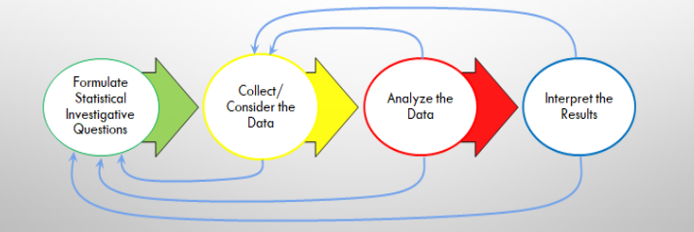
Figure 1. Statistical problem-solving process (Bargagliotti et al., 2020, p.13)

Day 1
Collect the Data: 10 minutes

The teacher begins the lesson by having the students be participants in the experiment. There needs to be two groups: the fun group and the reward group. This could be completed by assigning different class periods to each group. The data collection can be completed anytime prior to the lesson to allow for both groups’ data to be recorded and then presented to the students.

The fun group will be told that they are completing an exciting warm up activity. The students will be able to choose a partner and will have 5-minutes to write out as many English words as they can create from the phrase “Statistics is Fun”. At the end of the activity the teacher will record on the data sheet the total number of words created by each group.

The reward group will be told that they are participating in an activity where they can win a candy prize. The students will also be able to choose a partner and will have 5-minutes to write out as many English words as they can create from the phrase “Statistics is Fun.” At the end of the activity the teacher will record on the data sheet the total number of words created by each group.

Setting the Scene Discussion: 20 minutes

Once the data has been collected, the teacher will launch a discussion about motivation specifically focusing on intrinsic versus extrinsic factors. Students will all be given three post it notes where they will respond to the following questions.

- Question 1: What is motivation? Please explain factors that motivate you.
- Question 2: Describe the differences between intrinsic and extrinsic factors. Provide examples.
- Question 3: How best should you motivate students/adults in a creative task versus a procedural task?

Students will bring their post it notes to the board. Four student leaders will be selected to lead the class through a discussion on the student responses generated from the questions. This activity is to get students to understand the concept of motivation.

Day 2

Formulate Statistical Investigative Questions: 20 Minutes

Have students be placed into groups of four. The teacher will hand each group a printout of the data from the word creation activity that they will copy onto their student task sheet. The students will see the number of words created by each pair in the reward group and the fun group. See an example of sample data in Figure 2. The teacher will provide a recap of hypothesis testing and review the terms null hypothesis and alternative hypothesis. Students will be asked to develop a null and alternative hypothesis in their groups. Additionally, groups will try to develop three questions that they have about the data presented.

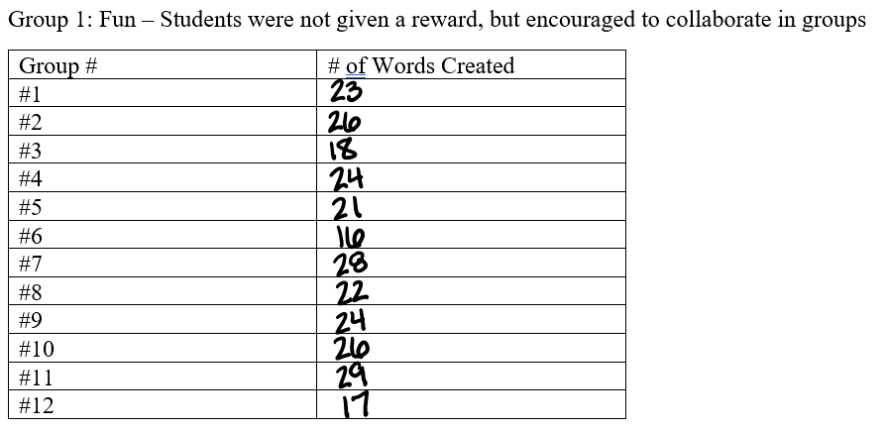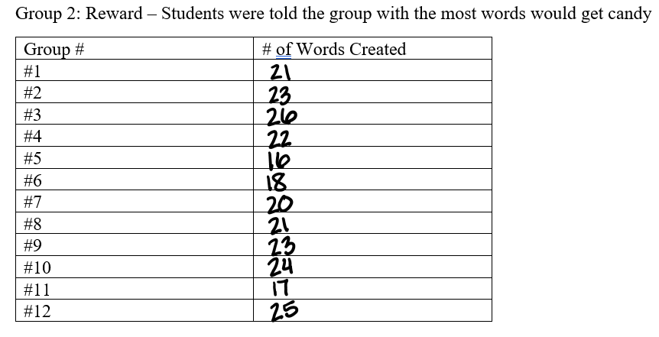
Figure 2: Sample Data from the class activity

Example of student hypotheses (two-tailed):
H₀: Mean Words Reward Group = Mean Words Fun Group
H_{a}: Mean Words Reward Group ≠ Mean Words Fun Group

Example of student hypotheses (one-tailed):
H₀: Mean Words Reward Group = Mean Words Fun Group
H_{a}: Mean Words Reward Group < Mean Words Fun Group

Examples of Student Developed Questions:
- Do rewards prevent creativity?
- How can we best motivate people on a creative task?
- What are the best rewards to increase productivity?

While students are working on developing the hypotheses and questions, the teacher should be visiting with the groups to check in on their progress. It is important for the teacher to check each group’s work and review the student questions. The teacher should check to make sure the questions created can be answered from the generated data. If the questions go beyond the data, the teacher should redirect the student thinking to ensure their hypotheses can be tested.

Analyze the Data: 25 Minutes

Students will continue to work in their groups of four. Each group should have access to a graphing calculator or a computer to use R statistical software. Resources on how to use a TI-84 graphing calculator or R statistical software have been included in the additional resources section. It is recommended that the teacher provides some guided examples if students have never used a graphing calculator or R code before to conduct a t-test. Guided examples could provide students with how to enter data into a list/variable, find the mean and run a t-test.

Steps for Using a TI-84 Graphing Calculator:

Using the data created as a class, students will select STAT, then EDIT and enter on their TI-84 graphing calculator. This will launch the lists feature where the students will enter the data collected. The first list (L1) will be the reward and the second list (L2) will be the fun group.

Students will then need to find the mean of each sample and record the results. To do this, they will select STAT, scroll over to CALC, and then select 1-Var Stats. They will enter the list number (L1 or L2), then select Calculate.

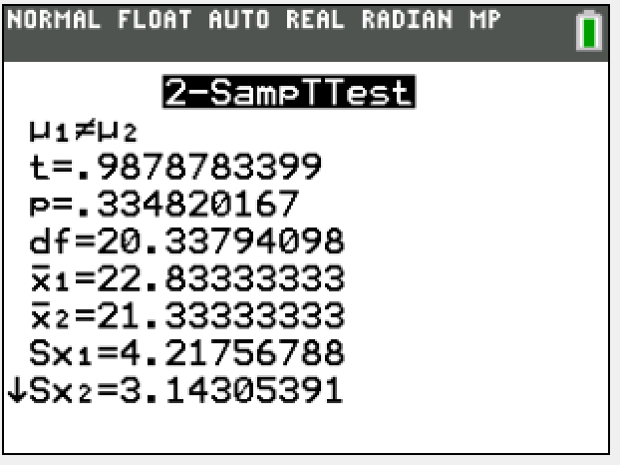
Then the students will run the t-test for the hypotheses developed. For this data, the students will want to perform a two sample t-test. Students will press the STAT button, scroll over to TESTS and down to 2-SampTTest and select enter. The list1 will be L1 and list2 will be L2. The frequency should be set at 1. Students will select if their test will be two tailed (≠) greater (>) or less than (<). They should select no for pooled and then calculate.

Figure 3 to the right shows the output from the TI-84 calculator from the t-test for the sample data.
Steps for Using R Code:

Using the data created as a class, students will create two groups in R. The first group will be the reward and the second will be the fun group. Students will then need to find the mean of each sample and record the results. Then the students will run the t-test for the hypotheses developed.
Students can choose an alpha level they find appropriate for the results. The student example is created with α=0.05.

Here is an example of student R code:
#Define the two groups and insert data
#Create group 1 "fun"
fun <-c(23,26,18,24,21,16,28,22,24,26,29,17)
#Create group 2 "reward"
reward <-c(21,23,26,22,16,18,20,21,23,24,17,25)
#Find the mean of each group
xbarfun <-mean(fun)
#Print the xbar for group fun
xbarfun
#Find and print the mean for group reward
xbarreward <-mean(reward)
xbarreward
#Run a t.test to determine if the difference in means is statistically significant
#Use t.test function with groups fun and reward, alternative can equal “two.sided”, “less” or “greater”
#var.equal = FALSE to run the welch two sample t-test
t.test(fun,reward,alternative="two.sided",var.equal = FALSE)

Figure 4 shows the output from the t-test for the sample data.
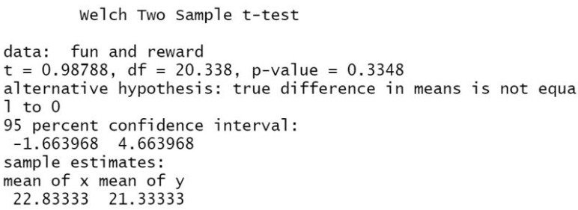
Figure 4: Results of Two Sample t-test example using R

Students will record their results on the student task sheet. The calculating process is very student directed. The teacher will be checking in with groups and aiding as needed.

To monitor student thinking, pose the following questions:
- Was the hypothesis that your group developed one or two tailed?
- What alpha level are you using for your test?
- How are you defining the list/variables of the two groups?

Day 3

Interpret the Results: 45 Minutes

Students in their groups of four will interpret the results of the t-test that they conducted about the two groups “fun” and “reward”. The student task sheet will have some probing questions that will guide the students through their analysis.

- Look at the means of the “fun” and “reward” group. What relationships do you see among the values just based on the means.
- Determine the p-value for your t-test. What does this value mean in the relationship of the hypotheses that you developed looking at an alpha level of 0.05?
- Research about motivation. Do your results support research on motivation? Why might the results match or not match the research your group finds?

The teacher will be visiting groups as they work on their interpretation of the results. Students might be confused that if the means were different between the two groups why does the t-test still suggest failing to reject the null hypothesis. Remind students that the t-test is used to decide whether the difference in the sample means is “statistically significant”. The teacher should discuss what it means for the results to be statistically significant. For example, a large p-value does not imply that the difference between the groups is not important. It is possible that the treatments were different, but it was not detected due to the small sample size (Type II error). After students have recorded the results, the teacher could have different groups share their findings with the class or peers. Additionally, the teacher could lead a debrief with the students about the concept of significance, limitations that the experiment had or discussion about the random assignment (or lack thereof) of the participants.

Attached Materials

- Student Task Handout Blank
- Student Task Handout with Sample Answers
- Teacher Data Collection Sheets

Reflections and Additional Recommendations

- Possible Extensions for the lesson: having students develop a different experiment to test motivation, having the students run the test again with a larger sample, or investigating a different alternative hypothesis
- Ideas for differentiation: providing guided examples of how to conduct a t.test using a graphing calculator or R code, providing reteaching as needed on hypothesis testing, and allowing group flexibility
- Recommendations for learning more about t.tests on a TI 84 Calculator: https://www.statology.org/two-sample-t-test-ti-84-calculator/
- Recommendations for learning more about R Statistical Software: https://cran.r-project.org/manuals.html

References

Bargagliotti, A., Franklin, C., Arnold, P., Gould, R., Johnson, S., Perez, L., & Spangler, D. (2020). Pre-K-12 Guidelines for Assessment and Instruction in Statistics Education (GAISE) report II. American Statistical Association and National Council of Teachers of Mathematics.

Cho, Y. J., & Perry, J. L. (2012). Intrinsic motivation and employee attitudes: Role of managerial trustworthiness, goal directedness, and extrinsic reward expectancy. Review of Public Personnel Administration, 32(4), 382–406.

Edirisooriya, W. A. (2014, February). Impact of rewards on employee performance: With special reference to ElectriCo. In Proceedings of the 3rd International Conference on Management and Economics (Vol. 26, No. 1, pp. 311-318).

Kuvaas, B., & Dysvik, A. (2009). Perceived investment in employee development, intrinsic motivation and work performance. Human resource management journal, 19(3), 217- 236.

R Core Team (2020). R: A language and environment for statistical computing. R Foundation for Statistical Computing, Vienna, Austria. URL https://www.R-project.org/.

Statology. (2022, May 17). Two-sample t-test TI-84 calculator. Statology. https://www.statology.org/two-sample-t-test-ti-84-calculator/.

Appendix A: Student Task (Blank)
Group Members: ______________________________________

Do Rewards Boost Creativity?
Do you remember having to write out all the English words that you could create from “Statistics is Fun.” There were two different conditions that students in this class had. One group was the “fun” group where they were told to enjoy the activity and write as many words as possible. The other group was the “reward” group where the winning pair got candy. We are going to investigate if having a reward helped the groups create more words or did it do more harm than good?
Step 1: Collect the Data Record the data that was generated as a class through the word creation activity.
Group 1: Fun – Students were not given a reward, but encouraged to collaborate in groups
Group # | # of Words Created
#1
#2
#3
#4
#5
#6
#7
#8
#9
#10
#11
#12

Group 2: Reward – Students were told the group with the most words would get candy
Group # | # of Words Created
#1
#2
#3
#4
#5
#6
#7
#8
#9
#10
#11
#12

Step 2: Formulate Questions Think about the sample of words that were created for each group. Consider that you would like to investigate if the difference in means is statistically significant.
Group Questions:
- ______________________________________________________________________________

- ______________________________________________________________________________

- ______________________________________________________________________________

Null Hypothesis:

Alternative Hypothesis:

Step 3: Analyze the Data Record the means and results of your t.test in the space provided below.
Sample Means:

T.Test:

Step 4: Interpret the Results
1. Look at the means of the “fun” and “reward” group. What relationships do you see among the values just based on the means.
2. Determine the p-value for your t-test. What does this value mean in the relationship of the hypotheses that you developed looking at an alpha level of 0.05?
3. Research about motivation. Do your results support research on motivation? Why might the results match or not match the research your group finds?

Appendix B: Student Task (Sample Answers)
Group Members: Sample Answers

Do Rewards Boost Creativity?
Do you remember having to write out all the English words that you could create from “Statistics is Fun.” There were two different conditions that students in this class had. One group was the “fun” group where they were told to enjoy the activity and write as many words as possible. The other group was the “reward” group where the winning pair got candy. We are going to investigate if having a reward helped the groups create more words or did it do more harm than good?
Step 1: Collect the Data Record the data that was generated as a class through the word creation activity.
Group 1: Fun – Students were not given a reward, but encouraged to collaborate in groups
Group # | # of Words Created
#1
#2
#3
#4
#5
#6
#7
#8
#9
#10
#11
#12

Group 2: Reward – Students were told the group with the most words would get candy
Group # | # of Words Created
#1
#2
#3
#4
#5
#6
#7
#8
#9
#10
#11
#12

Step 2: Formulate Questions Think about the sample of words that were created for each group. Consider that you would like to investigate if the means are statistically significant.
Group Questions:
- Do rewards prevent creativity?
- How can we best motivate people on a creative task?
- What are the best rewards to increase productivity?

Null Hypothesis: H₀: Mean Words Reward Group = Mean Words Fun Group

Alternative Hypothesis: H_{a}: Mean Words Reward Group ≠ Mean Words Fun Group

Step 3: Analyze the Data Record the means and results of your T.Test in the space provided below. Answers shown reflect using R code.
Sample Means:
#Define the two groups and insert data
#Create group 1 "fun"
fun <-c(23,26,18,24,21,16,28,22,24,26,29,17)
#Create group 2 "reward"
reward <-c(21,23,26,22,16,18,20,21,23,24,17,25)
#Find the mean of each group
xbarfun <-mean(fun)
xbarfun
[1] 22.83333
xbarreward <-mean(reward)
xbarreward
[1] 21.33333

T.Test:
t.test(fun,reward,alternative="two.sided",var.equal = FALSE)
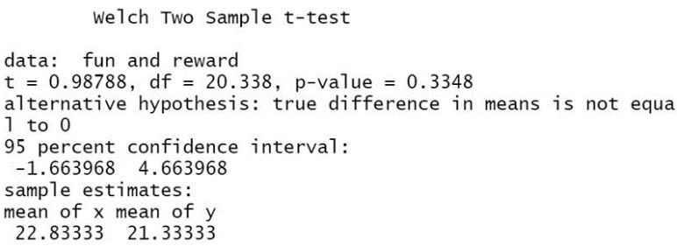

Step 4: Interpret the Results
1. Look at the means of the “fun” and “reward” group. What relationships do you see among the values just based on the means. The mean of the “fun” group is larger than the “reward” group.
2. Determine the p-value for your t-test. What does this value mean in the relationship of the hypotheses that you developed looking at an alpha level of 0.05? The p-value for the t-test is 0.3348. This mean that you should fail to reject the null hypothesis. Although the mean of the “fun” group is larger than the “reward” group the difference is not statistically significant at the alpha level.
3.Research about motivation. Do your results support research on motivation? Why might the results match or not match the research your group finds? Research on motivation shows that rewards are harmful towards creative tasks. The test should be conducted again with a larger sample size.

Appendix C: Teacher Data Sheet
Group 1: Fun – Students were not given a reward, but encouraged to collaborate in groups
Group # | # of Words Created
#1
#2
#3
#4
#5
#6
#7
#8
#9
#10
#11
#12

Group 2: Reward – Students were told the group with the most words would get candy
Group # | # of Words Created
#1
#2
#3
#4
#5
#6
#7
#8
#9
#10
#11
#12

