Student Task (Sample Answers)
Group Members: Sample Answers

Do Rewards Boost Creativity?
Do you remember having to write out all the English words that you could create from “Statistics is Fun.” There were two different conditions that students in this class had. One group was the “fun” group where they were told to enjoy the activity and write as many words as possible. The other group was the “reward” group where the winning pair got candy. We are going to investigate if having a reward helped the groups create more words or did it do more harm than good?
Step 1: Collect the Data Record the data that was generated as a class through the word creation activity.
Group 1: Fun – Students were not given a reward, but encouraged to collaborate in groups
Group # | # of Words Created
#1
#2
#3
#4
#5
#6
#7
#8
#9
#10
#11
#12

Group 2: Reward – Students were told the group with the most words would get candy
Group # | # of Words Created
#1
#2
#3
#4
#5
#6
#7
#8
#9
#10
#11
#12

Step 2: Formulate Questions Think about the sample of words that were created for each group. Consider that you would like to investigate if the means are statistically significant.
Group Questions:
- Do rewards prevent creativity?
- How can we best motivate people on a creative task?
- What are the best rewards to increase productivity?

Null Hypothesis: H₀: Mean Words Reward Group = Mean Words Fun Group

Alternative Hypothesis: H_{a}: Mean Words Reward Group ≠ Mean Words Fun Group

Step 3: Analyze the Data Record the means and results of your T.Test in the space provided below. Answers shown reflect using R code.
Sample Means:
#Define the two groups and insert data
#Create group 1 "fun"
fun <-c(23,26,18,24,21,16,28,22,24,26,29,17)
#Create group 2 "reward"
reward <-c(21,23,26,22,16,18,20,21,23,24,17,25)
#Find the mean of each group
xbarfun <-mean(fun)
xbarfun
[1] 22.83333
xbarreward <-mean(reward)
xbarreward
[1] 21.33333

T.Test:
t.test(fun,reward,alternative="two.sided",var.equal = FALSE)
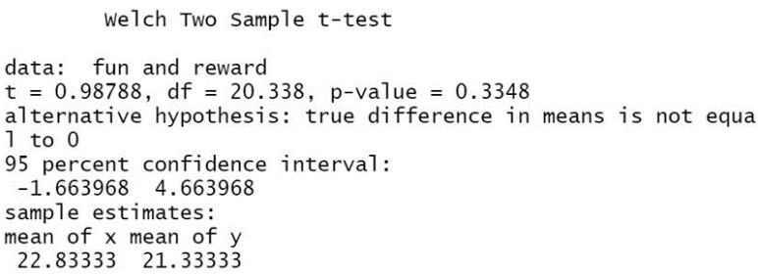

Step 4: Interpret the Results
1. Look at the means of the “fun” and “reward” group. What relationships do you see among the values just based on the means. The mean of the “fun” group is larger than the “reward” group.
2. Determine the p-value for your t-test. What does this value mean in the relationship of the hypotheses that you developed looking at an alpha level of 0.05? The p-value for the t-test is 0.3348. This mean that you should fail to reject the null hypothesis. Although the mean of the “fun” group is larger than the “reward” group the difference is not statistically significant at the alpha level.
3.Research about motivation. Do your results support research on motivation? Why might the results match or not match the research your group finds? Research on motivation shows that rewards are harmful towards creative tasks. The test should be conducted again with a larger sample size.

