Instructions for using RANDOM.ORG web-app:

- Go to the following website: https://www.random.org/geographic-coordinates/

- You should get a page that looks like the image below.

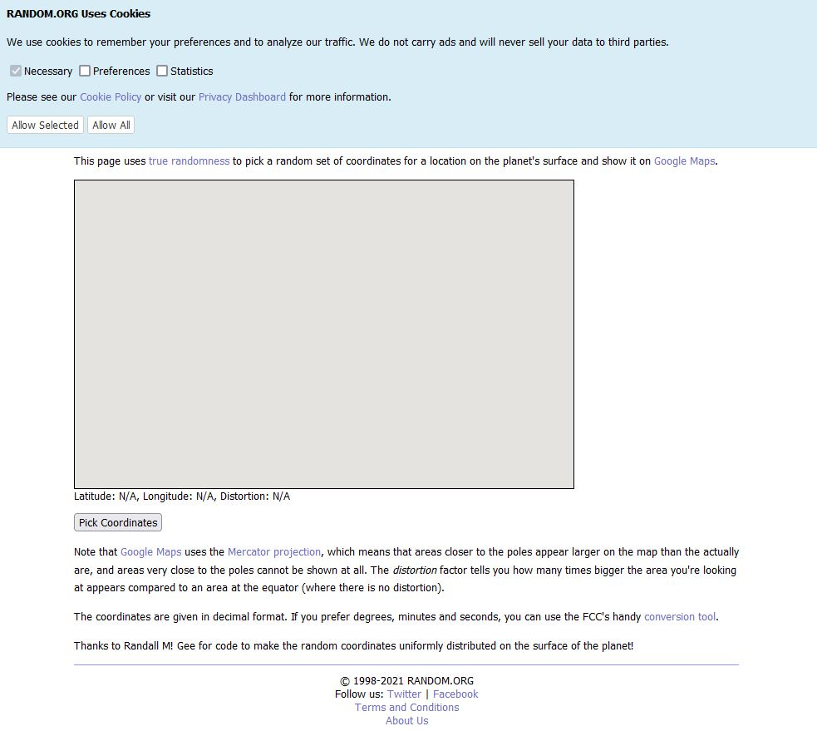
- Make your own personal choice on which cookies you will allow (or just skip down to 4).

- To get randomized geographic coordinates, click the “Pick Coordinates” button (shown below).
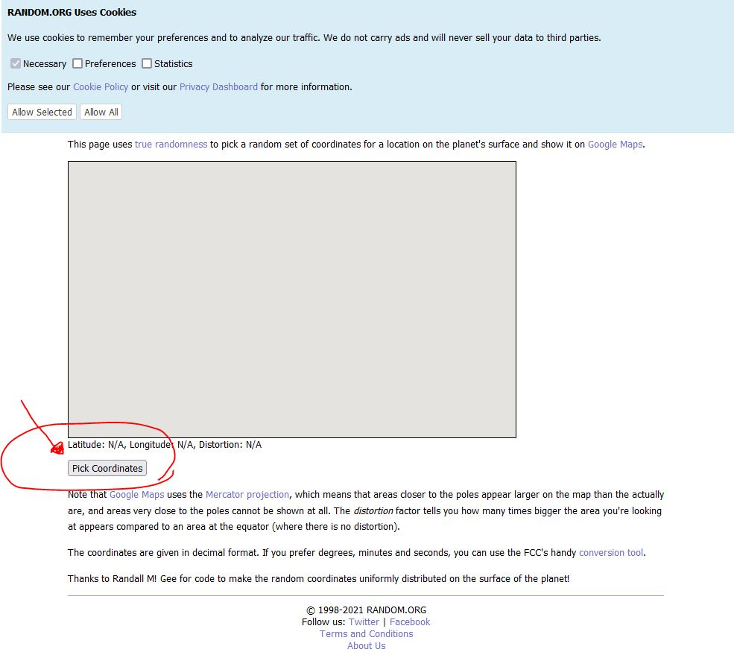

- If done correctly, you should get a randomized geographic coordinate inside the gray box (a demonstration is provided below).

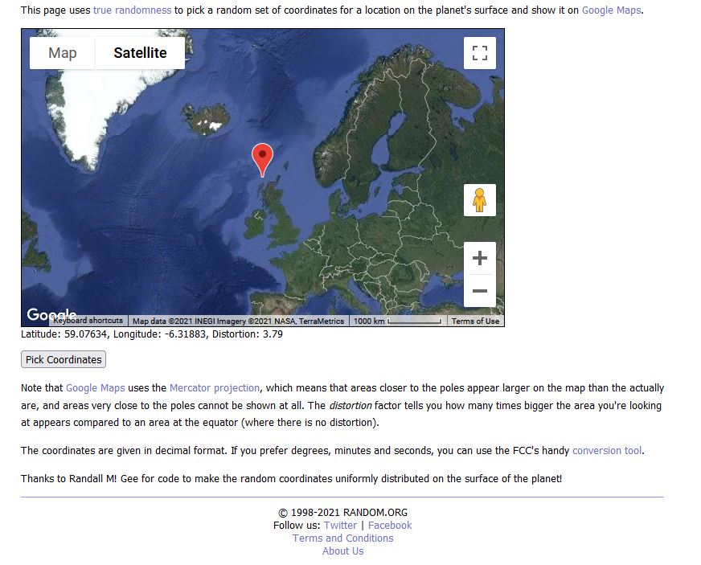
You can zoom in and out with the +/- buttons, respectively, to see if the pin point is on land or water (if you cannot tell from your current zoomed in status).

