Instructions for using Matt Bognar’s Probability Distribution Applet
- Go to the following website: https://homepage.divms.uiowa.edu/~mbognar/

- You should get a page that looks like the image below.

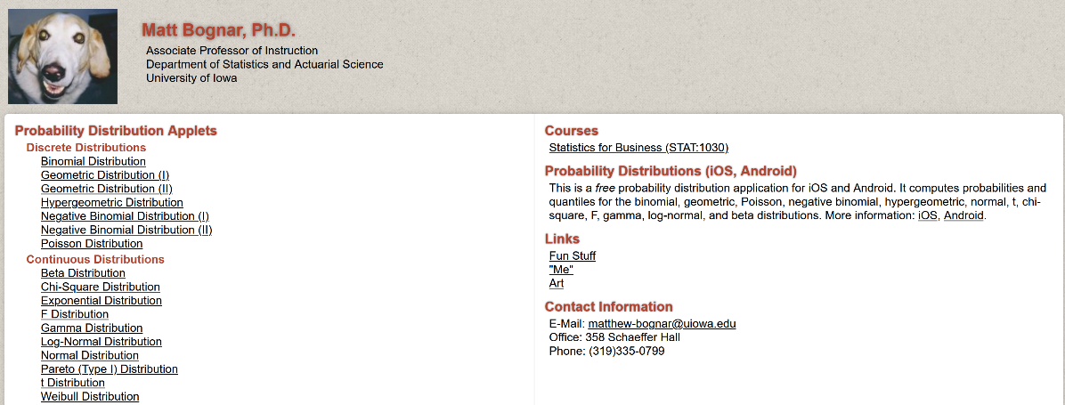

- Select “Beta Distribution” under the Continuous Distributions section.

- You should get a page that looks like the image below.

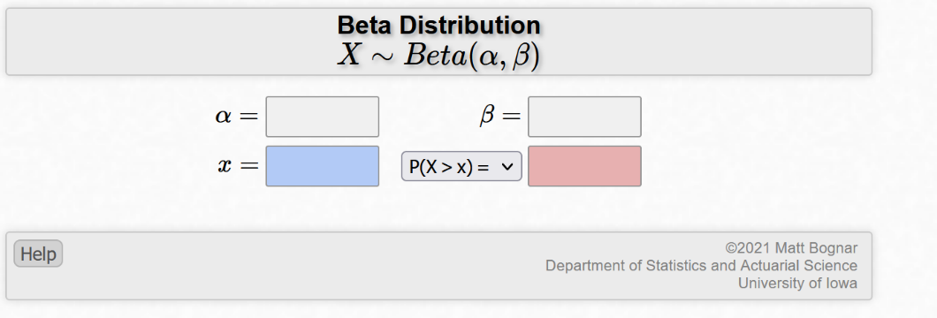

- The $α$ and $β$ variables are the parameters that control what the distribution looks like. In the lesson plan, you will be provided with example values to plug into each. The spaces for $x$ and $P(X>x)$ [or other probability relations through the drag-down menu] will help you find area under the curve [which is also covered in the lesson plan].

For example, see next page.

- Suppose we wanted to find the probability that our value of interest is greater than 0.5 (here a Beta distribution with $α=5$ and $β=10$). That can be done by plugging each value given into its space and then choosing the correct probability option in the drop-down menu. See below:

