Beta Distribution Briefly Explained:
I will suppose that the reader is familiar with the Normal distribution, as this ends up playing a major role in orthodox statistics courses. What I want to convey to the reader is that there are some similarities between these two distributions, and others but not the point here, in a certain sense.

The Normal distribution is controlled by two dials that the user can adjust, or parameters which determine its location and shape. Those dials, or parameters, are $μ$ and $σ$. The mean parameter controls the location upon which the bell-shaped curve is centrally located. The standard deviation parameter controls the shape, spread, of the bell-shaped curve. This is probably something the reader is familiar with. The mean parameter can take on any real value and the standard deviation parameter can on any positive real value.

While the Beta distribution is not controlled the same way as the Normal distribution is, the reader can still relate the parameters of the Beta distribution in a similar way. The parameters in charge of the Beta are similarly dials which control what the Beta distribution looks like. These parameters are $α$ and $β$ (I know, a beta parameter in the Beta distribution. Do not complain to me! I did not start the convention, but I totally understand your frustration or confusion!).

So, what do these two parameters do and why use the Beta distribution? Well to answer the second question first, the Beta distribution only covers numbers between zero and one (and includes them). Why is that important? Well, proportions and probabilities exist only on these numbers. When we are estimating proportions (or probabilities) then the Beta distribution covers exactly that space. To answer the first question, we can think of the $α$ parameter as a dial that pulls the distribution closer to one while thinking of the $β$ parameter as a dial that pulls the distribution closer to zero. What does that mean though?

Well, another way of phrasing this would be that $α$ represents the numerical count of the phenomena of interest and $β$ represents the numerical count of the other dichotomous outcome. With that in mind, these parameter values should both only take on positive real values. I will provide some examples of changing the dials on the Beta distribution below, but I would suggest the reader to do their own exploration as well.

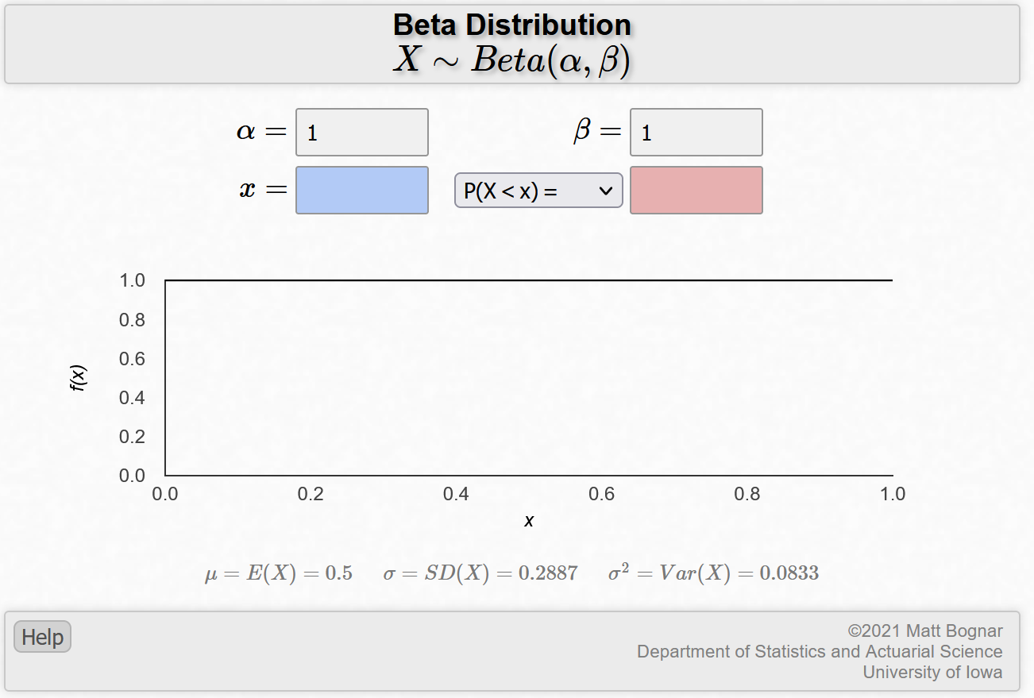
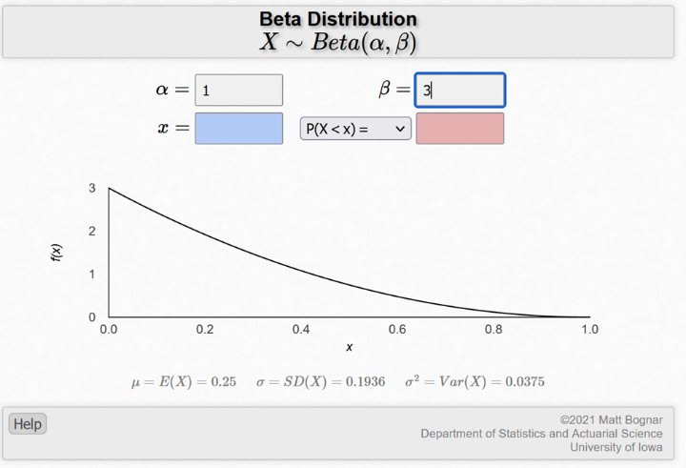
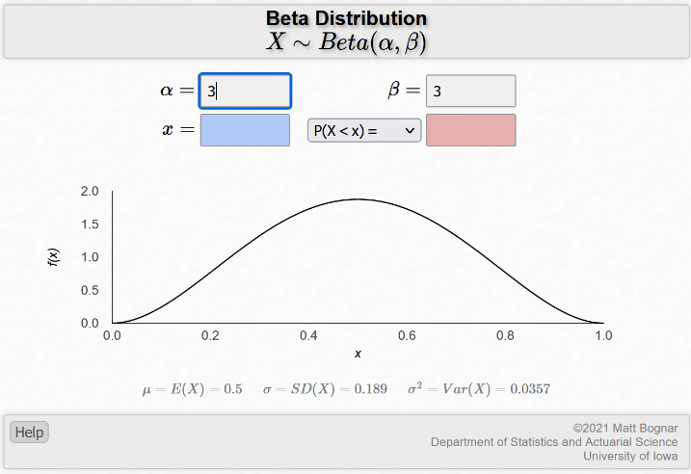
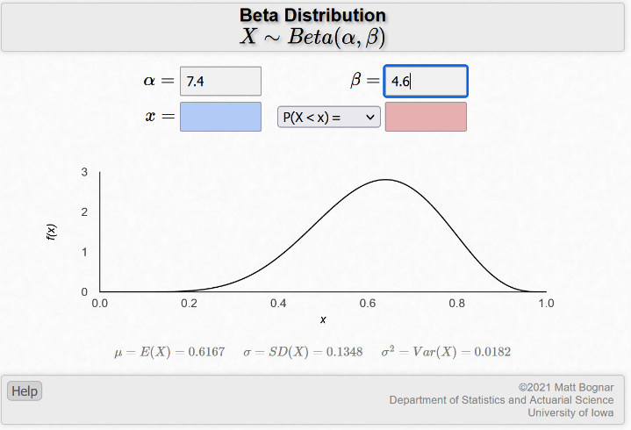
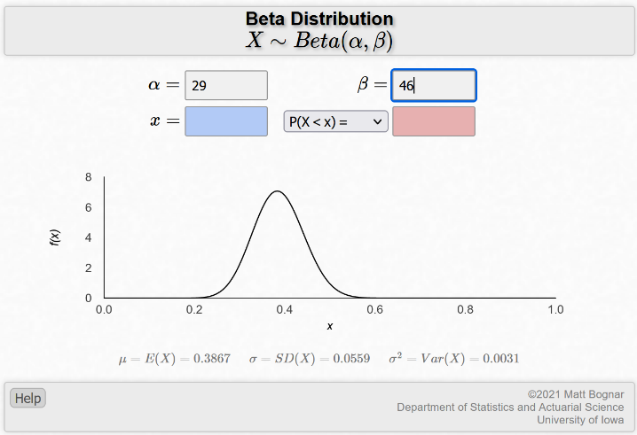
If we use the oldest statistical example of proportion estimation (that is, flipping a coin to estimate the proportion of heads), then we can think of the parameters as follows:
- $α$ – the number of tosses that resulted in the outcome heads.
- $β$ – the number of tosses that resulted in the outcome tails.
To connect this to the images, consider the last image presented above. It could be explained as us flipping a coin seventy-five times and getting twenty-nine heads and forty-six tails.
This is the Beta distribution’s big contribution to estimating proportions! When our data is dichotomous and we seek to find the proportion, the Beta distribution is a natural means of analysis!

