How much Water is on Earth?
Bayesian Inference Worksheet
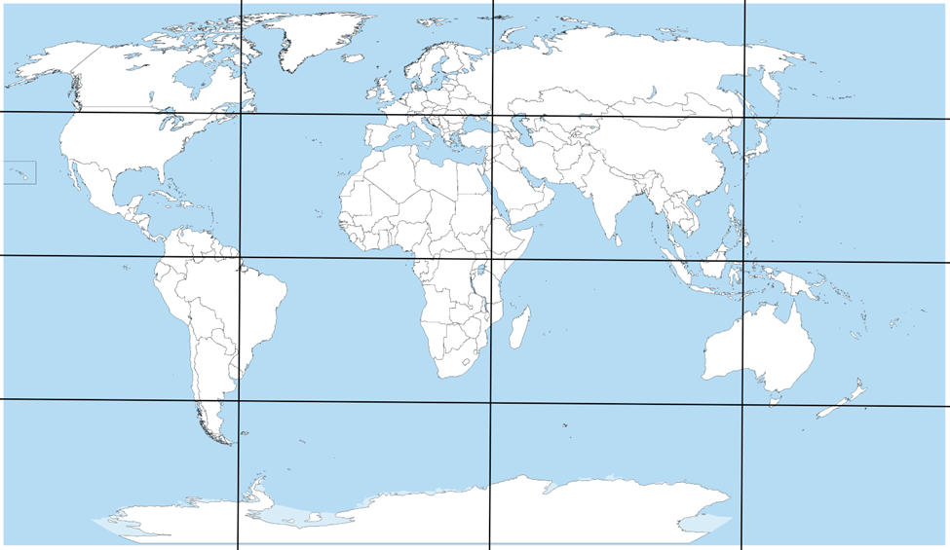
- Formulate your model assumptions. Consider the map above. How many grids are mostly land? How many are mostly water? Provide your model assumptions below and carry them throughout this worksheet wherever you see a Grid row in a table.

 | Count of Lands $(β)$ | Count of Waters $(α)$ | Total Observations | Proportion Estimate
Grid |  |  | 16 | /16

- Go to the following website: https://www.random.org/geographic-coordinates/

- Click the “Pick Random Coordinates” button to randomly generate a location on earth. “Map” is the default. You can select “Show with Google Maps Satellite View” after getting a random coordinate for visual display purposes. Map is usually easier to tell if the pin is on land or water and does not send you to another site. You can also zoom in with the “+” button and zoom out with the “-“ button to help identify if the pin is in land or water (see footnote below).

- Collect fifty observations through the randomly generated points. In groups of two to five students, this task can be performed quickly. Even with a group of two, one student can click “Pick Random Coordinates” and call out Water or Land while the second student tallies the counts of what is called out. Continue to fill out your table using the values from step 1 and those obtained in this step. That is, fill in the Simulation row provided below.
 | Count of Lands $(β)$ | Count of Waters $(α)$ | Total Observations | Proportion Estimate
Prior |  |  | 16 | /16
Simulation |  |  | 50 | /50

- Finalize the Combined row using the procedure discussed in class.

 | Count of Lands $(β)$ | Count of Waters $(α)$ | Total Observations | Proportion Estimate
Grid |  |  | 16 | /16
Simulation |  |  | 50 | /50
Combined |  |  | 66 | /66

- Go to the following website: https://homepage.divms.uiowa.edu/~mbognar/applets/beta.html

- Provide your answer to the first question your teacher posed. For reference “What proportion of earth is covered in water?” You can follow the instructions given in the lesson to fill in the Proportion Estimate above for the Combined row. Recall that the Point Estimate is the Proportion Estimate from the Combined row.
Point Estimate: _____________

- Put in your count of waters from the Combined row into the blank space for $α$. Put in your count of lands from the Combined row into the blank space for $β$. The web-app should change to provide you with a curve which we call a distribution. If you are looking for a 95% Interval Estimate, then you need two endpoints that make the middle contain 95% of the distribution. Subtract 0.95 from 1 and divide that by 2 (for the two tails of the distribution). In this case, you should obtain 0.025 for the two tails. To find the lower bound of the interval, select $P(X<x)$ option and type in 0.025 to the red highlighted box. You will obtain your lower bound in the blue highlighted box. To find the upper bound of the interval, select $P(X>x)$ option and type in 0.025 to the red highlighted box. You will obtain your lower bound in the blue highlighted box.
An image of the red and blue highlighted boxes are provided below for reference.

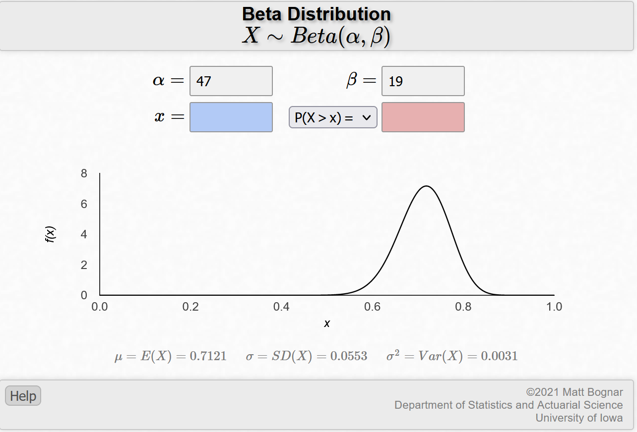
Interval Estimate: _____________

- It might be important to know how much of your analysis is based off the Grid and how much is based off the Simulations. If you’d like to be able to figure out how much your analysis relies on the Grid (or Simulation) then you can compute the weight of each. The computation (with the table you created in problem 5) is quite easy. To find the Weight of the Grid, find the Total Observations from the Grid row and divide that number by the Total Observations of the Combined row. To find the Weight of the Simulation, find the Total Observations from the Simulation row and divide that number by the Total Observations of the Combined row. Find and report those values below.
Weight of Grid: _____________
Weight of Simulation: _____________

- Suppose you want to provide support for (or against) the claim that the proportion of water on earth is less than 50%. Put in the blank space for $x$ the value 0.50 (which is the decimal representation of 50%). Also, click the drag-down menu and select the option $P(X<x)$ to obtain the probability of water being less than your input value of 50%.

- Write down the probability of water being less than 50% given your model.
$P\left(W<0.50\right)=$_____________________________________
Write down the probability of water being greater than 50% given your model.
$P\left(W>0.50\right)=$_____________________________________
You can click the drag-down menu and select the option $P(X>x)$ to obtain the probability of water being greater than your input value of 50%.

- Discuss if this provides support for or against the claim that there is less than 50% water on earth, how much your model assumptions (from the grid in problem 1) influenced the outcome, and if you would believe the hypothesis statement given all this information in a few sentences.

